
K&M Tire

Credit & Collections SOP
11/12/2025

Table of Contents
1. K&M Tire 1
2. Office Manual Introduction 4
3. Overview 5
3.1 Conventions 5
3.2 Cautions & Warnings 5
4. Credit 6
4.1 New Account Setup Procedure 6
4.1.2 When a New Application is Received 6
4.1.3 Account Setup Steps 7
4.1.4 Setting Up Employee Accounts 13
4.1.5 Pulling DNBi Reports 14
4.1.6 Pulling CBC Reports 15
4.1.7 Credit Line Review and Increase 16
4.1.8 Credit Department Coding 21
4.2 Managing Credit Lines 21
4.2.1 Credit Line Management & Credit Authorizations 21
4.2.2 Financial Statement Requests 23
4.2.3 Credit Lines over $200K Quarterly Review 24
4.2.4 75% of Credit Line Procedure 25
4.2.5 Filing UCC-1's 32
4.2.6 Filing a UCC-1 for the First Time or Re-Filing 32
4.2.7 Direct Ship Orders 37
4.2.8 Pre-Approval and Credit Line Review 37
4.2.9 Address Changes 37
4.2.10 Release of Liability 38
4.2.11 Salesperson Commission Maintenance 39
4.2.12 Creating Macros in MaddenCo 40
4.3 Daily Tasks 42
4.3.1 Credit Authorizations 42
4.3.2 Chargebacks/Misc. Collections 47
4.3.3 References Received 48
4.3.4 Terms Request 49
4.3.5 Equipment Orders 50
4.3.6 Making an Account Inactive 50
4.3.7 Increased Level Duties 51
4.3.8 Quarterly Accounts Receivable Health Assessment 51
4.3.9 "Do By" Tasks and Expectations of Completion 51
4.3.10 Employee Purchases 51
4.3.11 COD Statements 53
5. Collections 54
5.1 General Collections Policies- When an account goes past due 54
5.1.1 Pulling Reports 54
5.1.2 Large Chain Aging/E-Commerce 56
5.1.3 Checking Account in MaddenCo 58
5.1.4 Guidelines/Collections Policy 59
5.1.5 California Collections Guidelines 60
5.1.6 Status Changes 61
5.1.7 How to bill back NSF’s 62
5.1.8 Repayment Plans 65
5.1.9 Sending an Account to Outside Collections 66
5.2 Daily Tasks 68
5.2.1 Daily Tasks – Account Specialist 68
5.2.2 Final Demand Notices 69
5.3 Pulling Employee Statements 71
5.4 Service Charges 73
5.5 Payment Discrepancy Follow-Up 74
5.6 Credit Card Declined – Auto Payment via CC Report 76
6. Shared Duties 81
6.1 Terms Request 81
6.1.1 Equipment 82
6.2 Refunds/Check Requests 83
6.2.1 Check Requests 83
6.2.2 Refunds to Credit Cards 83
6.2.3 Manager Approval – Check Requests 83
6.3 Updating a Due Date 85
6.4 Making an Account Inactive 86
6.5 Daily Tasks 86
6.5.1 Driver Calls 86
6.5.2 Applying Credits in Cash Receipts 88
6.5.3 Memos/Notes on Customer Accounts 89
6.5.4 Chax Check Payments 90
6.5.5 Merchant Partners Payment Processing 94
6.5.6 Processing the CC Fee 96
7. Increased Level Duties 98
7.1 "Do By" Tasks and Expectations of Completion 98
7.1.1 Maintenance Log 98
7.1.2 Collection Agency Audit 98
7.1.3 Annual Report on Customer over $100K 98
7.1.4 75% Of Line KPI Tracking 99
7.2 Bad Debt and Collections Agency 101
7.2.1 Bad Debt Tracking 101
7.2.2 Query Procedure 102
7.2.3 Bad Debt Write-Offs 103
7.3 Customer Number Change 105
7.3.1 Customer Number Change Process 105
7.4 Signature Capture Report 108
8. MaddenCo Procedure in case of Dashboard or Internet Outage 113
8.1 Setting Up COD Accounts In Madden Co 113
8.2 Setting Up Charge Accounts in Madden Co 114
8.3 Setting Up PR/SSP Miscellaneous Accounts in Madden Co 116
8.4 Updating a Due Date in MaddenCo 118
8.5 Status Changes in MaddenCo. 119
9. Conclusion 121
Appendix B: Supportive Department Summaries 122
Appendix D: Referenced Documents 123
Appendix H: Revision History Tracking 125

List of Figures
No table of figures entries found.

List of Tables
Table 1 - Support Points of Contact Error! Bookmark not defined.
Table 2 - Acronyms 115
Table 3 - Glossary Error! Bookmark not defined.
Table 4 - Referenced Documents 116
Table 5 - Approvals Error! Bookmark not defined.
Table 6 - Revision History Tracking 118

K&M Tire
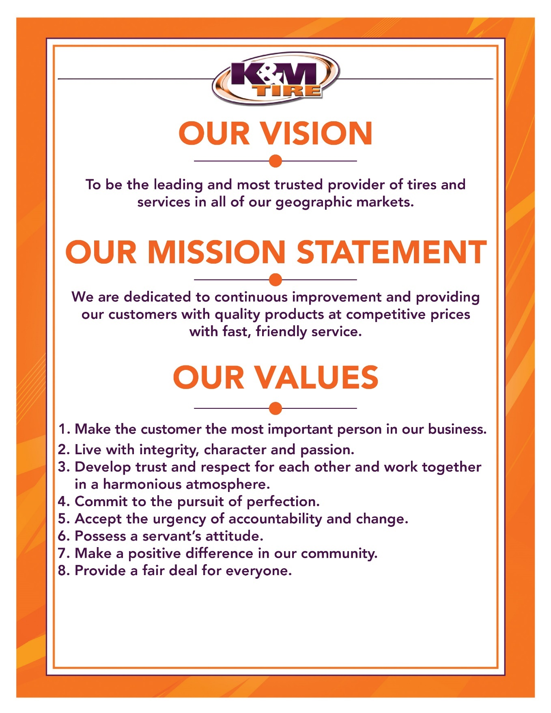



K&M Tire US Footprint
Click on the link below to see the footprint map.
http://kmtire.com/km-cgi/distmap

Office Manual Introduction
This manual is intended to aid in the training of the K&M Tire Credit & Collections team by providing step by step detail of the processes.

Provide link & path of where to find an up-to-date version

ADD PRIVACY AND/OR SECURITY CONSIDERATIONS HERE.

Overview

Conventions
This document provides screen prints and corresponding narrative to describe how to use the Maddenco, WISE and K&M Intranet, known as “company systems.”
When an action is required on the part of the reader, it is indicated by a line beginning with the word “Action:” For example:
Action: Click on OK.
Fields or buttons to be acted upon are indicated in bold italics in the Action statement; links to be acted upon are indicated as links in underlined blue text in the Action statement.
Note: The term ‘user’ is used throughout this document to refer to a person who requires and/or has acquired access to the company systems.

Cautions & Warnings
This manual does not supersede any safety or company policy.

Credit
The Credit Department is responsible for setting up new customer accounts, allowing customers to make purchases with K&M Tire. Additionally, the department manages customer credit lines, reviews financials, and files UCC-1 forms to ensure a smooth customer experience while minimizing the risk to K&M Tire.

New Account Setup Procedure
This procedure outlines the steps involved in setting up a new account and provides details on the different account types available.

When a New Application is Received
- When a customer wants to do business with K&M Tire, an account must be set up to facilitate their purchases. The Credit Department processes several types of applications:

  - Dealer Request Application: For Program or Large Chain accounts. Program Accounts require Marketing Approval before setup, which will be addressed further in the account setup process.
  - Account Application: For COD (Collect on Delivery) or Charge customers:
    - COD Account: Customers must fill out only the first page of the application (Note: COD is often referred to as a cash account, but it is distinct from a CASH ONLY account).
    - Charge Account: The first page must be completed, and the second page must be signed, confirming the Terms & Conditions.
  - Common Ownership Application: Used by existing Charge Accounts to set up additional Ship-To locations under the same Federal Tax ID. A W9 form must be submitted along with the application to verify the new location’s address.
- For COD/Charge Accounts, ensure the following information is completed:
  - Federal Tax ID
  - County
  - Delivery Address
  - Business Phone Number
  - Contact or Owner Name
If any of these details are missing, email the applicant to request the missing information before proceeding with account setup.

Account Setup Steps
Follow these steps to verify and set up a new account:
- Login to the Intranet:
  - Use your MaddenCo login credentials.
  - Navigate to the Credit & Collections section.
- Customer Search:
  - Click on Customer Search.
  - The purpose of this search is to avoid setting up duplicate accounts. Begin by searching for the customer using their Street Address. Clear the field, then search by Name and Phone Number. If an account appears in any of these searches, note it on the top of the application form.
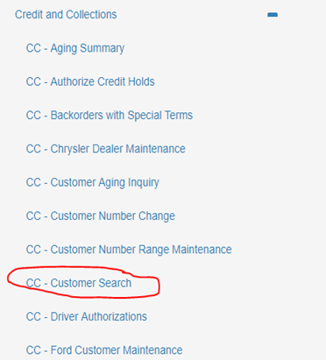

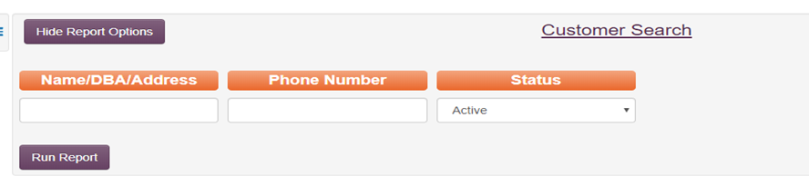

- Handling Duplicate or Existing Accounts:
  - Same Address, Different Name: Email the Sales Rep listed on the application to confirm whether this is a change of ownership or a name change. If no Sales Rep is listed, contact the Regional Sales Manager for clarification.
  - Ownership Change: If the customer has changed ownership, place the current account on No Sales.
  - Name Change: If it is simply a name change, update the existing account and save the new application.
- Required Information: Account setup cannot proceed if any of the following are missing:
  - Federal Tax ID
  - Phone Number
  - County
  - Sales Tax Exemption Information (if applicable)
- Enter Customer Information: After verifying the account details, enter the information into the Account Flow system on the Intranet:
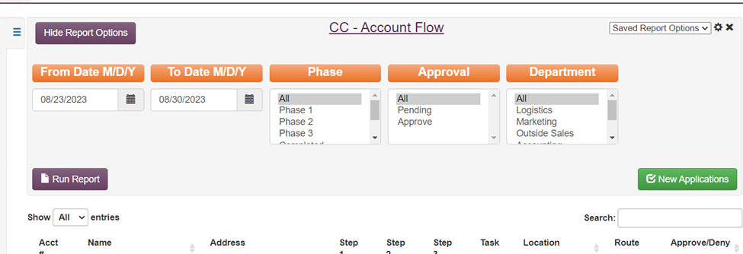
  - Select the correct Account Type from the dropdown menu.
  - Enter the customer’s Company Name, Email, Phone Number, Zip Code, Address, City, State, and County.
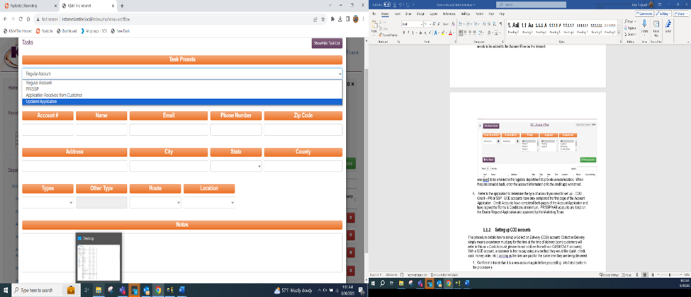
- Account Types:
  - Regular Accounts: Standard COD or Charge requests.
  - PR/SSP Accounts: Program accounts, requiring Marketing approval.
  - Application Received from Customers: Applications directly submitted by customers, which require approval from the Regional Sales Manager. These accounts are particularly scrutinized as K&M Tire primarily sells to wholesale and retail customers, not direct end users. We aim to direct retail customers to their designated wholesalers.
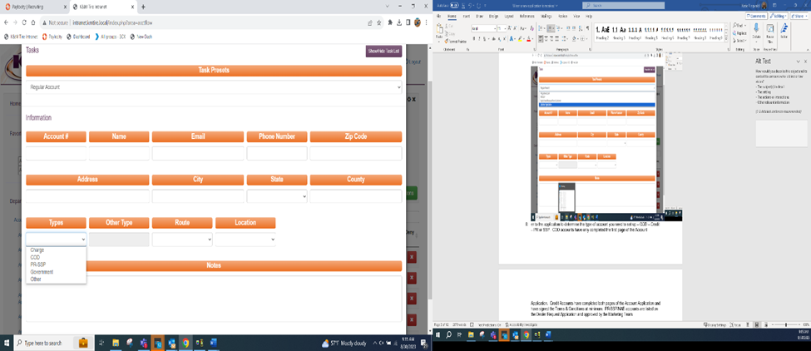
- Finalize Account Setup: After selecting the account type, ensure all necessary details are entered, and the application is saved in the system. Choosing the correct type is important as it will preselect the class for you on set up and it will also ensure the correct notifications are required prior to set up.
Once the new account is added to the Account Flow, it will notify the Logistics Department, which will assign the location/route code for the customer.
  - For PR/SSP accounts, Marketing approval is required before setup.
  - For applications received from customers, approval from the Regional Sales Manager is necessary.
The Account Flow system will highlight areas requiring approval. If the status is green, all steps are complete.
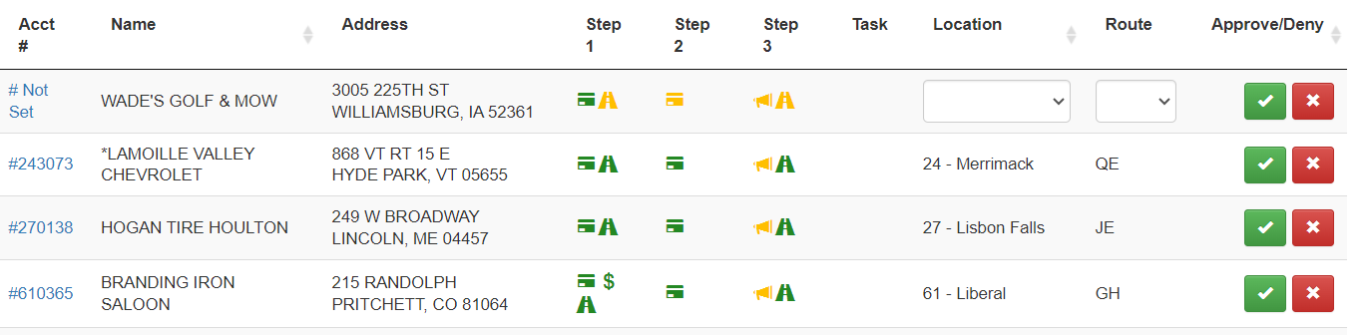
- Entering Customer Information
After all required steps are completed in the Account Flow:
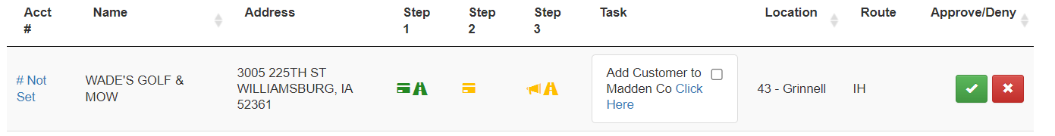
  - Pop-up Notification: You will see a pop-up message that says ‘Click Here’. Click this button, which will open a new screen to enter the customer's information.

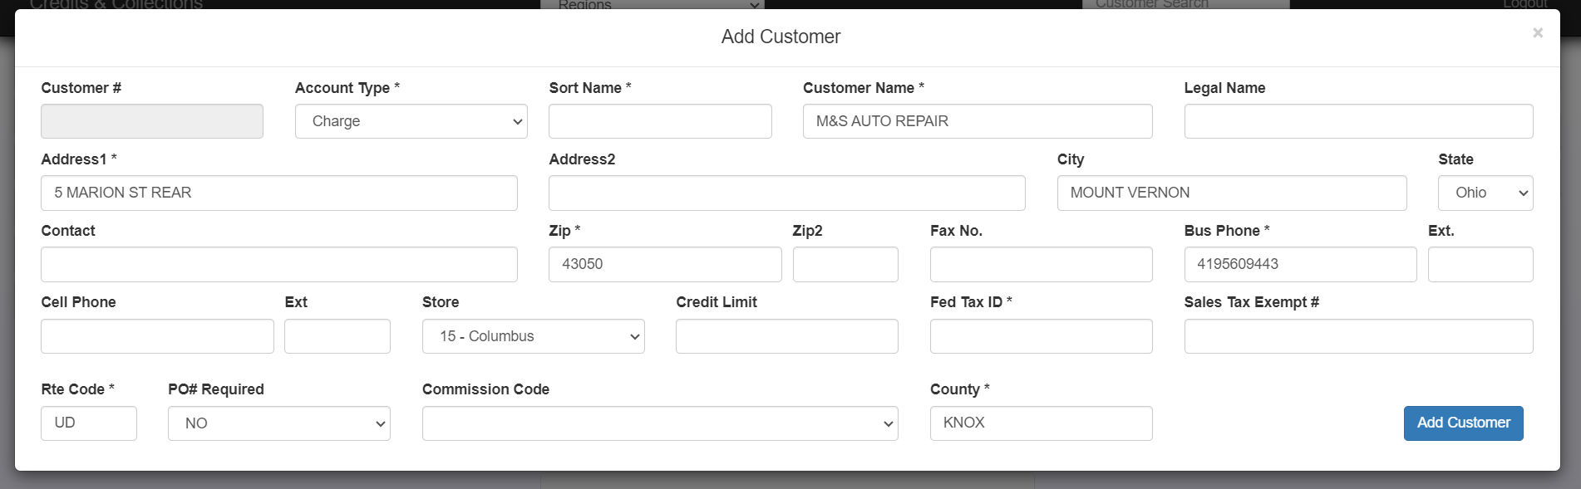

  - Sort Name:
    - Enter the Sort Name (business name).
    - The Sort Name should always match the DBA (Doing Business As) if listed.
    - The Sort Name and Customer Name must match.
    - Ensure the Sort Name procedure is followed:
      - No spaces or special characters.
      - Numbers should be spelled out.
      - Drop the word "The" from the beginning of the name.

Exceptions: For customers with 10 or more stores at different locations, use the following naming conventions:
- Belle Tire: Belle + Store number
- Discount Tire: Disc + Store number
- Firestone: Fire + City name
- Just Tires: Just + City name
- Levin Tire: Levin + City name
- Midas: Midas + City name
- Meineke: Mein + City name
- Monro Mufflers: Monro + City name
- Northwest Tire: Northwest + Store number
- Tireman: Tireman + City name
- Tires Plus: TiresPlus + City name
- Tuffy: Tuffy + City name
- Bob Sumerel: Bobsum + City name
- Goodyear: Good + City name
- TGK Auto: TGKAuto + Store number
- Sun Auto: SunAuto + Store number

- Add Customer:
  - After entering the required information, click ‘Add Customer’.
  - A verification screen will appear, displaying the assigned account number.
- Missing Information:
  - If required information is missing (e.g., Sort Name), a pop-up will appear. Complete the missing details and click ‘Add Customer’ again.
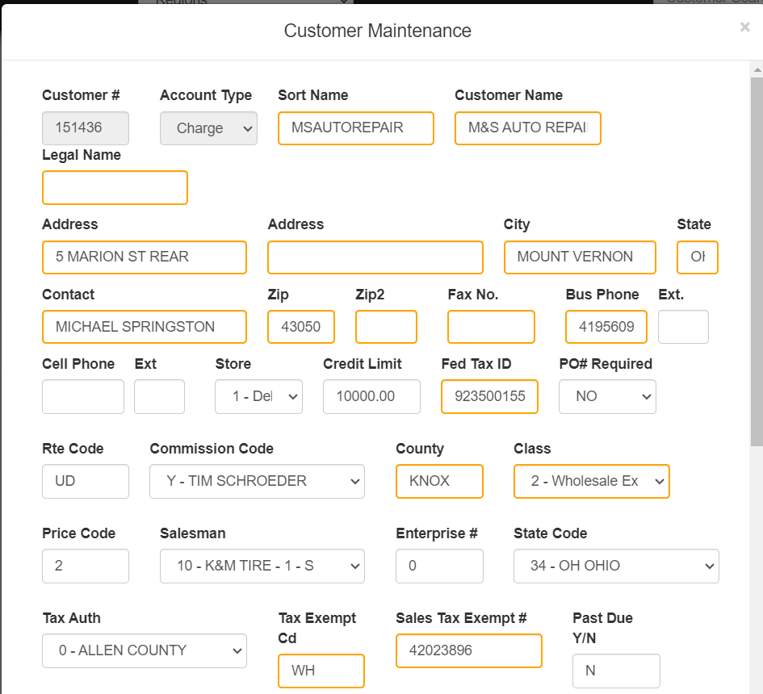

- Account Number:
  - Make a note of the Account Number as it will need to be added to the Account Flow screen.
  - Ensure that all required information is completed, paying special attention to areas marked Yellow.
  - Click ‘Save New Customer’ at the bottom.
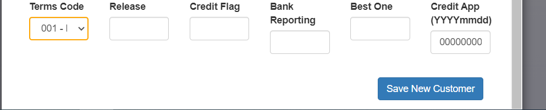
- Finalizing Account in Account Flow:
  - Go back to the Account Flow on the Intranet.
  - Click on the Not Set button and enter the customer’s account number.
  - Click ‘Update Application’ to save the changes.
  - Check the ‘Add Customer to Madden’ box.
  - Hit the Green Check to mark the task as complete. This will notify the next department of tasks they need to complete.
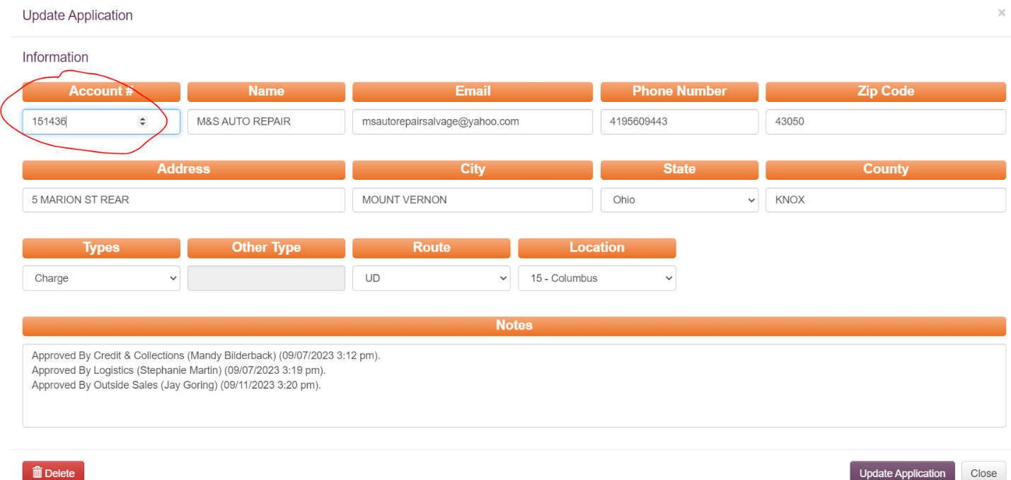
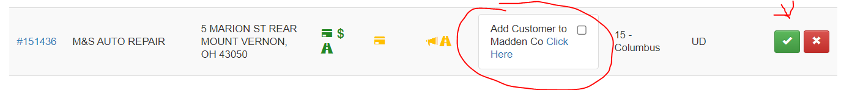

Setting Up Employee Accounts
Employee accounts allow staff to purchase tires or for billing purposes. These accounts should be set up upon request. If an employee has been with K&M for less than 90 days, the account set up must be approved by their manager.
- Enter Employee Details:
  - Sort Name: "xxlastname".
  - Class Code: 2 (unless Ohio, Maine, or New York, where it is 3).
  - Terms Code: 007 (COD).
  - Credit Limit: $1000.
- Additional Fields:
  - Tax Exempt: Leave blank (unless NH).
  - Past Due: n
  - Balance Forward: n
  - Service Charge Exempt: n.
- Inactivating Employee Accounts:
  - When an employee leaves, HR will notify Credit.
  - Go to Customer Balance Inquiry and add a Credit Management Note.
  - In Customer Maintenance, set their status to Inactive.

- Re-Review all listed steps for setup:
  - Enter new account number
  - Sort name xxlastname
  - All employees are cod
  - Enter name, address, and phone
  - Class code: 2 unless Ohio, Maine, or New York then it is 3
  - Home store: 000
  - Price code: 6
  - Salesman: 10
  - Terms cd: 007
  - Cr limit: 1000.00
  - Retread: n
  - State cd: f4 for drop down
  - Tax auth: f4 for drop down
  - Tax exempt cd: leave blank (all employees pay tax) unless NH
  - Walk-in: n
  - Tender type: cod
  - Past due: n
  - Bal fwd: n
  - Srv chg exempt: n
  - Statement hold: n
  - Allow back order: y
  - Can/can’t buy: n
  - Move acct to selling: n
  - Svc chg write off: 999
  - Allow hot sheet: y
  - Message: ***employee***
  - Po required: n
  - Vehicle required: n
  - Brand # required: n
  - F2 screen:
  - Statement: k
  - Check Enterprise: n
  - Commissions: z
  - County: enter County per zip code

Pulling DNBi Reports
A Dun and Bradstreet (DNBi) report is a Business Credit report – similar to a personal credit report, it provides an overall score, details of previous transactions, and where the business’ current payment standing are.
Not all businesses will have a DNBi report available (if the business recently opened, if they have always paid up-front, etc.). This report plays a part in determining if/how much credit we are willing to extend to a company.
The DNBi report helps assess a customer's creditworthiness. Follow these steps:
- Go to the DNBi Website.
- Search by Business Name and Verify the correct address.
- Click on the Blue Highlighted Report.
- Verify again the business is accurate.
- Print the Report and attach it to the application.

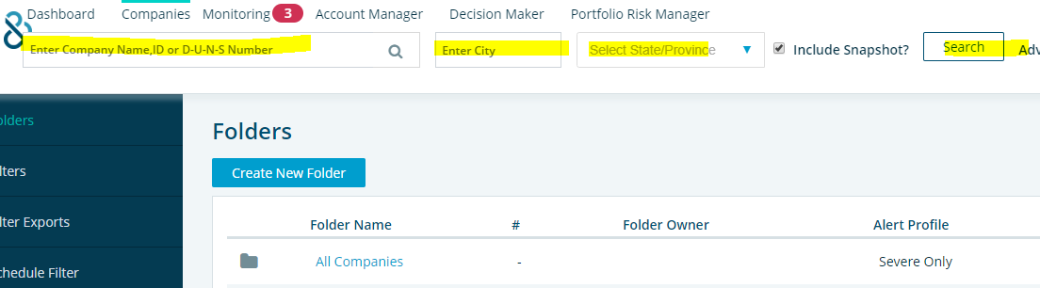

Pulling CBC Reports
If no DNBi report is available, you may pull a CBC (personal) report if the customer has signed a Personal Guarantee.
A CBC report is a personal credit report. In cases that a DNBi report (business credit report) is not available, but a customer still wants a line of credit, as long as the customer is willing to personally guarantee the balances will be paid and they sign our Personal Guarantee on the application, we are then able to pull their personal credit report and base the business’ credit limit on the finds from the personal credit report.
- Runing a CBC (Personal Reports) you must Login to CBCWeb and enter the required information.
- The signature on the personal guarantee located on the 2nd page of the application must match the name of the person submitting their personal information.
- If the name matches the signature and all personal information is provided (name, address, ss#, dob) you may continue to pull the reports
- Log onto cbcweb
- Enter ss# as application/loan #
- Enter your name in “requested by” field
- Enter all of the information in fields marked with a red asterisk
- Press submit

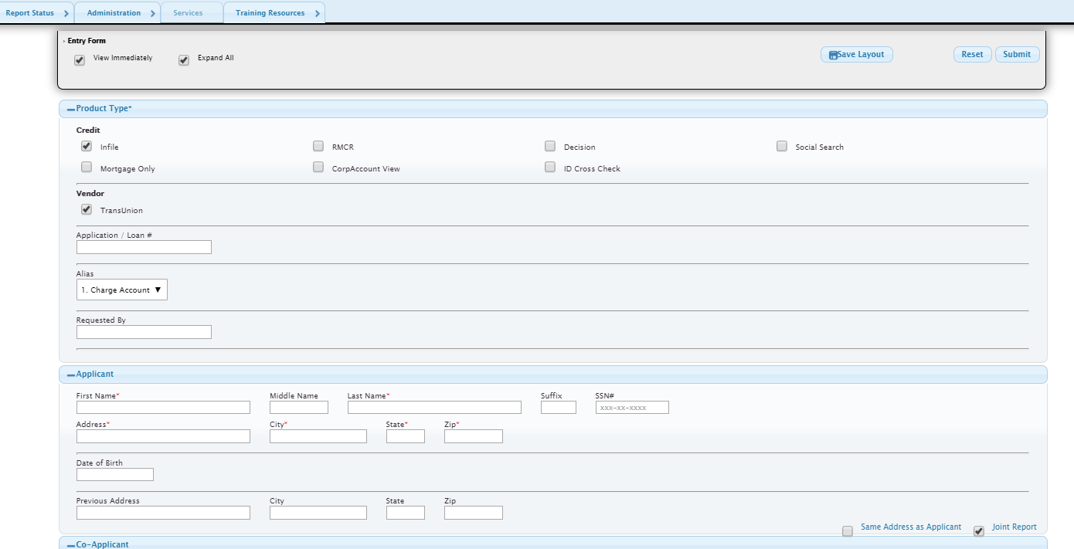
- This will pull up the report. Print this report and put it with application.
- When you pull a Personal Report you need to log it on the “Report List” Spreadsheet Located On the F: Drive
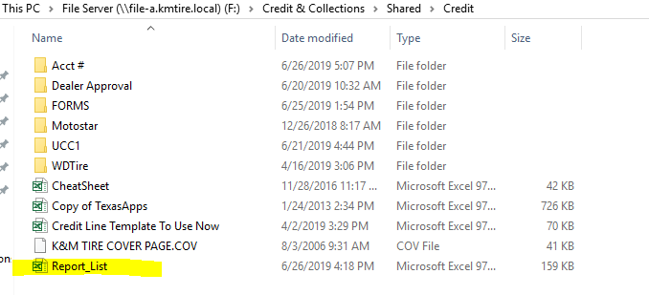

Credit Line Review and Increase
Credit lines may be increased using the Credit Line Template. This process includes reviewing DNBi scores, personal credit reports, or requesting financial statements from customers.
- Download and Save the Template from the F: Drive.
  - If the line doesn't populate, request further financial details or file a UCC-1.

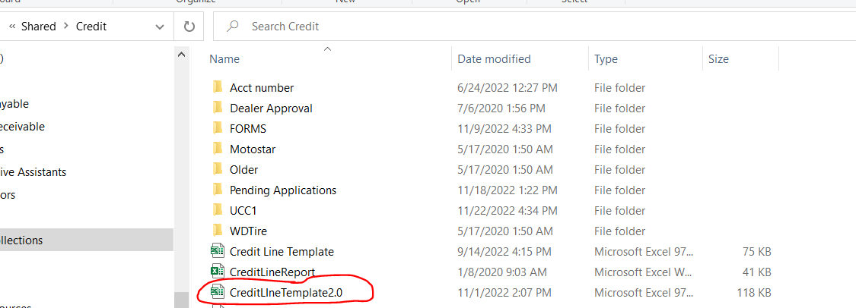

- Enter Customer Info and Annual Sales (from the application or Regional Sales Manager).
- Complete the Template to determine if the line can be increased. The template will require 2 YES features before assigning the line.

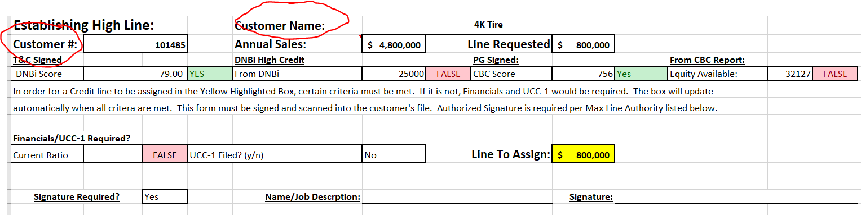

- Pull an updated customer DNBi score - please utilize using your personal log in information. You should have the website bookmarked for easier reference.

- From the DNBi report, pull the Paydex information and enter it as the DBNi Score in the template.
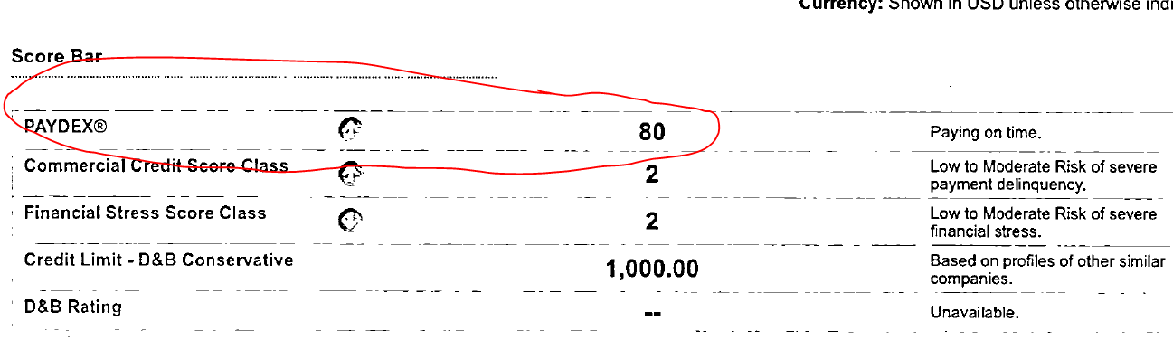

- Enter the DNBi High line into the template – See below example.

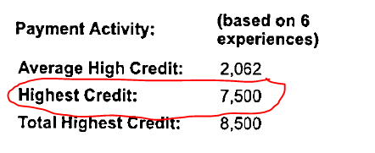
- If the line to assign does not populate, the next step is a Personal Credit Report. This report can only be pulled if the customer signed the Personal Guarantee section of our application and provided their personal information.

  - For security purposes, the only users that can pull CBC reports include the Credit Manager and the Credit Analyst (Level 3).

    - Personal Credit Scores are found on this report, average the below two scores and input the amount in the CBC Score of the template: (Average would be 733)

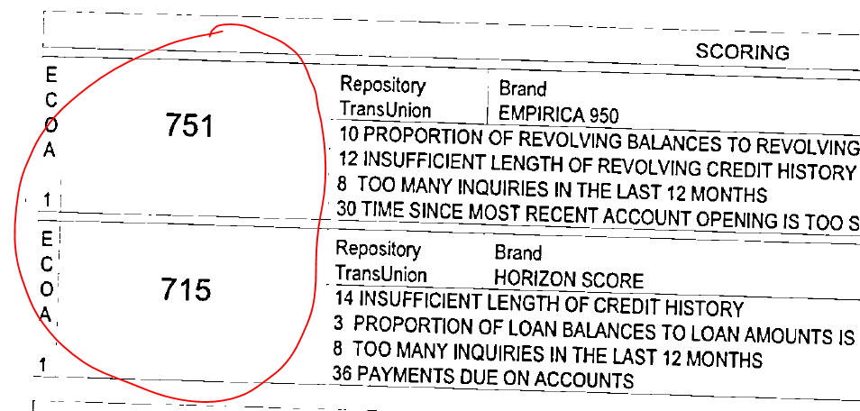

- Calculate the CBC Equity Available – from the Credit Summary of the report, subtract the total balances from the total limits: (Available Equity $36,914)

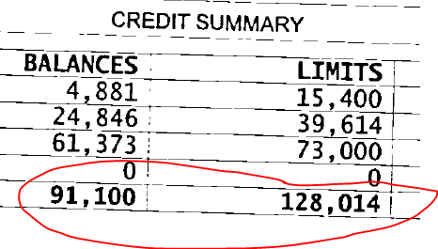
  - If the Line to assign still does not populate based on the information provided, contact the customer and request one of the following:

  - #1 – Allow us to file a UCC-1 or #2 – Provide their last two years financial statement.

    - To file a UCC-1 - follow the UCC-1 filing instructions and update the Template to ‘Yes’. If the line to assign populates – nothing additional is needed.

  - If the customer is not willing to allow a UCC-1 filing, request their last two years’ financial statements (balance sheet and income statement). Upon receipt, add the required information to the template. Their Ratio will calculate automatically on the template page.
- Input necessary customer information:
- Enter the customer number
- Customer name
- Your name as the preparer.
- Enter the first year of financial information received.
- All gray areas listed need to be completed.
    - The white areas will calculate simultaneously.

If this is the first time you have reviewed financials – schedule time with the Credit Manager to complete this process.

At the bottom of the template, several calculations will appear.

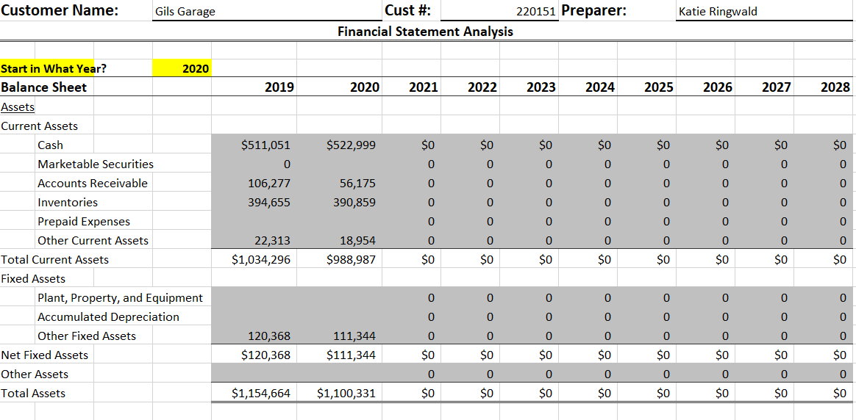

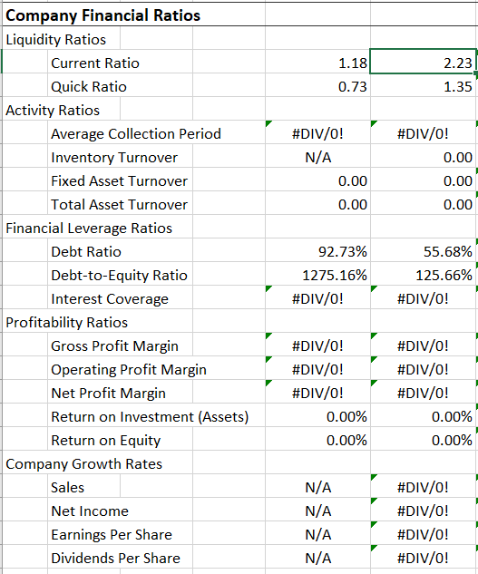

- The Current Ratio will populate for you in the correct field on the Template and will show the Green YES if it’s within our range. Our range currently is anything greater than 1.75.

- If the line to assign still doesn’t populate, the customer is unable to qualify for the line requested. You can offer them a lower line or leave the currently established line and request a reducer payment.

- Accounts that are $5K or more over their line of credit will need to be moved to a COD status if a reducer payment is not received and applied to their account Same Day.

- If the line is approved, review the below to obtain the appropriate signature(s). The appropriate person can provide a physical signature or an email approval.

Credit Department Coding
GM/Ford/Chrysler Maintenance on the Intranet. Information needs to be added.
Steps:
- Log into the Intranet and select the appropriate dealership type.
- Type in the customer number and hit ‘Search’.
- If the Dealer Number field appears blank, enter the dealer number and hit ‘Edit’.

Managing Credit Lines

Credit Line Management & Credit Authorizations
When an account is set up, it is assigned a Credit Limit (or credit line). As buying trends change, a customer’s credit line should be adjusted accordingly, ensuring K&M’s protection in the process. This procedure outlines how we manage credit lines and the options available.

Ways to Monitor Customer Credit Lines:
- Credit Authorizations
- Weekly Credit Line Reports
- Monthly Report/New Account Query when a customer first purchases from K&M Tire
- 75% Credit Line Utilization Query
The goal is to maintain all customers under their credit limits. While exceptions may be made, they should be minimal. Customers who may exceed their credit lines include:
- Accounts in collections
- Accounts on a repayment plan
- COD accounts with no issues related to NSF
Over Limit Account Management:
- If a customer exceeds their credit line, and a credit increase is not justified, a payment must be made within 3 days of exceeding the limit.
- If the customer cannot pay by phone (via Chax or credit card), the payment must be received within 3 days. If not, the account will be placed on COD status.
Handling Credit Authorizations:
- You may hold an order until the end of the business day only.
- Email the following recipients:
  - Inside Sales Manager
  - Assistant Sales Manager
  - Customer Service Group
  - Inside Sales Group
  - Regional Sales Manager
CC: Credit Manager, VP of Sales
- In the email, state:
  - Customer number and name
  - Reason the order will not be released
  - Invoice information
- Add the line item DONOT to the invoice.
- In Order Entry, press ‘Shift + F4’ to open the MaddenCo Credit Authorization Screen. Change the message to ‘Do not authorize!’.
End of Business Day Procedures:
- If the customer hasn't contacted, you back and they are on charge status:
  - Change their account to COD status.
  - Update current orders to reflect the status change.
- If the customer is on Cash or COD status:
  - Leave the order in the system, do not approve.
  - Email the Inside Sales team at insidesales@kmtire.com requesting that the invoice not be released and moved to backorder status.

Credit Line Increase Guidelines:
- Customers that are current should have their credit line increased if possible.
- Customers that are past due should have their credit lines frozen until a repayment plan is established.
- For COD customers with larger orders, pre-payment may be requested.
- When requesting credit line increases, ensure to include the following information:
  - Customer Number and Name
  - Current and Requested Credit Line
  - Documentation on file (Signed T&C, Personal Guarantee, Financials, UCC-1, Credit Scores, Equity Available)
  - K&M’s payment history with the customer

Financial Statement Requests
This procedure ensures we make informed credit decisions for our largest accounts by collecting financial statements annually from customers with credit lines of $150,000 or higher.
Procedure:
- Annually, K&M Tire will request financial statements from all customers with a credit line of $150,000 or higher. The Credit Manager tracks the last received financial statement using the “Financials Rec’” user flag field.
- The Credit Manager will either make the request or assign it to a team member (See Financial Statement Request – template letter).
  - For a standard request, we ask for the previous year's Balance Sheet and Income Statement.
  - For new customers with credit lines of $150,000 or higher, we request the last two years of financials, including Balance Sheet and Income Statement.
- Customers Excluded from Financial Statement Requests:
  - MyTirePlace
  - BestOne Tire locations
  - Amazon
  - Berry Tire (Exclusions can only be made by the President or EVP.)
- Customers who refuse to provide financial statements will be reported to the EVP and President. The report will include:
  - Customer name
  - Credit limit
  - Terms provided
- Financial Review Process:
  - The Credit Manager reviews the financials, including purchase and payment history, UCC-1’s, and personal guarantees.
  - Financial information is entered into the “Financials Review” tab of the Credit Line Template to analyze liquidity, financial leverage, and profitability ratios.
  - The MaddenCo “Financials Rec’” user flag field is updated with the date the financials are received.
  - Recommended changes to credit limits are submitted to the EVP, who will review them with the President.

Credit Lines over $200K Quarterly Review
Purpose:
Establish a process to review credit lines exceeding $200,000 quarterly, ensuring limits are appropriate.
Procedure:
- Report Generation:
  - The Credit Manager will schedule quarterly reviews with the EVP and Director of Finance in January, April, July, and October.
  - The Credit Manager will pull the credit report no later than the fifth day of the review month.
- Preliminary Review:
  - The Credit Manager will conduct a preliminary review to identify any recommended adjustments and submit the summary to the EVP and Director of Finance.
- Review Meeting with EVP and Director of Finance:
  - If necessary, the EVP and Director of Finance will meet with the Credit Manager to discuss any additional modifications.
- Recommendations and Adjustments:
  - The Credit Manager will prepare a final report, incorporating adjustments from the EVP and/or Director of Finance and send it out for final approval/review.
- Follow-up Actions:
  - Modifications or actions required by the EVP must be implemented by the Credit Manager within 3 business days.

75% of Credit Line Procedure
Purpose:
This procedure outlines the steps to generate and combine two reports—the credit line utilization and aging reports from MaddenCo—to evaluate customer accounts utilizing 75% or more of their credit line.
Steps:
- Pulling the 75% Credit Line Utilization Report:
  - In MaddenCo, press ESC, enter ‘1’ on the query line, and press Enter.

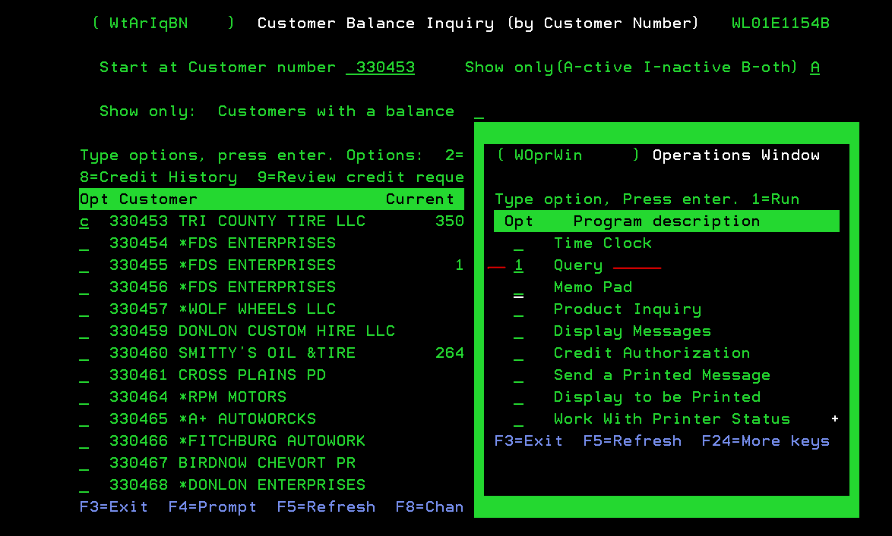
  - Select Option 2 for the library USRQRY, then select F4 to view saved queries.
  - Select Query CUST.CRLMT and run the query.
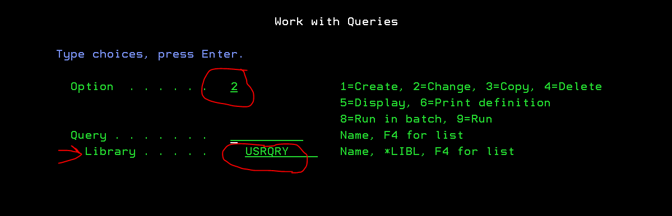
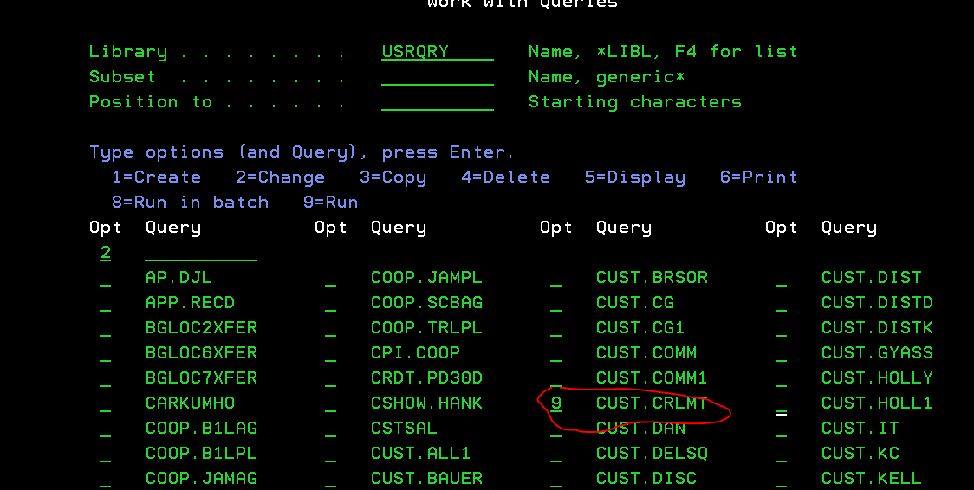
- Using the System Navigator:
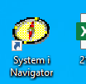
  - Log in to the system, and when prompted with an error code, press OK.
  - Use the Basic Operations dropdown, select Printer Output, and follow the steps to drag the report to your desktop.
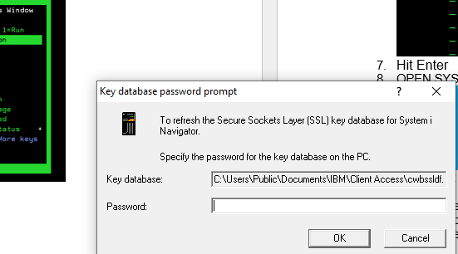

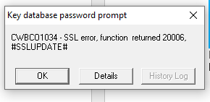
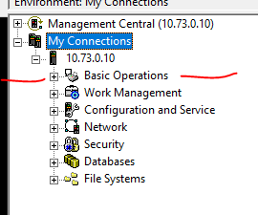
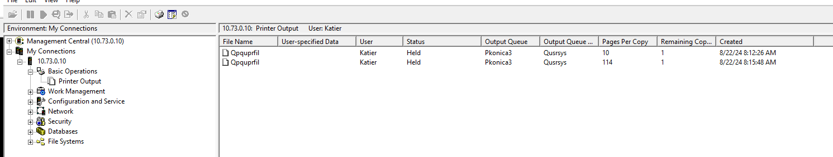
- Importing the Data into Excel:
  - Open Excel and browse for the report file, using the Text Import Wizard to properly format the data.
  - Once formatted, the data is ready to be analyzed.
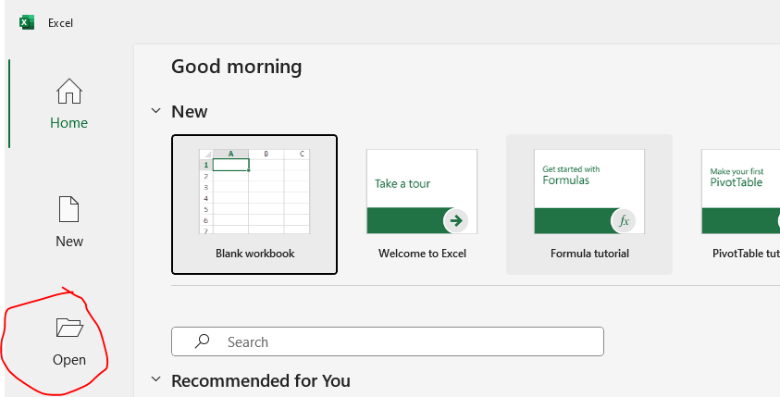
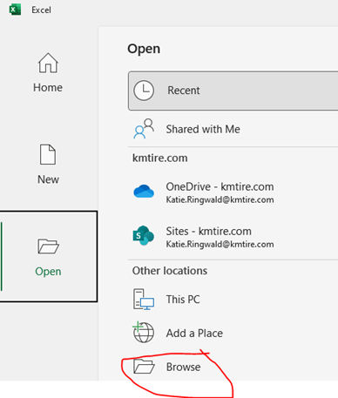
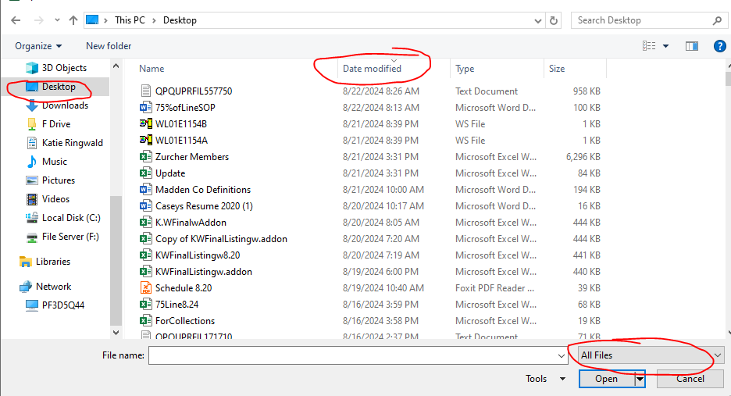
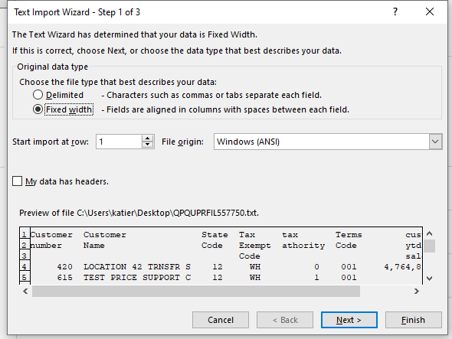
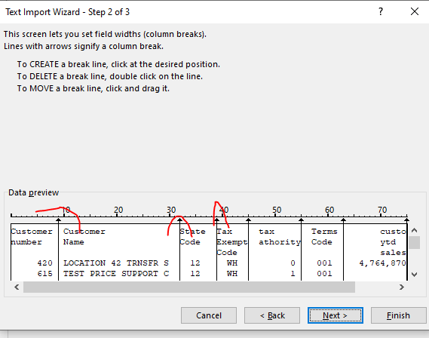
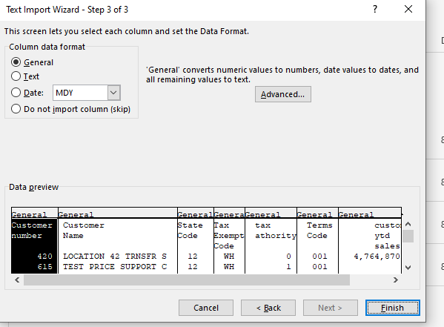
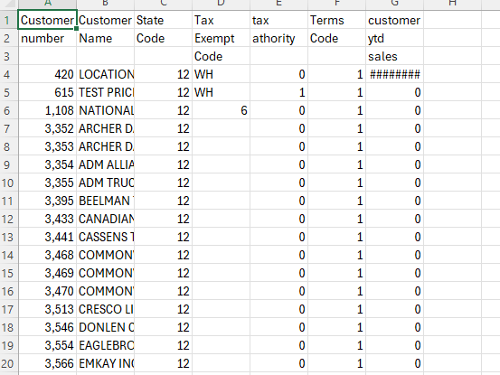

- Pulling the Aging Report:
  - In MaddenCo, follow these steps to pull the aging report:
    - Go to Tire Dealer System > Accounts Receivable Menu > A/R Report Menu > Aging Report > One Line Past Due Aging Report.
    - Follow prompts for the report, ensuring to set the correct dates and order criteria.
    - Save the report and follow similar steps as for the credit line report to import into Excel.
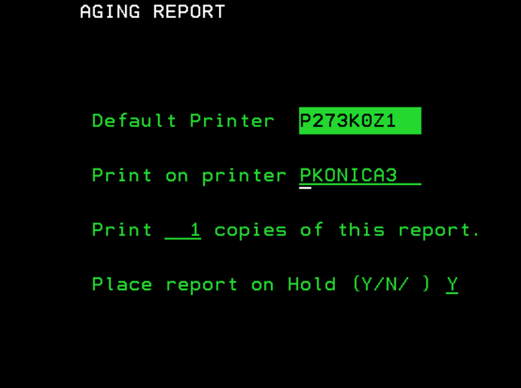
- Combining the Reports:
  - Create a new column in Excel for account number, customer name, and phone number.
  - Use VLOOKUP to pull past due information into the 75% credit line report.
  - Any account with a past due balance cannot be increased and should be reviewed by the Collections team.
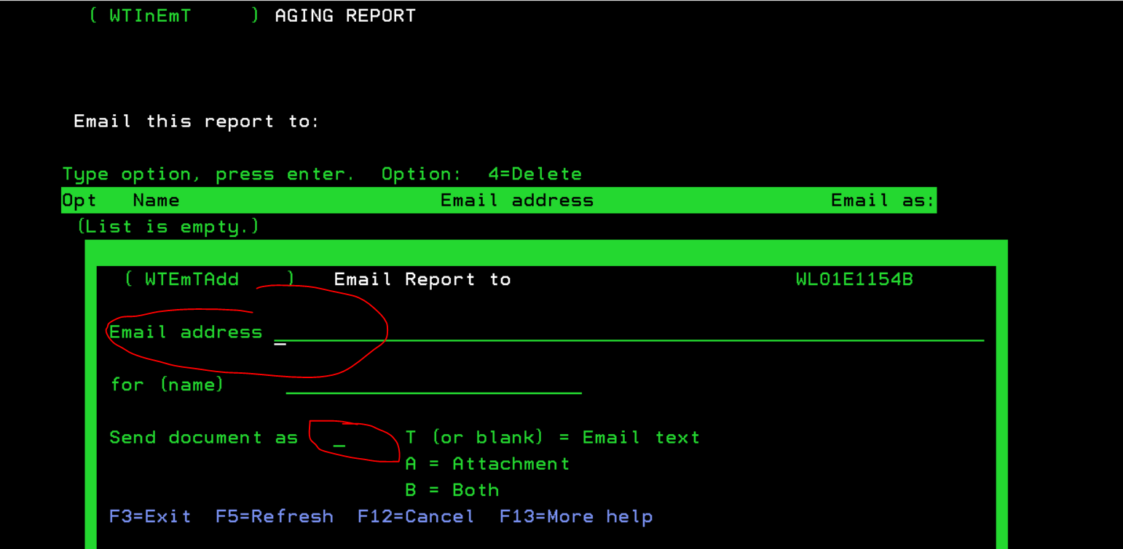
- Final Review and Action:
  - Evaluate accounts for possible credit line increases, based on past due balances and the guidelines in 4.2.1.
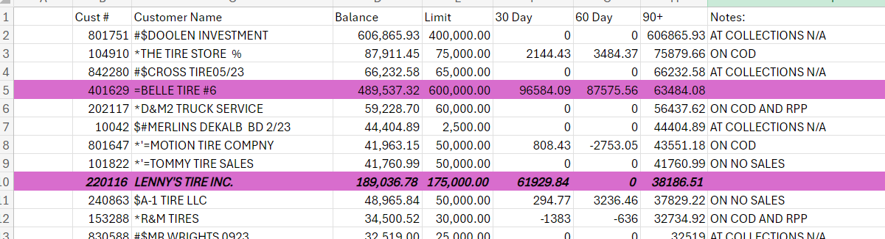

Filing UCC-1's
To establish lines of credit or request credit line increases, it may be necessary to file a UCC-1 Security Agreement with the Secretary of State. This document ensures that K&M is a secured creditor, even in the event of a customer's bankruptcy. The following outlines the process for filing and tracking UCC-1 Security Agreements.

Filing a UCC-1 for the First Time or Re-Filing
- Initial Filing
  - When ready to file a UCC-1 for the first time, or to re-file (re-files are reviewed at the beginning of every month), access the UCC-1 List located on the Credit Department F Drive under "UCC1."

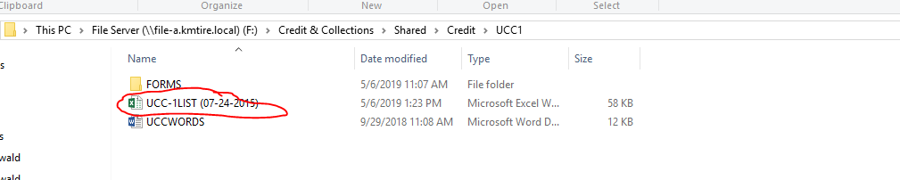
  - Review the filing requirements for each state in the "UCC Info" section. This document will indicate whether the filing should be done online or by mail. If filing online, the necessary user ID and passwords are listed.
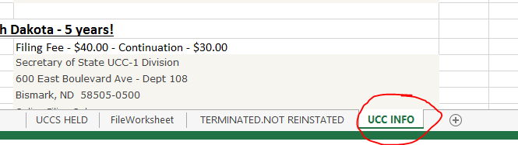
- Completing the UCC-1 Form
  - Complete the UCC-1 form online or on paper. Blank forms are available in the "Forms" section.

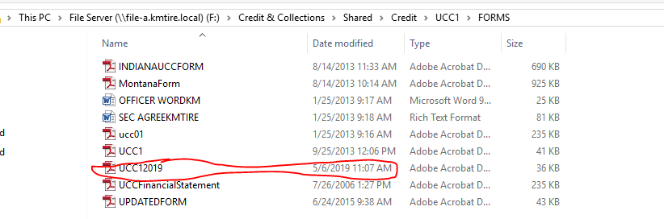
  - Fill out the form as follows:
- Red Circle – K&M and filer information (always the Credit Manager).
- Blue Circle – Debtor Information (Customer Name and Address).
- Black Circle – Secured Party Information (K&M Tire name and corporate address).
- Yellow Highlighted Area – Financing Statement (use the standard text saved in the document, which should be the same across all UCC-1 forms).
- Green Circle – Optional Filer Reference Data (list the current customer number).

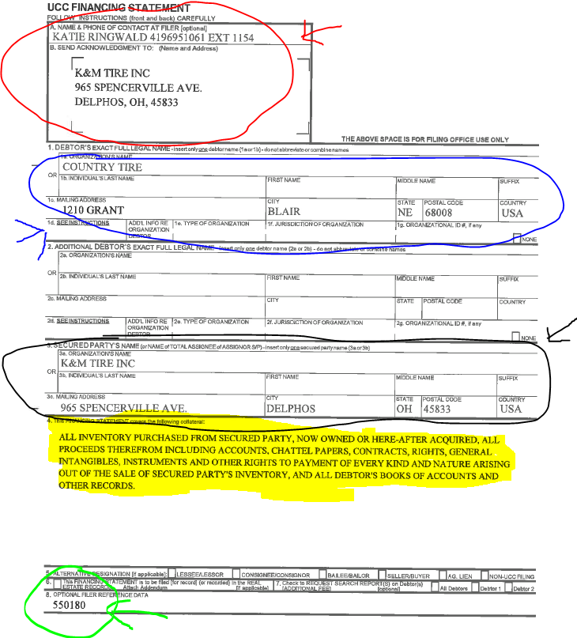
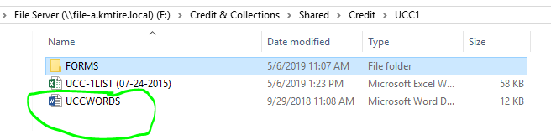
- Filing the UCC-1 Form
  - Submit the UCC-1 form. Online filings are accepted immediately; paper filings may take longer. A confirmation copy will be returned once accepted.
- Tracking UCC-1 Filings
  - After receiving confirmation of acceptance, record the UCC-1 filing details:
    - Customer Number
    - Customer Name
    - State
    - Filing Number (provided after acceptance)
    - Year Filed (Initial Filing Date)
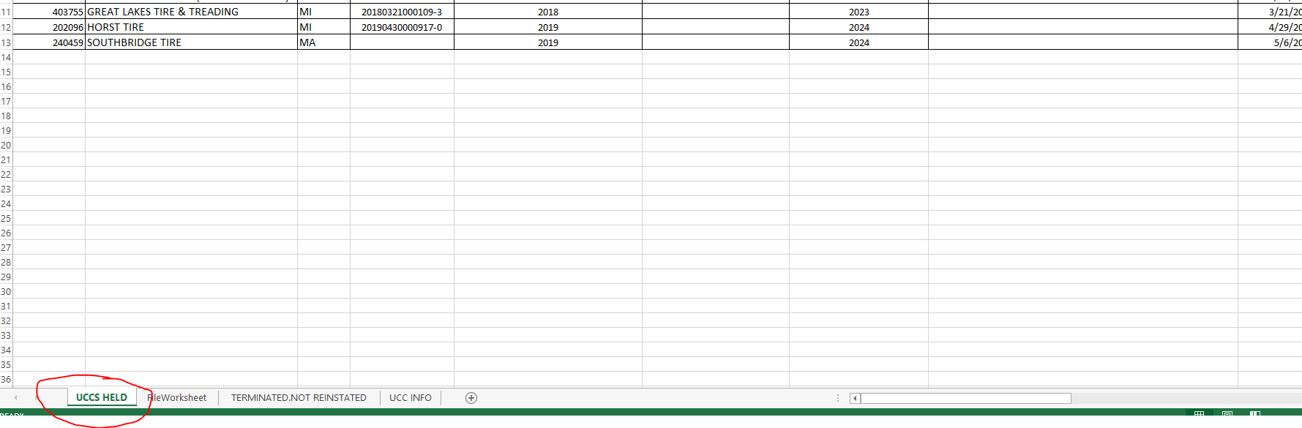
    - Next Re-file Date (5 years from initial filing).

- Continuation (Re-Filing) of UCC-1
  - Continuation Filings (UCC-3 Form)
    - Re-file by completing a UCC-3 Continuation form. Continuations are reviewed monthly by the Credit Manager to determine which customers require re-filing.
    - If a customer is inactive, no continuation is required.
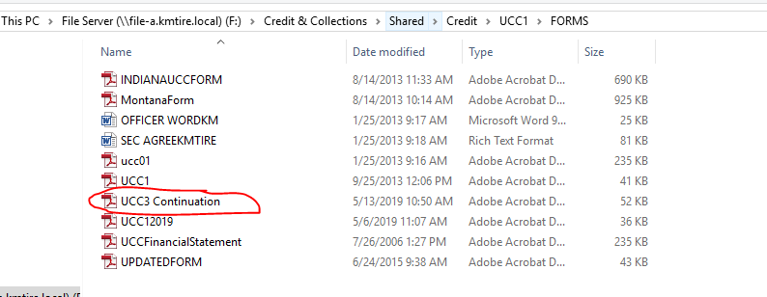

  - Completing the UCC-3 Continuation Form
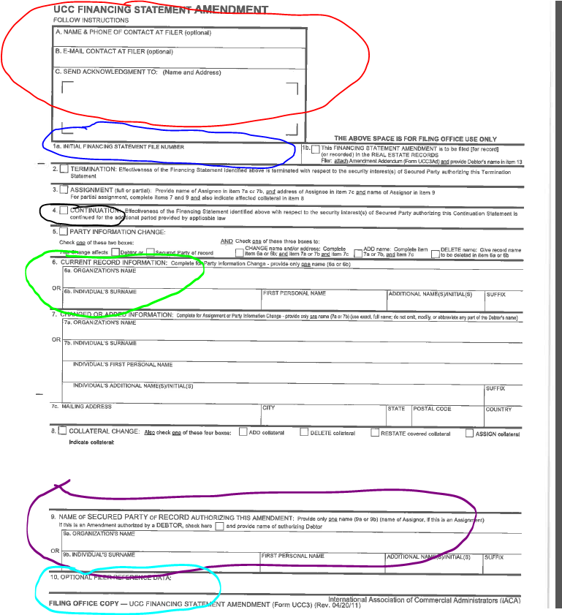
  - Fill out the continuation form as follows:
i. Red Circle – K&M and filer information (always the Credit Manager).
ii. Blue Circle – Initial filing number from the original UCC-1.
iii. Black Circle – Checkmark for continuation.
iv. Green Circle – Organization name from the original UCC-1.
v. Purple Circle – K&M Tire’s information.
vi. Aqua Circle – Optional Filer Reference Data (list the current customer number).

Direct Ship Orders
Occasionally, customers will order containers to be shipped directly from the manufacturer. These orders are treated differently due to the large volume of tires involved.

Pre-Approval and Credit Line Review
  - The Credit Department must pre-approve the customer's account for the order amount.
  - Generally, customers receive special pricing, so terms are not allowed.
  - If the customer's credit line cannot accommodate the order, the account will be reviewed to determine if pre-payment is required or if a COD (cash on delivery) option is possible.

Address Changes
When a customer relocates, it is crucial to ensure that address change requests are properly validated.
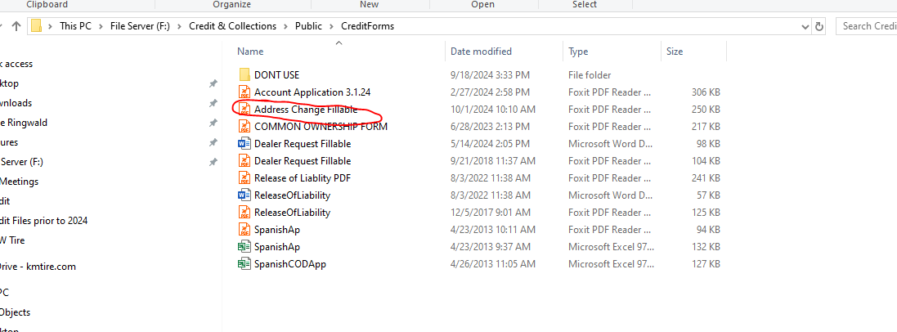
- Address Change Request Process
  - All address change requests must be in writing and come directly from the customer.
  - A fillable form for customers is available.
  - If a customer submits a web-based message, the address may be updated accordingly.
- Updating Shipping Address
  - Access Customer Maintenance in MaddenCo.
  - Enter the customer number and press Enter.
  - In the "Address Field," overwrite the old address with the new address and press Enter.
  - Update the Credit App Worksheet on the F:/Drive to notify Logistics of the address change.
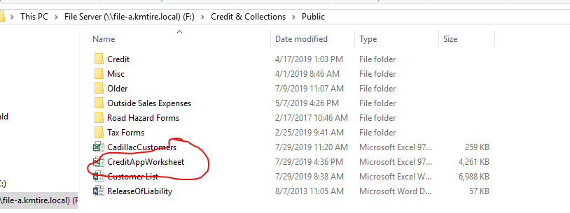
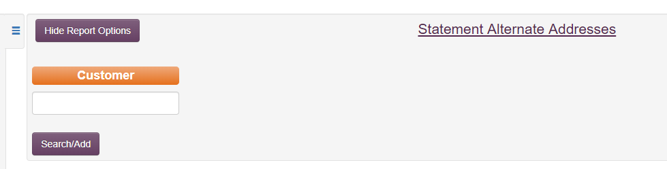
- Updating Billing Address
  - To change the billing address, go to the Intranet and select "AR Statements Alternate Address."
  - Enter the customer number and press Search/Add.
  - Add the new billing address provided by the customer and save the changes.
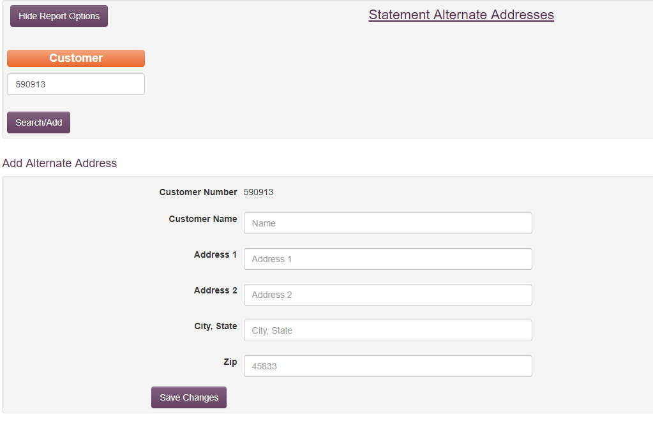

Release of Liability
A Release of Liability form allows our drivers to leave products at the customer’s location without obtaining a signature. This form releases K&M from liability for any damage, loss, or theft after delivery.
- Process for Obtaining a Release of Liability
  - The customer must sign the Release of Liability form.
  - The address on the form must match the address on file in MaddenCo.
  - To update the release in the system:
    - Go to the K&M Intranet and navigate to "WH - Release of Liability."
    - Enter the customer number and click "Search."
    - Check the red “No” box to change it to "Yes."
    - Click “Edit Notes” and enter the details from the release form (e.g., location to place tires).
  - Save the release form in the F Drive folder, ensuring the customer number and federal tax ID are included for reference.

Salesperson Commission Maintenance
- Assigning Commission Codes
  - When a new outside sales representative is hired, a Commission Code must becreated by IT and set up by HR.
  - Once set up, add the Commission Code to the Intranet under SalespersonManagement.
  - Follow these steps to add the commission details:
    - Select the Location # and RSM from the dropdown menus.
    - Click "Add Detail."
  - Ensure commission codes are updated by the end of the month for new accounts.
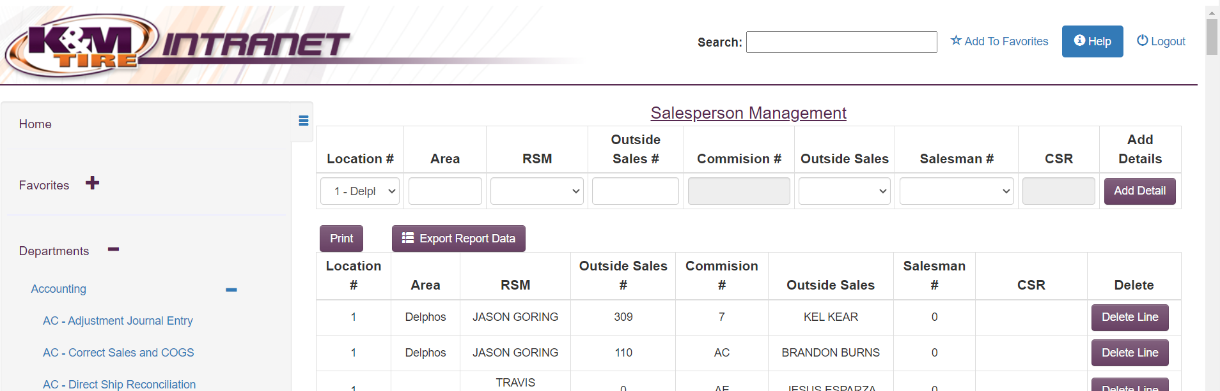
- Handling Terminated Sales Representatives
  - If an outside salesperson is terminated, ensure their commission code is reassigned before updating the report to avoid processing issues.
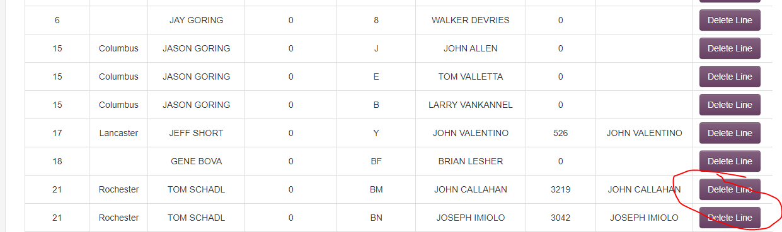
- Sales Changes Requests
  - Sales changes (territory shifts or new customer assignments) must be approved by the VP of Sales before being processed.
  - All changes must also be reflected in MaddenCo.

Creating Macros in MaddenCo
Macros automate repetitive tasks by recording keystrokes for repeated use.
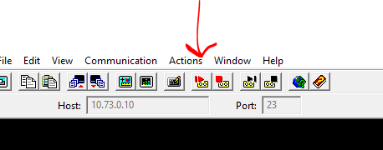
- Recording a Macro
  - Open the account in the maintenance screen.
  - Click the red "Record" button under the File menu in MaddenCo.
  - Name the macro and click "OK."
  - Complete the necessary actions for the task, ensuring all steps are identical for consistency.
  - Press "Enter" when finished and stop recording.
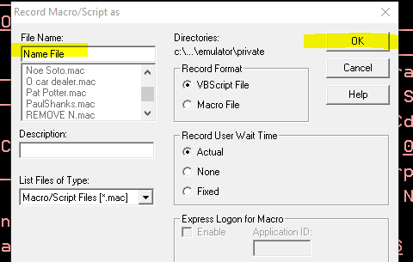
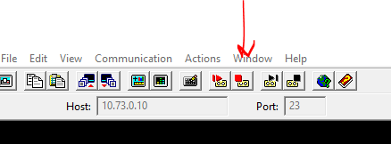
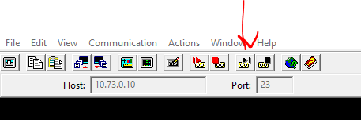
- Running a Macro
  - Open the account in the main screen.
  - Select the macro to use and press "OK."
  - The macro will update the fields according to the recorded actions.
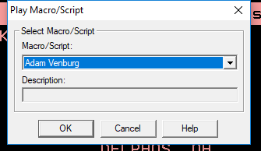
- Handling COD to Charge Terms Change
  - If the customer changes from COD to charge terms, ensure the invoice due date is updated accordingly, as invoice terms cannot be changed directly.

Daily Tasks

Credit Authorizations
If a customer places an order that exceeds their account credit limit, the order will be directed to the credit authorization section of MaddenCo. The order cannot close until it is either approved, placed on backorder, or canceled. This procedure outlines how to decide which option to select and the necessary next steps based on your decision.
- Credit Authorization Completion Times
Credit authorizations must be completed before the following times to ensure we are closing invoices for customers requesting same-day service. If an invoice is sent to Credit Authorization at 9:10 AM and is not authorized by 9:30 AM, the customer will not receive same-day delivery, which can cause issues for the warehouse and sales team.
  - 9:30
  - 11:30
  - 12:30
  - 1:30
  - 3:30
  - 4:30
  - 5:30
  - 7:00
- Credit Authorizations in MaddenCo
This should be done as a backup only if the Dashboards are down – Please seek Management Approval first.
If the Dashboard or Intranet is not working, credit authorizations must still be completed to allow the sales team to close customer orders once the systems are restored.
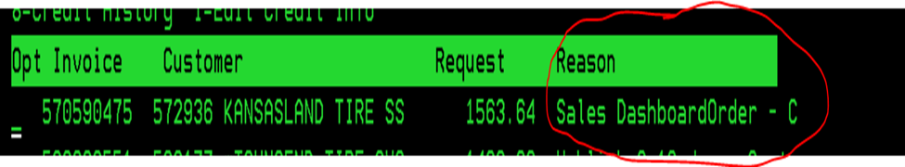
Steps: Select Escape in MaddenCo to open the operations menu.
  - Select “Credit Authorization” by entering “1.” The store number will appear.
  - Enter store number “000” and press Enter.
  - Place a “5” on the line to check if the tires are on backorder. If backordered, do not authorize. If not, proceed.
  - Select the invoice to authorize by placing a “2” next to the request. The Grant POS Authorization Request screen will appear.
  - If a customer is not to be approved, a reason will be listed in the note field.
  - Press F5 to display account information:
This screen shows the customer’s over-limit amount and any overdue payments.
Take note of how late the customer is with payments, as the credit limit system is designed to prevent customers from going too far into debt.
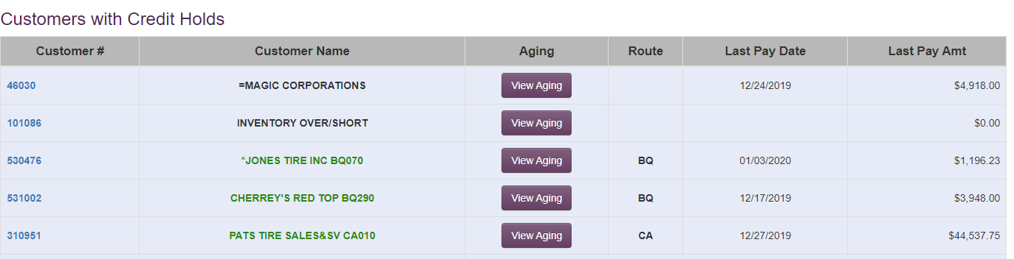

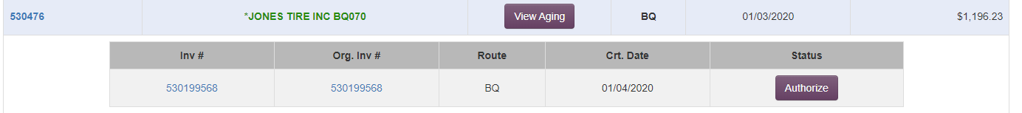
  - Press F3 to exit the screen and return to the request screen.
  - If the request is to be authorized, enter the requested amount and press Enter to return to the Credit Authorization Requests screen.
  - If the request is to be denied, enter “0.00.”
  - To refresh the screen and remove answered requests, press F5. Note: this will take you back to the top of the original screen.
  - Only the Credit Department and/or Management can approve a customer to exceed their credit limit by more than $5,000.
  - If the credit department or management is unavailable, review the customer’s account to determine whether authorization should be approved. Email the Credit Department/Management Team for review the following business day if necessary.
- Credit Authorizations on the Intranet
  - Access K&M’s Intranet and select “cc-authorize credit holds.”
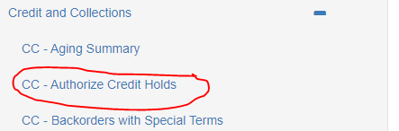
  - Click “Run Report.”
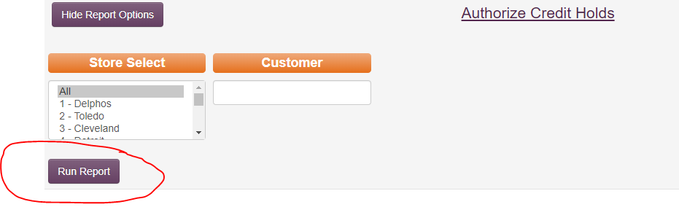
  - Customers requiring authorization will appear in green.
  - Click on the customer number to view the invoices needing authorization.
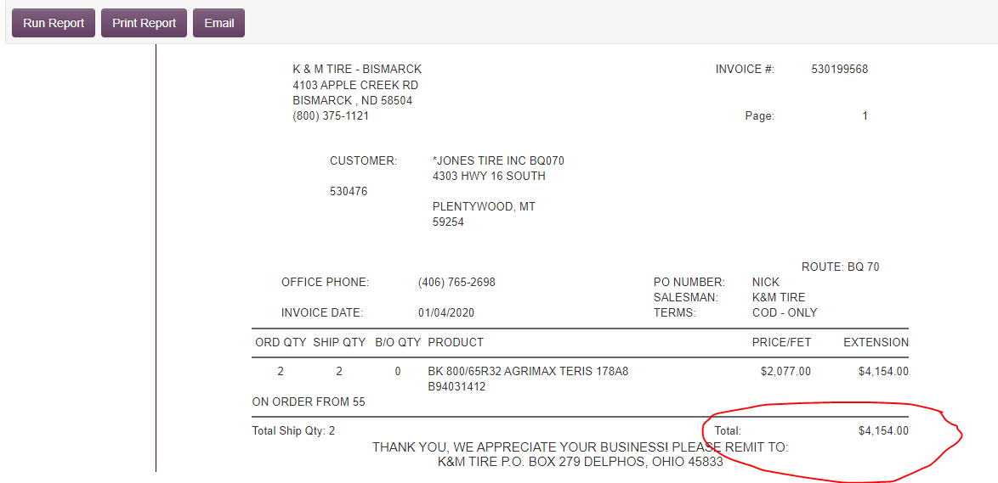
  - Review the customer’s available credit in MaddenCo by starting at the Tire Dealer Screen:
  - 1 → 1 → 12 → 5 → Enter for All Stores
  - Use F9 to search for the customer number and press Enter.
    - If the invoice does not exceed the credit line, authorize it.
    - If it exceeds the credit line:
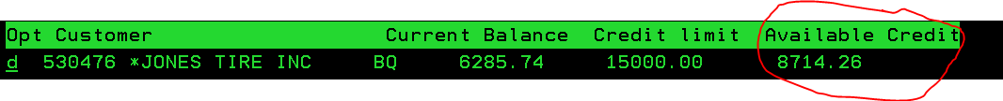
  - Is the account current? If yes, check if a high-line is established.
    - If the Net Income is higher than the credit limit, increase the line to that amount.
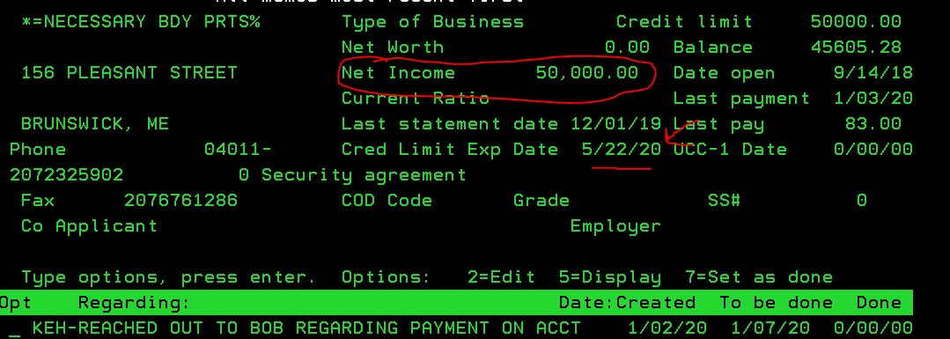
    - If no high line is established, establish it using the Credit Line Template/Decision Tree.
- If the account is not current, send an email to the Account Specialist to advise the customer to submit payment. Copy the Credit Manager in the email.

- When Not to Authorize Invoices
If an account specialist informs you that an invoice should not be authorized, send an email to inside sales/customer service and cc the Credit Manager and VP of Sales.
Follow these steps:
  - Add a note to the invoice by going to order entry (MaddenCo 1-7-1 → Invoice location).
  - Place a “2” on the line of the invoice, press Enter, and then F6.
  - Use the product line "DONOT" and write “do not authorize” or “waiting for pre-payment.” Press Enter and F3 to save.
  - Add a pop-up note for the sales team in MaddenCo by pressing F16 (Shift + F4). Enter "DO NOT AUTHORIZE!" and save.
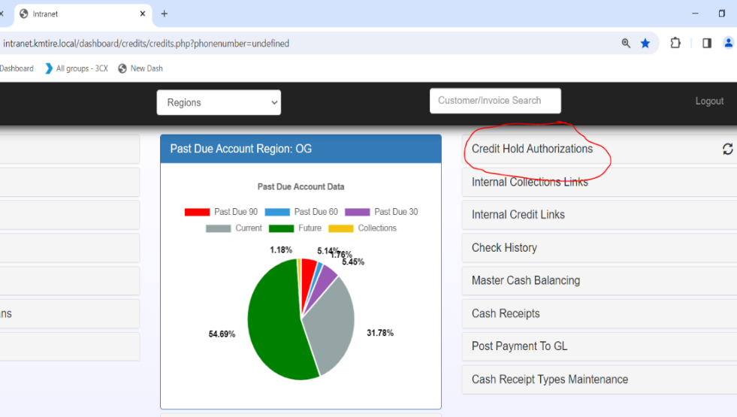
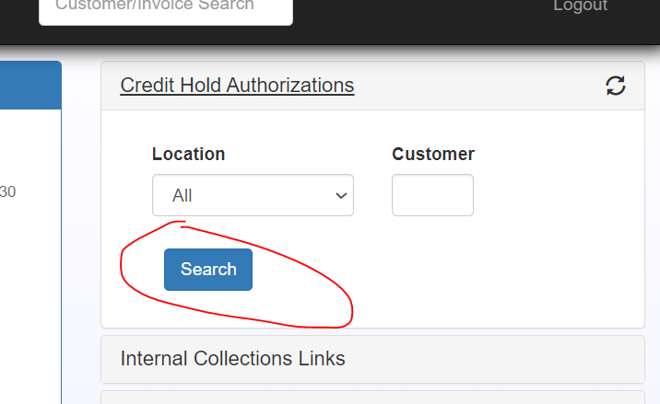

- Credit Authorizations on the C&C Dashboard
  - Log into the C&C Dashboard and click on “Credit Hold Authorizations.”
  - Click “Search” to display customers requiring authorization.
  - Click the customer number to view the invoice(s) needing approval.
  - Pull up the customer’s available credit in MaddenCo as described above.
  - Follow the same steps as outlined in section 4 for authorization or denial.
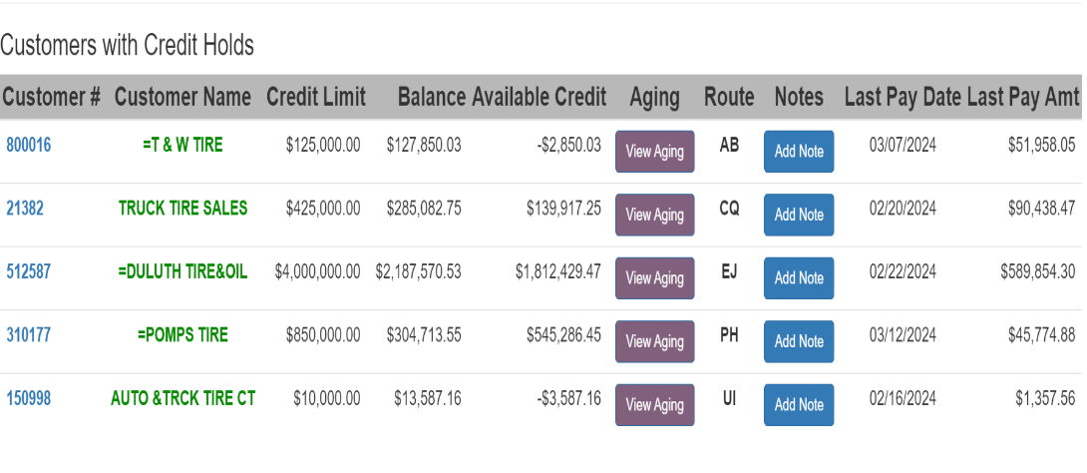



- Pop-up Will Call Screen
a. Pull up the SA-Will Call Order Report from K&M’s Intranet each morning.
b. Highlight any orange invoices and review them for credit hold authorization.

Chargebacks/Misc. Collections
If chargebacks or balances need to be placed back on a customer’s account, follow this procedure:
- Access the Tire Dealer System and navigate to:
  - 8 → Point of Sale
  - 4 → Counter Billing
  - Enter the store number and customer number, then proceed with the following:
    - Hit Enter, then F6 to create a new invoice.
    - Enter your salesperson’s number.
    - If prompted for a PO number, enter "Charge Back" and press Enter.
    - Enter the product code for chargebacks (e.g., NSF Wells Fargo).
    - Enter the chargeback amount and description.
    - Press Enter, then F3 to verify.
    - Close the invoice once verified.
  - Reach out to the customer regarding the chargeback and collect the necessary funds.

References Received
When a customer uses K&M Tire as a trade reference, companies may send reference request questionnaires. Follow these steps to handle such requests:
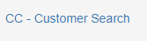
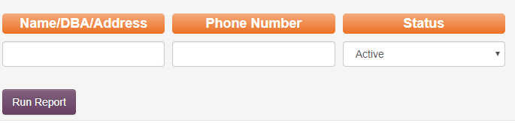
- Find the customer number in K&M’s Intranet or MaddenCo.
  - Intranet: Search by name, DBA, city, address, or phone number.
  - MaddenCo: Search by name (no spaces or dashes), field exit (+), and Enter.
  - Inactive customers are not eligible for reference requests.
- Answer the questionnaire:
  - Account opened date (use 2 screen).
  - Credit limit (do not disclose).
  - Average outstanding balance (8 screen).
  - Payment history (8 screen).
  - Additional comments: Include information for COD accounts or accounts with recent issues.
  - Last sale date (6 screen).
  - Highest credit in the last 12 months (8 screen).
  - Terms (2 screen).
- Provide a signature and send the completed reference via fax or email.

Terms Request
Special terms may be granted for larger orders if they meet the following requirements. Any requests outside these guidelines require additional approval.
- Terms for Single Orders
  - For 30/60 Terms:
    - Customer’s account must have sufficient available credit, and the order should be over $5,000.
  - For 30/60/90 Terms:
    - Customer’s account must have sufficient available credit, and the order should be over $10,000.
- Commercial Terms
  - For 30/60 Terms:
    - Customer’s account must have sufficient available credit, and the order should be over $10,000.
  - For 30/60/90 Terms:
    - Customer’s account must have sufficient available credit, and the order should be over $20,000.
- Change in Account Terms
  - 30/60 Terms: Requires evaluation for a credit line increase. Monthly sales should be at least $15K.
  - Straight 60 Day Terms: Requires evaluation for a credit line increase. Monthly sales should be at least $20K.
  - 30/60/90 Day Terms: Requires evaluation for a credit line increase. Monthly sales should be at least $20K.
    - If approved, the customer will be notified that prior orders will not be backdated, and they must pay the current statement balance accordingly.
- Approval for Terms Outside Standard Range
  - Requests outside the standard criteria must be approved by the VP of Sales, EVP, or President.

Equipment Orders
K&M Tire also sells equipment. These orders follow special rules due to external vendor involvement and direct deliveries. Below are the policies for handling equipment orders.
- Equipment Billing Policy
  - Location #48 and #58: Orders are salesperson-specific, not location-specific.
  - COD Accounts:
    - Orders over $5K require Credit Department approval. Pre-payment may be required.
    - For new or cash accounts, prepayment is mandatory.
  - Charge Accounts:
    - Notify the Credit Department for any new equipment orders over $5K to adjust the credit line as necessary.
  - Orders Over $20K:
    - Orders require pre-payment one week in advance or a UCC-1 filing. UCC-1 filings can take up to 30 days, and orders will not be approved until the UCC-1 is confirmed.
    - For well-established accounts with Credit Department approval, pre-payment or UCC-1 filing may not be required.
- Payment Terms for Equipment
  - COD Accounts: Payment is required upon delivery or pre-payment as determined by the Credit Department.
  - Charge Accounts: Payment is required according to the terms of the invoice (typically standard account terms).
  - Using Credit: No credit can be used for returns unless it has already been issued to the account.

Making an Account Inactive
The Credit Department will mark an account as inactive if the account is closed, written off as bad debt, or upon request from the Regional Sales Manager.
- Steps to Make an Account Inactive
  - Access the customer balance inquiry menu and add a credit management note (e.g., "Ab - account made inactive per Regional Sales Manager. New owner").
  - Go to the customer maintenance screen.
  - Enter the customer number and press F3 to return to the customer’s main screen.
  - Change the status to “6” (inactive) for the account to be marked as inactive.
  - Confirm the status change when prompted: Set customer status to inactive... Y/N. Enter “Y” to confirm.

Increased Level Duties

Quarterly Accounts Receivable Health Assessment
The quarterly AR health assessment meeting is scheduled by the Credit Manager on the third Monday after the end of each quarter. This meeting will include the Credit Manager, AR Manager, Controller, Director of Finance, and EVP.

1. Topics Covered in the AR Health Assessment
- Accounts Receivable Aging:
  - Review changes in past-due dollar amounts and percentages from the previous quarter.
- Significant Accounts:
  - Discuss any accounts that have worsened or are cause for concern.
- Disputed Claims:
  - Review any unresolved disputed claims at the quarter-end.
- Collections:
  - Discuss accounts that were turned over to collections during the quarter.
- Accounts Written Off:
  - Report on accounts written off during the quarter.
- Collections Update:
  - Provide an update on accounts in collections, including any significant recoveries or pending legal actions.

"Do By" Tasks and Expectations of Completion
These tasks are completed on a regular schedule throughout the month, quarter, or year.

Employee Purchases
The purpose of this SOP is to establish a clear and efficient process for employees to purchase tires while ensuring compliance with company policies and proper payment procedures.
- Employees must notify their manager to initiate tire purchase request:
  - If an employee contacts the Inside Sales Manager or Assistant Inside Sales Manager directly, they will be referred to their manager.
  - All tire purchase requests must go through the employee’s manager, so the manager has awareness of who is purchasing tires from their location.
- Manager verifies employee eligibility:
  - The Manager verifies employee eligibility per K&M Employee Handbook including:
    - The employee has completed their initial 90 days of employment
    - The employee has not exceeded limit of 12 discounted tires per year
- Manager emails EmployeeOrders@kmtire.com
  - The manager emails EmployeeOrders@kmtire.com with either a request for tire options and pricing, or to initiate an employee order.
    - When emailing EmployeeOrders@kmtire.com, the employee’s manager must be clear in differentiating between asking for a quote and placing an order.
  - When initiating an order, the Manager’s email must include: 1. Employee name; 2. What tires they are purchasing (size, qty, & type if known); and 3. Employee’s form of payment.
  - At this point, the employee’s Manager can have the employee contact the Inside Sales Manager or Assistant manager directly with any specific tire or fitment questions.
- Verification by Inside Sales:
  - Inside Sales Manager and Assistant Manager receive emails sent to EmployeeOrders@kmtire.com and will verify form of payment before placing the order in MaddenCo.
    - Acceptable forms of payment are cash, check, credit card, or payroll deduction. See step 8 below for more information on payroll deductions.
  - If an employee account needs to be set up, the Inside Sales Manager or Assistant Inside Sales Manager will contact the Credit Department for assistance.
- Order Creation:
  - The Inside Sales Manager or Assistant Inside Sales Manager creates an invoice and places the order on backorder.
    - This order will remain on backorder until payment is verified below and the Credit department sends Inside Sales a Credit Authorization Number.
- Employee Payment by Cash, Check, or Credit Card:
  - For cash, check, or credit card purchases, payment must be submitted to the AR Department or the Warehouse Manager before the employee can receive the tires.
    - If submitting payment to AR, Employees must call ext. 2015 or email AccountsReceivable@kmtire.com and Credit&Collections@kmtire.com with payment information.
Note: As K&M transitions to PNC merchant processing, a 3% credit card fee will be added to all credit card transactions including employee purchases, where applicable.
  - If submitting payment to the Warehouse Manager, the Warehouse Manager must notify the Credit Department once payment has been received.
    - If paying the CC/AR team with a Credit Card – The Authorization # must be added to the invoice.
    - Once payment is received and confirmed, the Credit department will then email EmployeeOrders@kmtire.com to release the tire off of backorder.
- Employee Payment by Payroll Deduction:
  - If the employee opts for payroll deduction, a copy of the Payroll Deduction Form must be emailed to HR, Credit & Collections, and Accounts Receivable.
    - HumanResources@kmtire.com, Credit&Collections@kmtire.com, AccountsReceivable@kmtire.com
  - Once Payroll deduction is received and confirmed, the Credit department will then provide Inside Sales (EmployeeOrders@kmtire.com) an Authorization number confirming Payroll Deduction has been received. Authorization # must be added to the invoice #.
- Order Release:
  - Once payment is confirmed and Inside Sales will release the tires from backorder.
  - A member of the Credit Department will release the tires from credit hold so that the invoice can close and employee can receive tires.
- Tire Pickup:
The employee receives the tires or can pick them up at the will-call door.

COD Statements
COD customers should generally not have statements, as they pay when they receive their product(s). That being said, sometimes things happen and balances linger on their account. To address this issue, COD statements are reviewed monthly. This is the process:

- Pull all cod and cash statements on 10th of every month
- 1 - tire dealer system
- 1 - accounts receivable menu
- 10 - A/R report menu
- 7 - statements past due
- Enter 001 - Enter
- Report date - back date to the 1st of the month
- Report spacing - 1
- Enter
- Sort by 01 - Enter
- Enter through next screen
- Under customer user flag screen Enter C on statement line
- Enter
- Print on pkonica3
- Repeat same steps to print out the “cash only” customers by Entering “S” on the statement line on user flag screen
- Only statements with balance due from last month should print
- Hand out to the coordinating account specialist to review and handle accordingly

  - Payment method and/or authorization # must be entered in when the employee signs for the tires. If being paid with Cash/Check no authorization number will be listed on the invoice, it should be handled by the Warehouse Manager through Payment Notes as normal customer procedure.
***Tires will not be available for pickup until after payment has been made***

Collections
The Collections side of the Department is responsible recouping balances owed to K&M that have not been paid by their due dates. These balances are accumulated by a Charge account missing a monthly payment, service charges accrued due to any past due balance, NSF checks, charge backs, and oversites/errors to list a few. It is the responsibility of our collections team to ensure these balances are addressed by consistent follow-up and contact with customers.

General Collections Policies- When an account goes past due

Pulling Reports
There are a number of ways to adjust reports that you would like to pull for many different purposes. This procedure will outline the Aging (past due) report, as this report is pulled and used most frequently. This report is used by the Account Specialists to monitor past due account.
- From MaddenCo start screen, follow the following:

- 1 – Tire Dealer System
- 1 – Accounts Receivable Menu
- 10 – A/R Report Menu
- 3 – Aging Report
- 2 – One Line Past Due Aging Report
- Enter through ‘Enter Number of Days for Aging’
- Enter through ‘Enter Store or Region Number to be used’
- Report Date – hit Enter ONLY if it’s prior to the 10th of the month. If it’s the 10th, Enter the first business day of the month (Example on 9/10/18, you will need to Enter in 9/4/18 as the date).
- Select the order in which you want the report to be printed, I generally use ‘02’ for customer name. Hit Enter.
- Enter Select Field Values. Utilize the High and Low numbers for your set customer # range. Hit Enter.
- Hit Enter.
- Enter printer PKONICA3 – Tab to where it says ‘Place report on Hold (Y/N)’ – If you don’t want to utilize a paper report, select Y for Yes. Hit Enter.
- Hit F6 to enter an email address. Enter your email address and tab down to ‘Send document as’ B for Both. Hit Enter.
- Hit Enter.

Moving the Text file to an Excel file:
- Drag the attached Text document (That was sent to your email) to your desktop.
- Open up Excel.
- Click Open Other Workbooks.
- Computer then Desktop (where you dragged the Text file)
- Select ‘All files’.
- Choose your text document. (I generally have my documents sorted by date, which helps to make sure that you chose the right document.)
- A box will pop up to help you convert it into an Excel document.
- Hit Next
- The lines that appear are where your cells will be once it’s converted over to Excel. You should create a new cell for the account number, name which includes the route code, a small cell around the ‘M’, phone number and each of the number columns. (to ensure that you capture the correct number, take the line to the last digit and then go one more space to the right to make sure that the ‘-‘ sign is captured).
- Hit Next
- Hit Finish
- This will bring up all of your past due accounts into an Excel Spreadsheet, but it will need some work. Once you have this part down, you can work on setting up a Macro to do the next steps for you.
- Click data – Sort – Uncheck, My data has headers and sort by column A. hit your Control Key and ‘F’ together. Select the ‘Replace’ tab. Enter in Find what ‘=’ and Replace with ‘’=’ then hit ‘Replace All’.
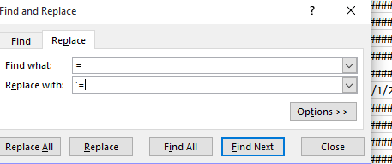

Delete the column that contains an ‘M’.
Delete all the rows at the bottom of your document at the bottom, that don’t contain direct customer information. Account #, Customer Name, Phone, Future Due, Current Due, 30 Days Past due, 60 Days Past Due, 90 Days Past Due, Total Due and Date Last Active. Title accordingly.

After this report is sorted, the customers need contacted per the below deadlines:

90 Day Customers- Need to be on Repayment Plan or Outside Collections by the 5th
60 Day Customers- Need to be on COD by the 10th
30 Day Customers- Call any that have missed payments around the 18th and the remainder call on the 23rd
Almost 30 Day Customers- Call on the 25th

Below are links for letters commonly sent out by the credit department:
F:\Credit & Collections\Shared\Collections\Letters\Reminder.docx
F:\Credit & Collections\Shared\Collections\Letters\SC Letter.docx
F:\Credit & Collections\Shared\Collections\Letters\ThankYouBut(TYB).docx
F:\Credit & Collections\Shared\Collections\Letters\NSF-1.docx
F:\Credit & Collections\Shared\Collections\Letters\FD - Letter.docx

Large Chain Aging/E-Commerce
Purpose
To outline the process for handling past-due invoices for Large Chain and E-Commerce accounts. Due to the nature of these accounts, individual store managers often have limited control over payments, requiring a structured approach for collections.

- Collection Procedures
- Pull up the Large Chain “LC” Region on the Dashboard. This will display all past due stores notated as Large Chain.
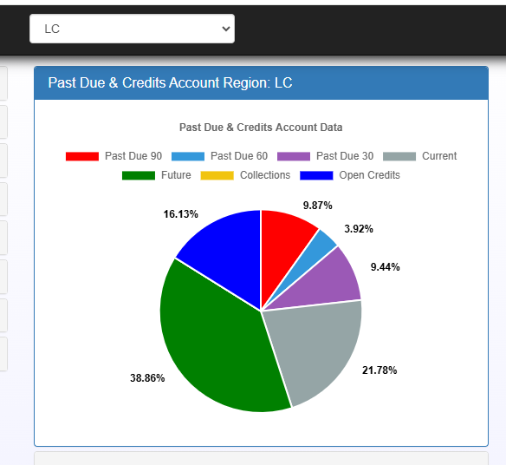

- Large Chain Accounts (Firestone Retail Stores, Goodyear Retail Stores, Just Tires, Tires Plus, etc.)
  - Steps for Collections:
    - 30 Days Past Due:
      - A K&M Account Specialist contacts the store manager to inquire about past due invoices and ask if they need a copy reprinted or emailed.
      - For any invoices that don’t need reprinted, we ask the store manager if the invoices have been uploaded for payment.
    - 60 Days Past Due:
      - Account Specialist contacts the store manager to verify invoices have been submitted for payment.
      - The corporate office should be called to confirm invoices have been submitted for payment.
    - 90 Days Past Due:
      - An email or phone call should be made to the store’s corporate office to confirm invoice submission.
      - The individual store should be moved to COD.
    - 120 Days Past Due:
      - An email should be sent to the corporate office to notify them of the status change.
      - The account should be moved to No Sales until payment is received.
- E-Commerce Accounts (Delticom, Simple Tire, Gigatires, etc.)
  - Steps for Collections:
    - 30 Days Past Due:
      - A spreadsheet listing all open/past-due invoices should be emailed to the AP Contact.
    - 60 Days Past Due:
      - The spreadsheet should be emailed to the AP contact, copying the Credit Manager.
      - The account has 30 additional days to pay past-due invoices.
    - 90 Days Past Due:
      - Review past-due invoices with AP contact and the Credit Manager.
      - Determine if further action is necessary.

Email Templates & Tips
- Firestone/Tires Plus/GCR
  - 30/60 Days – Store Contact Example:
Subject: Past Due Invoice Notification
Good morning,
Please see below as the following invoice remains unpaid on the account:
[Invoice Details Here]
Please remit payment within 30 days. Let me know if you need any additional information.
  - 90/120 Days – Store & Corporate Contact Example:
Subject: Urgent: Past Due Invoice Status
Store Contact: [ASKBSROAP@BFUSA.COM]
Corporate Contact: [Corporate Email]
Good morning,
The following invoice remains unpaid:
[Invoice Details Here]
If payment is not received within 30 days, the account will be placed on COD/No Sales Status. Please confirm if additional information is required.
  - Firestone Large Chain Tips:
    - Ensure past-due invoices cannot be billed under the PR account.
    - Firestone Fuzions cannot be billed under PR – the open account is responsible.
    - Do not offset Firestone Large Chain credits – corporate handles these.
    - When placing an account on COD, email both corporate and store, then call the store location.
- Goodyear/Just Tires
  - 30/60 Days – Store Contact Example:
Subject: Past Due Invoice Notification
Store Contact: [GSR(4DIGITSTORE#)@GOODYEAR.COM]
Good morning,
Please see below as the following invoice remains unpaid on the account:
[Invoice Details Here]
Please remit payment within 30 days. Let me know if you need additional information.
  - 90/120 Days – Store & Corporate Contact Example:
Subject: Urgent: Past Due Invoice Status
Store Contact: [GSR(4DIGITSTORE#)@GOODYEAR.COM]
Corporate Contact: [APQUESTIONS@GOODYEAR.COM]
Good morning,
The following invoice remains unpaid:
[Invoice Details Here]
If payment is not received within 30 days, the account will be placed on COD. Please confirm if additional information is required.
  - Goodyear Large Chain Tips:
    - Ensure past-due invoices cannot be billed under the SSP account.
    - Offsetting invoices/credits are permitted for Goodyear Large Chain accounts.

Checking Account in MaddenCo
Now that you have your past due report, you need to look up the customers information in MaddenCo. You can do that by following these steps:

1 – Tire Dealer System
1 – Accounts Receivable Menu
12 – Credit Management Menu
5 – Customer Balance Inquiry
Hit Enter for all stores
To view by customer # instead of name, select F9.
Now we are going to look up the customer’s information prior to contacting them for payment.
- Select a ‘C’ to view all their Credit Management notes. All contact with the customer should be notated here (unless it’s a Driver Call, which is a separate procedure). You can also list follow up dates to follow up with the customer after your initial call/letter/etc.
- Select a ‘6’ to view their open AR. Here you can hit F8 to change your view. Leave it at something that is easy for you to understand. This is a listing of all open and past due invoices/service charges/etc.
- Select ‘7’ for a quick snapshot of their aging. After the 10th, this screen does need to be back dated to the 1st to give you an accurate aging.
- Select ‘8’ for a review of the customer’s credit history with K&M Tire.
- Select ‘E’ and all related accounts will pop up, if applicable.

Guidelines/Collections Policy
Purpose:
The purpose of this Collections Policy is to establish clear guidelines and procedures for managing past due accounts. By following these guidelines, K&M Tire aims to ensure a timely collection of outstanding balances while maintaining positive relationships with customers.
- 90 Day Past Due Accounts:
    - Contact these accounts prior to the 5th of the month.
    - To remain ‘In House’ with K&M Tire Collections, they must be on a written repayment plan (See 5.1.8 Repayment Plans).
- 60 Day Past Due Accounts:
    - Contact these accounts next, payments should be received no later than the 10th of the month.
    - If payment is not received by the 10th, place the account on COD.
    - Accounts with unpaid service charges are not placed on COD.
    - If an account has paid all but one invoice, review it and consult with Team Lead or Credit & Collections Manager before determining course of action.
    - For any questions about changing the account status, consult the Credit & Collections Manager (See 5.1.6 Status Changes).
- 30 Day Past Due Accounts:
    - Review these accounts after the 60 & 90 Day past due accounts have been contacted. We should be on these accounts by the 20th.
    - If a payment or invoice has been skipped, contact the customer to inquire about payment (e.g., do they need an invoice copy, etc.).
    - Send a Reminder Letter if necessary.
- Almost 30 Days Past Due Accounts:
    - These accounts have not paid the balance due by the 10th.
    - Call accounts that usually pay by this time or have skipped invoices.
    - If a customer generally pays at the end of the month, follow up before the month-end.
    - Do not contact until the 27th or later unless the customer usually pays by this time.
- Accounts with ‘*’ or ‘$’ in Past Due Report:
    - Review these accounts immediately if they are 30 days past due.
    - These may be customers where a payment was missed on the Operations Side, so immediate follow-up is needed.
- Credit Department Account Notations:
      - – COD (Cash on Delivery)
- $ – Cash Only (No checks, Accept Only: credit cards, cashier’s checks, money orders, or cash)
- = – Designated as a bill-to account
- # – Along with either * or $ designates accounts at collections
- $ (at the end of the customer’s name) – Accounts receiving special discounts

California Collections Guidelines

(In Compliance with the Rosenthal Fair Debt Collection Practices Act)
Purpose: To outline the procedures and legal requirements for collecting debts from customers located in the state of California, in compliance with the Rosenthal Fair Debt Collection Practices Act. This SOP ensures K&M Tire maintains compliance while pursuing collection efforts on qualifying accounts.
- General Guidelines
  - This SOP applies only to accounts located in California.
  - The Rosenthal Fair Debt Collection Practices Act governs debts and transactions under $500,000.
    - If the amount owed exceeds $500,000, follow the standard Collections Policy outlined in section 4.1.5.
  - Prior to contacting any California-based customer regarding a past due balance, the Credit & Collections Team Member must review the account with the Credit & Collections Team Lead and/or Credit Manager.
- Authorized Contact Requirements
  - Communication is limited to the owner of the business or the designated Accounts Payable contact.
  - When contacting a customer:
    - Identify yourself by name
    - Clearly state you are calling on behalf of K&M Tire
- Telephone Contact Rules
  - California customers may only be contacted during their normal business hours, which are 8:00 a.m. to 9:00 p.m. (Pacific Time).
  - Only speak with the authorized Accounts Payable contact or Owner.
  - Phone etiquette guidelines:
    - Do not allow the phone to ring excessively
    - If there is no voicemail, limit the number of rings to 10 or fewer
- Email Communication Requirements
  - All emails must include the following disclosure notice in 12-point font at the bottom of the message:

“You have the right to request, without charge, specific information such as the debt balance, delinquency date, creditor and debtor inquiries, assignment history.”
  - The body of the email must include:
    - The balance due
    - The delinquency date
    - An explanation of interest and fees assessed
Sample email language:
“Dear John Smith,
We are reaching out to you regarding the past due status of XXXXXX Tire. Please note that your account became 30 days delinquent on 7/1/2025, as we did not receive your payment of $123,450.00. Per our policy, any past due account incurs a 2% fee assessed on the total past due amount per month until rectified.
We would like to work with you on this balance—please reach out to me via email or phone at your earliest convenience.
“You have the right to request, without charge, specific information such as the debt balance, delinquency date, creditor and debtor inquiries, assignment history.”

- Final Demand Letter (90+ Days Past Due)
  - When an account reaches 90 days past due, a Final Demand Letter must be sent via Certified Mail.
  - The letter must clearly state:
    - The debt will be sent to an outside collections agency
    - The debt may be reported to the proper credit reporting agencies
  - The letter must include the same 12-point disclosure notice used in email communications.
  - The envelope must be plain and include only:
    - The customer's name and mailing address
    - The label: Attn: Owner / Accounts Payable
    - Do not include any reference to debt or balance due on the envelope

Status Changes
Purpose: To provide step-by-step instructions for updating a customer’s account status in the C&C Dashboard and MaddenCo systems during the in-house collections process.
- Status Changes via C&C Dashboard
- Before changing a customer's status:
- Refer to the Collections Guidelines in SOP 5.1.5 to determine if a change is warranted.
- Customers must be contacted or an attempt to contact must be made unless they personally request the change.
- A Credit Management Note must be added, documenting the status change and communication attempts.
- To change status in the Dashboard:
- Go to the A/R Inquiry Screen on the C&C Dashboard.
- Click the ‘Status Change’ button at the bottom of the screen.
- Select the appropriate status change option (refer to Collections Policy SOP for guidance).
- Click ‘Change Status’ to finalize the update.
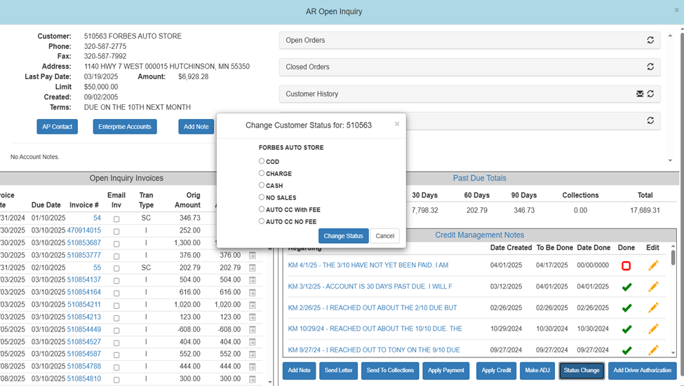
- This process ensures:
- Proper coding of status changes.
- Notifications to key stakeholders (Credit Manager, IT, Marketing, etc.).
- Status Change Email Notifications
- Send the following emails when making account status changes:
- Charge to COD or CASH:
      - Send to:
        - Warehouse Manager of the Customer, Inside Sales Manager, Assistant Inside Sales Manager, Regional Sales Manager
      - CC:
        - Credit Manager, VP of Sales
    - If to Inactive or No Sales Status:
      - Send to:
        - Director of Marketing, Marketing Reports Supervisor, Sales & Marketing Assistant, Logistics, Inside Sales Manager, Assistant Inside Sales Manager, Regional Sales Manager, National Accounts Supervisor, IT Support
      - CC:
        - Credit Manager, VP of Sales

How to bill back NSF’s
If a customer submits a check payment, but the funds are not available in their bank account at the time that we cash the check, the bank will return a copy of the check to K&M as Non-Sufficient Funds (NSF). This procedure outlines the steps to take to ensure the balance is transferred back to the customer’s account along with the standard process we use to collect those funds.
- Look up customer account information in MaddenCo.
1 – Tire Dealer System
1 – Accounts Receivable Menu
12 – Credit Management Menu
5 – Customer Balance Inquiry
- Enter – 000 – All Stores
- Type in the name on the check; see if it will pull up an account. If the name matches, place a 5 on the line to see if the customer address matches as well. If it’s not a match, look through other accounts if there are some other like names listed to see if you can find an address match. If you can’t find the check, an inquiry can be performed by searching just the check # to find what account it had been applied to.
- If you think that you found the correct account, hit F3 to bring you back to the look up screen.
- Place a 6 on the customer line to view their invoice history
- Charge Customer – At the top, left hand screen, you will see a date along with the last payment amount. If they match, it’s a good indication that you have the right account.
- COD Customer – Customer pays by invoices, hit F10 to view all invoices – tab down to the date field and Enter in a date shortly before the date of the check (I usually do about a month prior) and then hit Enter. You should be able to scan down to see if there was a purchase made on the account in the same amount of the check. Once you find a match, place a 5 on the line and hit Enter. This will bring up a screen that will show you the date the payment was applied and the check number. If you have a match, write the account number down on the NSF invoice received back from the bank.
- Exit the current screen by hitting F3
Note the customer account, by placing a Credit Management note on it with the NSF information and make contact with the customer.
- Hit F3 to exit until you reach the customer look up screen. From this screen, type C on the customer line to Enter in a new Credit Management note.
- Hit F6 to create a new note.
- Type in example -KB-Rec’d NSF check #1234 back in the amount of $452.00.
- Make sure you also detail your conversation:
  - Ex: Spoke to Mike, explained that we received an NSF on his account, told him bank verified we would re-deposit, but he would be responsible for paying the NSF fee. Let him know that he will receive an NSF invoice in the mail.
  - Hit Enter to save the note.
- How to invoice back to the customer’s account
Hit F3 to exit back to the Tire Dealer System Screen
8 – Point of Sale
- – Counter Billing
Enter the Store Number 001 (All NSF’s are billed out of Location #1)
Enter the customer number
Field Exit (+) sign on number screen
Hit Enter
Hit F6 to create a new invoice
Hit F6 again to start the invoice and assign an invoice number
Hit Enter
Enter your salesperson number
Hit Enter – Sometime a screen will pop up asking you to Enter in a PO#, type in the NSF ck# and hit Enter on this line
Type in Product Code NSF hit Enter
Type in Quantity of 1
Tab over to the price and Enter in amount of NSF check
Tab past FET and down to the Production Description
Type in Returned Check and then ck#
- Hit Enter
- Type in product NSFFEE
- Type in quantity of 1
- Hit Enter
- Hit F3 – You will see what was billed and can make any necessary corrections
- If everything looks good, hit F3 again
- Invoice to be closed – Make sure Y is in there, hit Enter
- Hit Enter to close the invoice

- 7. Invoice will print out on the Konica 3. (You can reprint the invoice if necessary).

- 8. A copy of the K&M NSF invoice is mailed out to the customer along with the appropriate NSF letter if you are unable to reach them on the phone.
- K&M cannot re-deposit checks as they are always presented twice.
- Staple the K&M invoice to the Bank NSF invoice. Keep this to ensure proper follow-up is done. Once it has been paid, you can add it to the credit scanning pile.

- 9. How a customer is expected to clear their NSF

- Call the customer to let them know that we have received an NSF check. They should also be made aware that a $25.00 NSF Fee will be assessed and that they are expected to have the NSF and Fee paid within 10 Days.
- Texas Customers need to be placed on CASH as soon as the NSF is received.
- If the customer cannot be reached by phone, send customer out first NSF notice
- If check is not cleared up within the initial ten days, send out a final demand notice and place the account on Cash Only.
- If Check is not cleared up after 14 days, the account should be placed on No Sales.
- If check is not cleared up within 3 weeks, and the customer is not on a re-payment plan, then an email needs to be sent to the Credit Manger to see if the account needs to be sent to collections.

NSF Checks must be followed up on a weekly basis. Contact must be noted in the credit management notes.

- 10. Placing an Account on CASH Status:
- To change an account to CASH only:
- Place a $ in front of the name, remove the * if necessary, do not remove the =. Change the Terms Code to 008 and the Tender Type to CASH. On the F2 screen, update the Statement screen to be coded “S” for Cash.

Repayment Plans
Purpose: To outline when a customer should be placed on a repayment plan, what a standard plan includes, the expected timeframe for resolution, and when higher-level approval is required.

- When a Repayment Plan Is Required
  - Any account that reaches 90 days past due must be placed on a repayment plan before the 5th business day of that month.
  - If the customer refuses to comply, refer the account to an outside collections agency (see SOP 5.1.9 for additional steps).
- Repayment Plan Guidelines
  - Plans should be structured to resolve the balance within 3–4 months.
  - Payment frequency options:
    - Weekly: If agreed upon by both parties
    - Bi-monthly: Due on the 10th and 25th of each month
    - Monthly: Due on the 10th of each month
  - Plans exceeding 4 months require Credit Manager approval.
  - Be sure to:
    - Include all service charges in the repayment total
    - Exclude any invoices for tires in-transit and their related payments that were supposed to be paid COD or in cash
- Steps to Set Up a Repayment Plan
  - Flag the Account:
    - In MaddenCo or the Dashboard, add an ‘R’ in the F2 Credit Flag field to indicate a Repayment Plan is in place.
  - Set Service Charge Exempt Status:
    - Temporarily mark the account as Service Charge Exempt — only if the customer has signed the repayment agreement.
  - Complete and Sign the Repayment Plan:
    - Use the official Promissory Repayment Plan template.
    - Obtain signatures from:
      - The Account Specialist
      - The Customer
  - Scan and File the Signed Plan:
    - Save the complete agreement in the designated Repayment Plan Folder.
      - F:\Credit & Collections\Shared\Collections\PYMNT AGREEMENTS\Signed RPPs
  - Update the Tracking Spreadsheet:
    - Enter the customer’s repayment details into the Repayment Plan Excel spreadsheet.
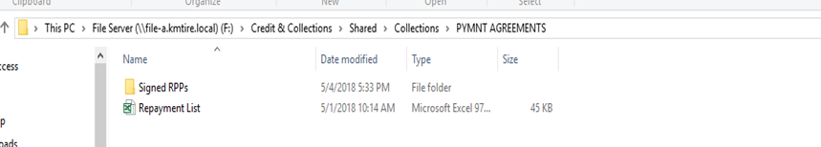
  - Document and Follow Up:
    - Add a detailed Credit Management Note in MaddenCo or the Dashboard.
    - Perform regular follow-up to ensure compliance with the repayment terms.
- When Repayment Plan Ends
  - Re-enable Service Charges on the account.
  - Remove the ‘R’ from the F2 Credit Flag field in MaddenCo.

Sending an Account to Outside Collections
All attempts need to be made in order to collect the outstanding balance in house. However, that may not always be attainable. When this happens, we place the balance/account with an outside collection agency. This procedure explains that process.

We have two Collections Agencies that we use to recover our bad debt.

Before the following information is completed, be sure to receive approval from the Credit Manager.

After approval has been received, fill out a Collection Form; print out a copy of the customer’s current statement as well as any credit/cod application. This information should all be paper clipped together with any other necessary documentation such as NSF checks, signed FD receipt, etc.

  - Fill out the Collection Form located under:
F:\Credit & Collections\Shared\Credit\FORMS
**Please note that this form totals the invoices and s/c’s automatically for you!**

  - Place the paperwork in the following order:

Collection Form
Current Statement
COD or Credit Application
Other pertinent information
**Invoices must be included on all accounts that we acquired during an acquisition**

  - Scan this documentation to your email and send it to the Credit Manager. This ensures that proper approval was given prior to being sent to the collection agency.

  - The following information needs to be noted in MaddenCo:

The customer must be on either COD or CASH and on PL2 with no discount. A notation must also be made on the address line to read: B/Dt01/14 – This information needs to be right aligned one the first address line so that the ‘4’ is on the outermost line.

A credit management note must be made – Example:
KR-Turned account over to ESP for collections, account on CASH and pl 2- I removed the d/s of 402715. Balance turned over is $854.00, breakdown:
Invoice $700.00
S/c’s $154.00

No additional credit management notes are made until the customer has settled the balance in full, made no effort to make payment, or paid in full.

**The agencies that we use assume that we only use them – please try to keep it that way so we aren’t constantly bombarded by them wanting more of the business**

Notations made by either Credit Manager or Credit Analyst / Level 3:

The following spreadsheets will then need to be notated:

K&M Bad Debt:

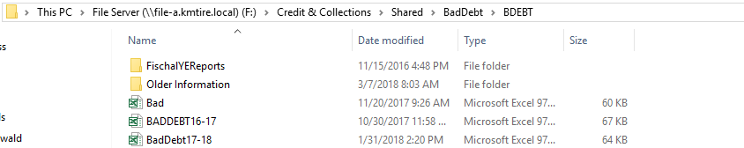

This track amounts that are necessary to adjust off in any fiscal year for tax purposes.

Collections Spreadsheet:

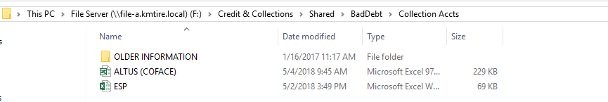

Notate the account turned over in the corresponding agency file for easier tracking on our end.

Payments Received from the Agencies:

Posted to the customer’s account. Overpayments should happen if an account pays the entire balance, including service charges. This information needs to be reported to the Credit Manager so that the proper notations can be made. All amounts paid need to be notated on the corresponding agency spreadsheet for easier tracking.

Notes/Misc. Information:

Once an account has paid off their collections balance or made a settlement on the account, it should be notated accordingly.

Example – KR-Account paid balance off in full
KR-Account settled for $6K, customer still owes $3K; we will not review for charge b/c of balance owed.

For Settlements, we legally cannot request payment, but it is our choice and right to not allow them to charge again.

Bankruptcy accounts – Notate them as Bankruptcy and what chapter in the Credit Management notes – Place in the Bankruptcy Accounts File. Notate something like this:
KR-Account filed Ch13 – We are left with a balance due of $13K.

Once an account is either paid in full - noted as uncollectable – or has filed bankruptcy – Which customer line needs to be highlighted grey on both the Agency Spreadsheet as well as the K&M Bad Debt Spreadsheet.

Daily Tasks

Daily Tasks – Account Specialist
Purpose: To outline the routine tasks Account Specialists should perform daily to ensure timely collections and account maintenance.
- Daily Responsibilities
  - Collections Activities:
    - Call customers who are past due or over their credit limit
    - Follow up on open Credit Management Notes
    - Respond to incoming queue calls and follow up on the previous day’s driver calls
  - Account & Billing Maintenance:
    - Bill back NSF (non-sufficient funds) checks
    - Make appropriate status changes on accounts
    - Send Collections Letters as needed
    - Research account issues and resolve discrepancies
- Productivity Tips
  - Use time blocking to structure your day:
    - Example: Review Driver Authorizations in the first hour, then follow up on Credit Notes
  - Prioritize tasks according to SOP 5.1.5 Guidelines/Collections Policy
  - Communicate with your Team Lead or Credit Manager immediately if you fall behind
  - Management understands peak times and will help with task reallocation when needed

Final Demand Notices
Purpose: To send a final collection notice via certified mail before referring a delinquent customer to a third-party collection agency. This step gives the customer one last opportunity to resolve their balance and avoid additional fees.
- When to Send a Final Demand Notice
  - All prior collection efforts have been exhausted
  - Approval has been received from:
    - Level 3 Collector OR
    - Team Lead OR
    - Credit & Collections Manager
- Steps to Send a Final Demand Notice
  - Access the Letter Template:
    - Open the C&C Dashboard
    - Click on Internal Collections Links
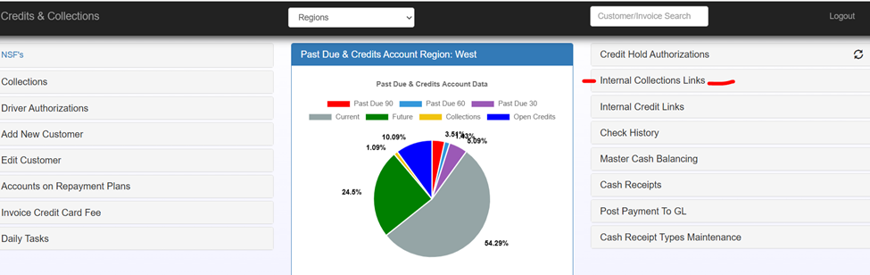
    - Click on FD-Letter (Final Demand)
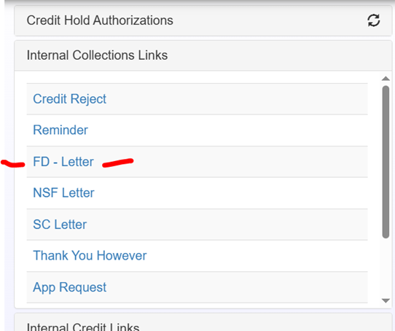

  - Complete the Letter:
    - Update customer name and amount owed
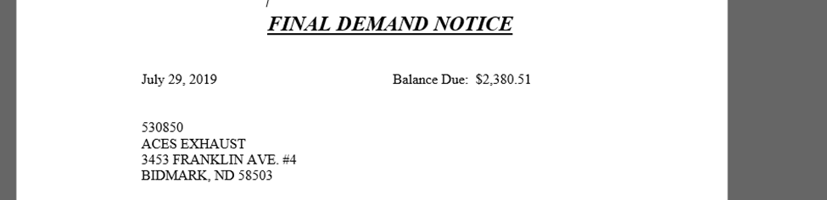
  - Prepare the Envelope:
    - Print and insert the completed FD-Letter
    - Fill out the two certified mail slips:
      - White & Green slip
      - Green & Black two-sided form
    - Remove the tracking sticker from the White & Green slip
      - Place it in the article number spot (#2) on the Green & Black form
    - Affix White & Green slip to the front of the envelope
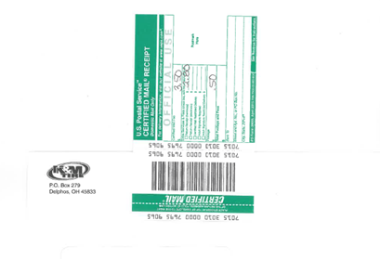
    - Attach Green and Black form to the back of the envelope
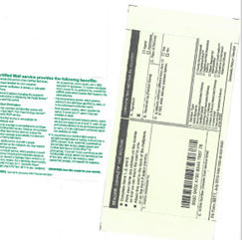

  - Postage:
    - Weigh and meter the envelope under “New Job – Certified”
    - Postage should total $9.64 (Check current postage)
    - Place in outgoing mail

Pulling Employee Statements
Purpose:
To ensure the accuracy and timely collection of Employee Receivables arising from Employee Account Purchases and Employee Chargebacks. This process confirms that appropriate payroll deductions are in place for employee purchases and that any outstanding balances with no movement are addressed promptly.
This SOP is necessary because employee statements do not print when we run monthly customer statements. They do not print because employee purchases should either be paid upfront before the tires are received, or else the employee should be pre-enrolled in a payroll deduction. We don’t send statements because we don’t want to confuse employees already enrolled in a payroll deduction.
- Responsibility: The Credit Manager or Credit & Collections Team Lead is responsible for completing this task.
- Frequency: On the first business day of every month.

- Steps to Pull and Review Employee Statements:
  - Log into the Intranet
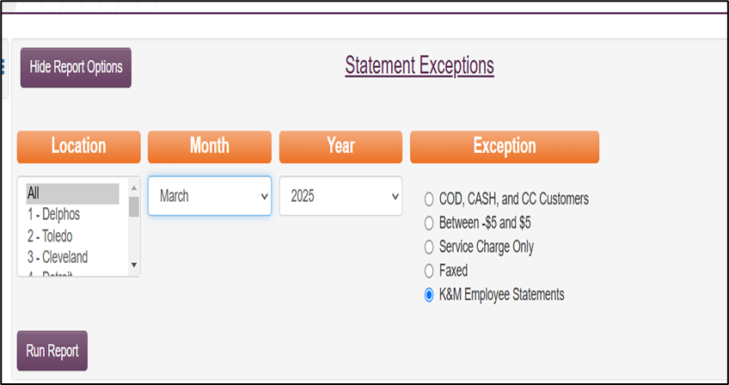
  - Generate the Report
    - Location = ALL
    - Ensure the current month is selected.
    - Select “K&M Employee Statements”.
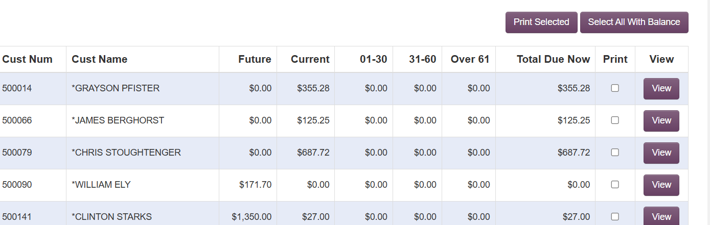
Click Run Report.

  - Select and Print Statements
    - Click ‘Select All with Balance.’
    - Click ‘Print Selected.’
    - Statements will be printed to the Konica 3 Printer in Accounting.

  - Review Statements for Payroll Deductions
    - Verify that each employee’s balance is being processed through Payroll Deduction.
      - Deductions are coordinated with HR and sent to AR weekly.
      - An active Payroll Deduction will display as follows on the dashboard:
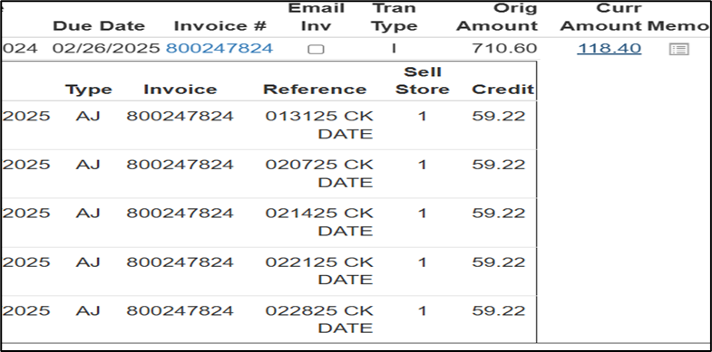

  - If we Discover No Payroll Deduction is on File
    - Investigate the invoice details:
      - If for Tires: The invoice should not have been released without either:
        - Payment received (Check/Cash/Credit Card), or
        - An active Payroll Deduction on file.
    - If for a Charge Back (e.g., personal purchase on company card):
      - Contact the employee to confirm they’re aware of the chargeback and request payment of the balance due.
      - Notify employee payment can be made by Check/Cash/Credit Card
      - If paying by credit card, offer to accept payment, transfer, or have EE call extension x-2015 with payment.
  - If Employee Account on No Sales
    - This is generally only the case for terminated employees. HR withholds the outstanding balance from EE’s last paycheck unless otherwise prohibited by state law.
    - If balance remains after the last payroll, follow standard collections procedures which may include referring the account to collections.
  - Uncollectible Accounts
    - If an employee’s account is turned over to outside collections and remains uncollectible, notify HR.
Note: The employee will be marked as ineligible for rehire until the outstanding balance is paid in full.

Service Charges
MaddenCo automatically assesses service charges to an account at the change of a month if there is a past due balance. The service charge is 2% of the past due balance. This section gives detail on how to address service charges given different situations.

Grace period: Accounts Receivable will adjust off all service charges on payments that are received (and bring the account current) through the first two business days of the month.

Example – January 10th due payment is received on February 4th so the service charges will be adjusted off.

When to waive: Service charges under $50 may be waived on accounts that are current.

How to waive: All service charges that are adjusted off need to be tracked in an Excel Spreadsheet. The Headers need to be in the following format:

Waive Date | Customer # | Customer Name | Location | Amount | Notes:

This spreadsheet needs to be sent to the Credit Manager on the first business day of every month.

When to Send S/C Letters:

If an account is current on all invoices, but not on their service charges, a SC Letter should be mailed out. If the service charges remain and the account is current in another 30 days, we will then need to send out a Second Request SC Letter. (This is the same as the SC Letter, just add second request to the header.)

If you are still unsuccessful, please send a request to the Credit Manager to review and see if the charges can be waived.

Payment Discrepancy Follow-Up
Purpose
To ensure prompt and consistent handling of payment discrepancies related to COD and Cash customer invoices. This procedure outlines the reasons discrepancies are issued, who is responsible for follow-up, and how issues should be addressed and resolved.

- Payment Discrepancy Notification Process
When AR identifies an issue while applying a payment to a COD or Cash invoice, a Payment Discrepancy is logged. This action automatically sends an email notification to the designated team responsible for follow-up.
Discrepancy Triggers & Routing

Discrepancy Type: | First Discrepancy Sent To:
Check amount does not match | Warehouse
Cash missing or not received | Warehouse
Credit card not processed | Credit & Collections

Note: Refer to AR Binder, sections 3.6 Payment Notes Procedure & 4.3 Discrepancies for more information on how AR handles the process prior to C&C receiving notification.

- Credit & Collections Follow-Up Steps
Once a Payment Discrepancy notification is received by Credit & Collections, take the following action based on the payment type:
  - Credit Card Discrepancy
    - Determine why operations listed a credit card authorization number on the invoice.
    - Confirm if the customer is set up for automatic credit card payments.
      - If yes, and it's within 2 business days, run the card.
      - If not, contact the customer directly to confirm whether payment can be collected.
    - Document the resolution in the Credit Management Notes.
  - Check Discrepancy
    - Investigate the reason for the short payment.
    - Email the Warehouse to confirm:
      - Whether the full amount was delivered and collected.
      - If the driver attempted to collect or noted a reason for the shortfall.
    - Follow up with the customer after confirming from the warehouse if necessary.
    - Document findings and resolution in the Credit Management Notes.
  - Missing Cash
    - Do not contact the customer.
    - Email the following individuals:
      - Warehouse Manager
      - Regional Operations Manager (ROM)
      - Credit Manager (CC)
    - Request a status update on the missing payment.
    - If unresolved, the ROM and Credit Manager will escalate to Security for investigation.
    - Any further adjustments will be made by the Management Team.

- Monitoring & Timelines
  - Payment discrepancies should be followed up similar to past due accounts.
  - The goal is to have all COD/CASH discrepancies resolved within 14 days of notification of the discrepancy.
  - Items must not be marked complete until payment has been received—not simply because the customer has been contacted.
  - This ensures proper accountability at the warehouse level.
  - The discrepancy should remain open in the system until fully resolved and collected.

- Documentation Requirements
  - All Payment Discrepancies must be documented the Credit Management Notes
  - Notes should follow standard format and include:
    - Date of follow-up
    - Method of contact
    - Summary of resolution attempt
    - Next steps, if any

Credit Card Declined – Auto Payment via CC Report
Purpose
To outline the process for handling customers enrolled in Auto Payment via Credit Card, where payments are automatically processed by the Inside Sales/Customer Service Teams before order fulfillment.
Process Overview
Some customers opt in our Credit Card Report, allowing the Sales Team to process their credit card payments automatically before fulfilling orders. The Inside Sales/Customer Service Teams manage this process.
Before running a payment, the Inside Sales or Customer Service Team will review the credit card dashboard to see if our customer has available credit that should be first applied to the order. If a credit exists on the customer’s account that should be applied, Inside Sales/Customer Service will reach out to AR/Collections to have that credit applied.
When Inside Sales/Customer Service is running the credit card payment, if the customer’s credit card declines or if no card is on file, the invoice is removed from the Credit Card Report, and a decline notification is sent via email to the Credit & Collections dept to address further. At the same time, the customers Tender Type is automatically reset from CC “Credit Card” to match their Terms Code which is most often COD but may also be Charge in some cases.

Credit Card Processing Workflow
- Order Placement & Payment Processing:
  - Customers on the Credit Card Report will have payments processed by the Sales Team at scheduled times before order fulfillment.
  - Inside Sales/Customer Service teams are responsible for running this process.
- Credit Review Prior to Processing:
  - Before running the card, the Inside Sales or Customer Service Team must contact the Credit Department to verify if any credit needs to be applied to the order.
  - If applicable, the credit is applied before processing the card. (Step 3.)
- Credit Applied Instead of Card Payment:
  - The Inside Sales/Customer Service Team will call into our phone queue to have us allocate credit from the account to the invoice.
    - We must add our authorization number to the invoice at that time.
  - If the open credit does not cover the full amount of the invoice, notify the Inside Sales/Customer Service associate of the remaining balance due so they can run a credit card payment for the remaining unpaid balance at that time.
    - They must also add their authorization number for credit card payment
- Handling Declined Transactions:
  - If a credit card declines, an email notification is received.
    - Example:
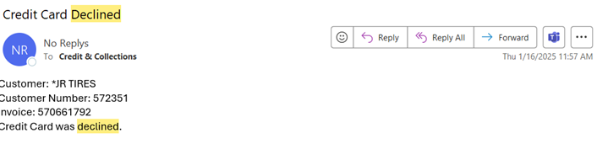
  - If the email pertains to a customer within your assignment, follow the steps below.
- Review the Account to Identify the Issue:
  - Is there an issue with the card on file?
  - Does the customer have a credit that should be applied to the invoice first before the card is run?
  - Has the stored card expired or fallen off the system?
  - Are there other issues that require further research?
- Action Steps Based on Declined Reason:
  - Card Declined Due to Payment Issue:
    - The invoice is converted to COD terms.
    - Reach out to the customer to secure a new payment to avoid order delays.
  - Expired/Missing Credit Card on File:
    - Contact the customer to obtain updated card information.
    - Ensure the new card is added to the system for future transactions.
  - Other Reasons for Decline:
    - Investigate the issue and determine if further action is required.
- Reset Customer Tender Type Back to Credit Card Report:
  - Once the issue is resolved, follow these steps to reset the account’s tender type back to “CC” Credit Card Customer:
    - Log into the C&C Dashboard.
    - Enter the Customer # into the “Edit Customer” section.
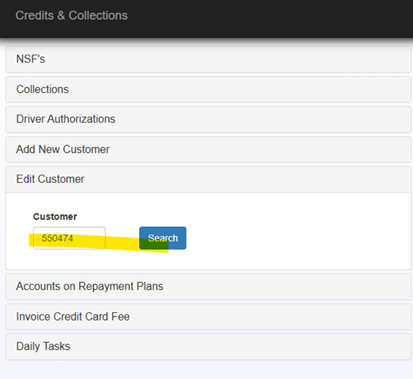
    - Scroll to the bottom and locate Tender Type.
    - Change the Tender Type back to CC – Credit Card Customer.
    - Click Save.
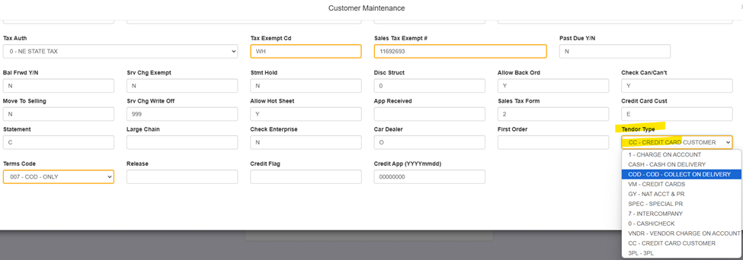

MaddenCo Instruction Addendum (To be included in the back of SOP in a section for MaddenCo addendums.)
To reset the payment method / Tender Type in MaddenCo, follow these steps:
- Access the Tire Dealer System:
  - Navigate to Accounts Receivable Menu → Press ENTER.
  - Select 8. Customer Inquiries Menu → Press ENTER.
  - Choose 1. Customer Balance Inquiry → Press ENTER.
  - Enter Store Number 000 → Press ENTER.
  - Press F9 to input Customer # → Enter the Customer Number.
  - Select 2 on customer line → Press ENTER.
  - Set Tender Type back to CC – Credit Card Customer → Press ENTER.
Example of Correct MaddenCo Setup After Changes:
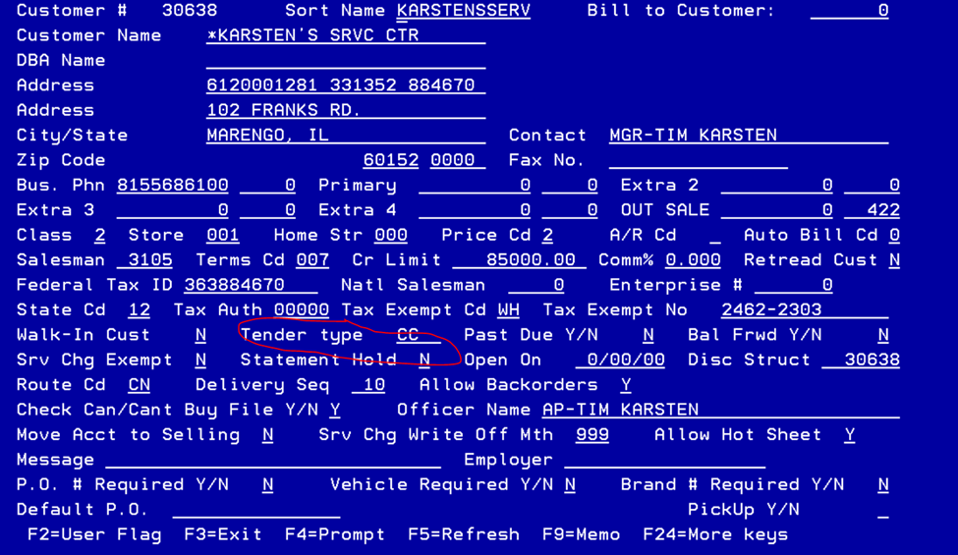

This SOP ensures that all credit card transactions are processed efficiently, declines are handled appropriately, and customer accounts remain up to date.

Shared Duties
Some tasks within the department are done by both sides. Most of these tasks will consist of responsibilities as a result of a phone call, which everyone in the department is expected to take part in. This section will detail such tasks.

Terms Request
Sometimes, a customer might want special terms on larger orders. We are able to grant a special terms request if the account and the order fall within specified requirements. These requirements are listed below. Any requests that do not fall within these requirements are generally not permitted.

On a single order
**Customer cannot be past due**

Regular:

For 30/60 Terms – Customer’s account needs to have enough available credit and the single order should be for over $5,000.00.

For 30/60/90 Terms – Customer’s account needs to have enough available credit and the single order should be for over $10,000.00.

Commercial:

For 30/60 Terms – Customer’s account needs to have enough available credit and the single order should be for over $10,000.00.

For 30/60/90 Terms – Customer’s account needs to have enough available credit and the single order should be for over $20,000.00.

- Once terms have been approved – A CM note must be placed on the account. Terms must be added to the invoice prior to the invoice closing out. At the time the order is in order entry, before terms can be added it must be at the above listed minimum requirement.

For A Change in Account Terms (From Net 10th) To:

30/60 – Customer will first need to be evaluated for a credit line increase as they will most likely need one due to the terms change. Sales on the account should be at least $15K per month.

Straight 60 Day – Customer will first need to be evaluated for a credit line increase as they will most likely need one due to the terms change. Sales on the account should be at least $20K per month.

30/60/90 Day – Customer will first need to be evaluated for a credit line increase as they will most likely need one due to the terms change. Sales on the account should be at least $20K per month.

If the terms are approved the customer needs to be notified that we will not be back dating any orders prior to the terms change. They will therefore need to pay their statement balance accordingly.

Equipment
In addition to selling tires, K&M offers customers the opportunity to purchase their tire equipment from us as well. Equipment orders have a special set of rules for a few reasons; (1) we order from outside vendors, (2) the product is often delivered directly to the customer, so we are not always notified when the delivery has been made. This section outlines how we handle equipment orders.
Location #48 - #58 - #68 Equipment Billing Policy.
COD Account:
For Existing customers - Any amount over $5K must be approved by the Credit Department. Pre-payment may be required.
For New or Cash Account - Prepayment is required.

Charge Accounts:
Please notify the Credit Department prior to any new equipment orders over $5,000. It is best to get pre-approval so that credit lines can be adjusted accordingly.

Orders over $20K:
Any Equipment Purchase over $20K will require pre-payment 1 week in advance or UCC-1 filing. UCC-1 filings can take up to 30 days so the order will not be approved through the credit department until the UCC-1 is confirmed through the State of filing.
If an account is well established with the K&M Tire and the Credit Department has approved the order, it may be allowed without pre-payment or UCC-1 filing.

Payment on Equipment:
COD Accounts – Required to pay on delivery or pre-payment if required by the Credit Department.
Charge Accounts – Payment is required per the terms of the invoice. (Typically, their standard account terms).
Using Credit – No credit can be used for a new return of equipment unless the credit has been issued to the account.

Refunds/Check Requests
Purpose: To establish clear guidelines for processing refunds and check request inquiries, including appropriate handling of overpayments, credit card refunds, and exception-based approvals. This ensures consistency, minimizes fees, and maintains accountability within the Accounts Receivable and Credit departments.

Check Requests
K&M Tire does not typically issue refunds via check or credit card, especially when the customer is active and current. Common items such as Warranty Credits, Marketing Program Credits, Government Pricing, and Program Tire Credits should be used toward future purchases — not refunded.
If a customer continues to push for a check refund, follow these steps:

- Send an email to the AR & Credit Manager – Include:
  - Customer Name
  - Account Number
  - Amount of Refund Requested
  - Reason for Credit (e.g., returns, adjustments, etc.)
- Create a Credit Management Note indicating a check request has been sent for approval.
  - Note the related invoice(s).
- Take a screenshot of the Dashboard showing the matching credit amount.
- Attach the Check Request Form to the email.
  - Form Location:
F:\Credit &Collections\Shared\Credit\FORMS\CHECKREQUEST.xls
  - Save the completed form to: F:/Accounts Receivable/Shared/Check Request
    - Use the naming format: CKRQT CUST XXXXX DATE
- Upon approval, the Credit Manager will forward the email and documentation to:
  - Accounts.Receivable@kmtire.com
  - Invoices@kmtire.com

Refunds to Credit Cards
K&M pays fees on all transactions, including credits. To help minimize fees, not every customer needs their credit card refunded - the overage can be utilized on the next delivery.
- Email AR & CC Manager with customer name, account number and amount of requested refund.
- If credit/debit card refund is approved, the refund can be done only by AR & Credit Manager, Credit Analyst, and/or the AR Team Lead.
IF AN ISSUE IS FOUND SAME DAY, A CC TRANSACTION CAN BE VOIDED! THIS DOESN’T CHARGE A FEE TO K&M TIRE AND MERCHANT PARTNERS ACTS LIKE THE TRANSACTION NEVER HAPPENED. PLEASE DO THIS IF AT ALL POSSIBLE.

Manager Approval – Check Requests
The Credit Manager reviews and approves all check requests.
- Approved Check Requests
- The following situations may be approved without further research:
    - The customer made an overpayment and needs a refund for accounting purposes
(Note: If actively purchasing, ask to apply credit to future purchases.)
    - Customer is closing their account
    - Monthly check for Karstens Tire (30638) — special exception due to switch from CHARGE to COD
    - Quarterly check for Performance Tire (591081) — exception approved by VP of Sales
- Denied Check Requests
- Check Requests should be denied and referred to the Inside Sales Manager and Assistant Inside Sales Manager if:
- The account is actively purchasing from K&M
- The request is related to Adjustments, Warranty Credits, or NAB Credits
- If the Inside Sales Manager or Assistant Inside Sales Manager pushes for an exception:
- It must be approved by the VP of Sales
- Include the approval email in your request to AP/AR to process the check
- Further Research Required
  - Send the following situations to the VP of Sales for review:
    - Any NAB/Marketing Credit or Adjustment Credit
    - Regular credits where the customer is active but disputing denial
    - Any pushback after denial from Inside Sales Manager/Assistant
  - When submitting to the VP of Sales, be sure to include:
    - Year-to-Date (YTD) Purchase Totals
    - What the credit is for
    - Reason for requesting an exception
  - After approval, forward the approval email along with the Check Request to AP/AR.

Updating a Due Date
Purpose: To correct or change invoice due dates, most commonly needed when a customer has recently transitioned from COD back to a charge account and they have open COD invoices on their account where the terms need to be updated to reflect the term status change.

- When to Update a Due Date
- A customer was previously on COD, and
- The account has now been changed to charge terms, and
- An invoice was issued with COD terms and needs to be updated to 1st 10th or Net 30
Example:
An invoice dated 8/2/25 should reflect a due date of 9/10/25 under 1st 10th terms.

- Steps to Update the Due Date in the C&C Dashboard
    - While on the C&C Dashboard, locate the invoice needing the due date correction.
    - Click on the Due Date field for that invoice.
⚠️ Note: This is a permission-based function. If you do not have access, contact a:
    - Level 3 Collector
    - Team Lead
    - Credit Manager
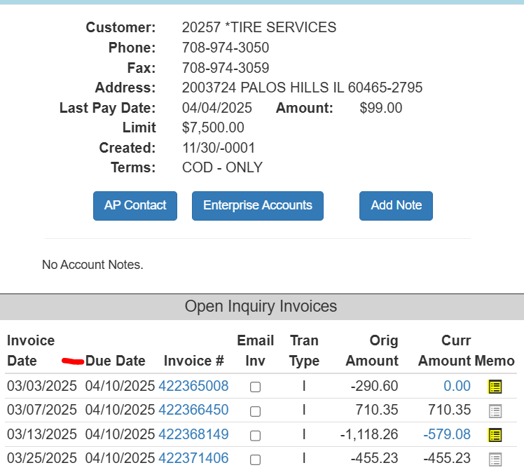

    - A Change Due Date box will appear:
      - Select the correct new due date
      - Click Submit
      - The date will be updated

Note: Refer to SOP 8.4 Updating a Due Date in MaddenCo if Dashboard is unavailable.

Making an Account Inactive
Upon approval, the Account Specialist can make it inactive only if no longer in business or no sales because of end user. These are the steps to change the account from active to inactive.
- Note the account by going into the customer balance inquiry menu.
- Add a credit management note.
- Example:
- Ab- account made inactive per Regional Sales Manager. New owner
- Then go into the customer maintenance screen.
- Store 001
- Enter customer number to be made inactive then F3 to go back to screen where the customer name/number should be at the top or close to top.
- Put a 6 (status) on the line of the account you wish to be made inactive.
- You will get a message.
- Set customer status to inactive...Y/N
- Enter a ‘Y’

Daily Tasks

Driver Calls
When drivers make deliveries, they often call in to the credit department. There are many different reasons they could be calling. This section gives details regarding different likely reasons drivers call in, along with how to handle each of those situations. If you encounter a situation, you are not sure how to handle, it is best to briefly place the call on hold and ask for confirmation from someone within the department – it is always better to make someone wait for the right answer than to guess and give them the wrong answer.
How to handle Driver Calls
The route drivers will contact the credit department if an exception is requested to collect a different amount other than what is stated on the invoice.
Examples of this may be:
Customer is COD and wants to sign an invoice.
To handle this matter, first Check the Credit Management Notes to see if this has been allowed in the past without it being an issue. K&M does not allow COD customers to charge, however there are a select few customers (most in locations 1,2,4) that have been allowed to do this in the past because we have a signed Charge Application on file, but the account requested to pay on Delivery.
Customer is on COD and wants to use credit.
Look up the customer’s account. If there is open credit, check to see if there is a memo on this invoice. If so, see what the available credit amount is and then let the customer deduct that amount from the invoice they are purchasing today. Make a memo on the invoice being purchased as well as on the credit itself.
Customer is CASH ONLY and wants to pay with a Check.
This is not allowable. The CASH status must be lifted before the customer can pay again with a check.
Customer CHECK NAME doesn’t match the K&M ACCOUNT NAME
Review the CM notes to see if this has been approved in the past, sometimes customers have other business names or are paying with a check from the owner’s personal account. If the check name has been authorized in the past, it is okay to authorize. If it hasn’t, you will need to pull up the customer’s application to verify that the Business Name/Owner name is on the application. Once that has been verified, you can authorize.
Instant Credit for Return
Instant credit is only allowed if the customer has been in possession of the tires for 3 days or less. Then you deduct the amount of the returned tire from the customer invoice being delivered. If the tires are older than 3 days OR it’s for an adjustment – NO INSTANT CREDIT will be allowed.
***CUSTOMERS THAT ARE ON COD FOR BEING PAST DUE AND/OR ON A REPAYMENT PLAN MAY NOT USE INSTANT CREDIT OR HAVE CREDITS APPLIED TO DELIVERIES AS THIS MONEY WILL NEED TO BE UTILIZED TO CLEAR UP THEIR PAST DUE BALANCE.***
Once the discussion with the driver is complete and the credits/invoices notated, the driver must be given an authorization number. Please be sure to list on the memo the invoice that is being utilized for instant credit.

Authorization Numbers are given to the driver via the Intranet Drivers Authorization Screen.
To get to this screen you will need to go to the K&M Intranet page and go to CC-Driver Authorizations
Click “Add Authorization” and enter in the customer number. The authorization number to give to the driver is in the upper left corner. The note should state how much credit was utilized, which invoice(s) and how much the driver should collect.
For example:
APPLIED $48 CREDIT TO INVOICE 40179522 ***DRIVER TO COLLECT $58***
Then click save.
If the Credit will not be able to be applied the next day, please ensure that you note it as needing to be followed up. To do this, click “yes” next to follow up when giving an authorization number. You will be responsible for ensuring that your own Drivers Authorizations are set to complete.
How to check the customer’s account information from MaddenCo. after your sign on screen:
1 – Tire Dealer System
1 – Accounts Receivables Menu
12 – Credit Management Menu
5 – Customer Balance Inquiry
Enter through the next screen (000) for all stores.
From this screen you can enter the customer’s name, or you can hit F9 to be able to enter the customer’s number.
Place a 6 on the line in front of the customer you need to look up.
Here you will see a list of invoices/credits, you may need to page down to get to the invoice that is being delivered today. The driver will be able to give you the invoice number and/or the amount.
Scan through to see if they have any open credit, if so, place an ‘M’ on the line in front of the credit to see if there are any Memos. If there are, it will state a credit amount available.
Ex: KB-6/19/08 - $12.00 allocated to inv#3210 - $24.00 credit available.
Deduct the amount of the credit from the invoice being delivered and note the credit by placing an M on each line individually. If there was already a Memo started, you may add to it by pressing F2 in the body of the Memo then by paging down to the appropriate line. For easier understanding, please always start a new memo on a new line.
For Credit and A/R - Go into Cash Receipts to apply the credit to the invoices. There is a separate Cash Receipts Procedure listed.

Applying Credits in Cash Receipts
As customers receive credit (for returns, reimbursements, claims, marketing promos) on their account, the credits can be used to pay off other invoices. Most credits are used as payment for deliveries on COD accounts. This procedure outlines how to apply the credits.
*** it is very important to apply the credit immediately after telling the customer or driver they it is available – if it is not done, someone else could use the credit for something else – this can make a mess of things for the customer ****
- Open MaddenCo
  - 1 – MaddenCo Tire Dealer System
  - 1 – Tire Dealer System
  - 1 – Accounts Receivable Menu
  - 3 – Cash Receipts

- “Enter Store Number to be Used” = ‘001’ always

- F6 to add new payment.
  - Enter customer number.
  - Enter the Title ‘KR5.6.19 APCR’ your initials and date, AP CR for Apply Credit.

- F9 to add a memo such as notes concerning payment arrangements.
  - If payment does not match remit explain how you posted the payment.
  - Enter to exit the application screen.

- Select credits to use.
  - Enter the amount on the line and include the ‘-‘sign.

- Select invoices to pay by typing the amount onto the line.

- Make sure that the Amount Remaining to Apply at the bottom is 0.00.

- Hit F3 to end the payment.

Memos/Notes on Customer Accounts
All contact with a customer and/or driver regarding account balance/invoice copies/payment discrepancies/credit applies should be notated in the Credit Management Note Field and/or via an Invoice Memo. This ensures that everyone has access to the same information discussed during the conversation. It reduces confusion and mistakes. This section explains what the expected notation method is for different scenarios.
Drivers Calls – Invoice Memo Note Field
Invoice Copies – CM Notes
Account Balance/Past Due Calls – CM Notes
Payment Discrepancies – Both Invoice Memo and CM Notes.

Format
Initials’- ‘and then start note. Example: KR-Called for payment on the account
CM notes should be detailed and professional! We can be required by law to supply copies of our notes if we are filing a lawsuit with a customer.
One New CM note Per Issue. Examples…One CM Note per month for past due calls, if the customer is placed on COD and an invoice were to happen to not get collected and a payment discrepancy is received or we received an NSF, a new note would be created.
CM Notes must be done date set for follow up.
For example:
(On the same note)
KR-1/7/19-Called and left message for the AP regarding payment. Will try back in two days if I don’t receive a call back.
KR-1/9/19-Called again for the AP, left her another message. Advised the message taker that I need a call back today.
KR-1/10/19-AP didn’t call me back – Placed account on COD and left yet another message about the status of the account.

(New Note)
KR-1/17/19-Rec’d NSF Check #1234 for $1234.00 – Left a message for AP regarding the NSF check and placed account on CASH only.
KR-1/19/19-Called for AP again regarding NSF and non-payment on the account – no recent account activity so I placed them on No Sales and sent a FD Letter.

Invoice Memos
Initials space’-‘and then start note. Example: KR 1/7/19 – Allocated $65.37 to invoice #123456789 ***$24.24 Credit Avail!***

Chax Check Payments
CHAX is software that allows us to physically print a check that can be processed for payment with permission of the checking account owner. The CHAX software is installed on the computers of the AR Team Lead, Collections Team Lead and one AR Level 3 clerk.

K&M Tire offers the Chax Payment option to our customers as a service. The benefit is Chax payments get posted to the customer’s account on the same day they are printed and scanned through the desktop scanner; prior to seeing the deposit in our account, like mail payments.

Chax does not guarantee payment. Chax checks can return due to Insufficient Funds.

- Requirements for using Chax:
- Customer approval
- Customer verification of at least the last 4 digits of their account number
- Phone approval is acceptable and must be notated on support with Chax

- Frequent uses of Chax Payments:
- Customer is past due and facing change in account status (i.e. Charge to COD) – updates account same day
- Customer is over credit limit (often referred to as ‘reducer payments’)– updates account same day
- Charge customer calling to make payment after the 25th of the month
  - avoids service charge
  - statement is updated with final payment before mailing on 1st business day
- Customer emails payments
  - If after the 25th of the month or over credit limit, otherwise process through Merchant Partners
- Customer’s check is torn during delivery
  - Must contact customer for approval

- Requirements to Process Chax Payments:
  - Verbal or written consent is required from the customer. (NOTE: Per Chax Software Inc, a recording is not required, it is best practice. K&M does not record phone conversations.)
  - Email requests should include the last 4 digits of the bank account if not the full routing and account number, with each payment.
    - If the last 4 digits are not included, a follow up email or call customer to verify last 4 digits of account number is required.
  - If payment is taken over the phone, put a note in credit management notes stating that the last 4 digits of account have been verified.
    - For example, “Contacted [customer name] to confirm last 4 digits of bank account are #### and payment of $xxx.xx will be processed via Chax Check.”
  - When providing payment information to have Chax Check processed, including customer number.
    - Can be found on CC Dashboard if not provided
  - Support documentation (such as an email or a note from a phone call) verifying the account number should be reviewed and approved (initials + date) by a second AR or Collections clerk, then filed along with the check copy.

- To process a CHAX payment, follow the steps below:
**Please note that a customer’s checking account information should be kept confidential, please ensure you are being completely accurate when processing this information**
  - Check printer for Chax paper & reload if necessary.
  - Log into Chax Software.
  - Click on Enter Check
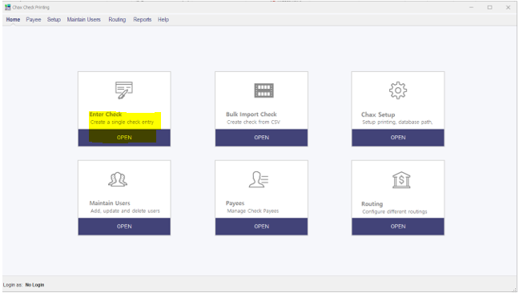
  - Payer and Payee Info need to be completed.
    - Enter Payer Name (customer name)
      - If previously entered in Chax Software, the Payer Address and Bank Information will populate
      - Confirm that the information in Chax Software matches what was received with Chax Check request (name, address, etc)
    - Enter Payer Address
      - Available on dashboard
      - Enter if available, but will process without if not available
    - Enter Pay to the Order of K&M Tire populates
    - Enter Payee Address 965 Spencerville Rd, Delphos, OH 45833 populates
    - Enter Amount of Payment
    - Enter Memo (customer #)
      - Can also give direction on application of payment
        - For example, statement balance, Invoice# etc
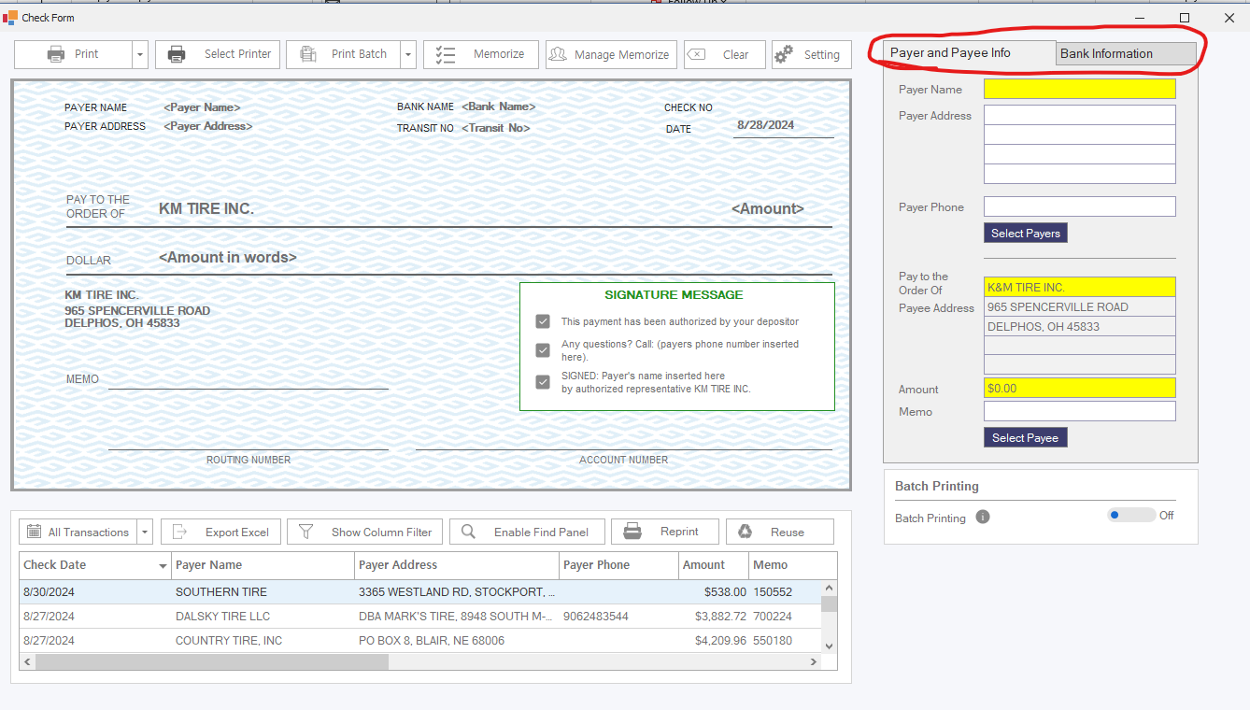
  - Bank Information needs to be completed or verified
    - If bank information populates, verify the last 4 digits with support requesting payment from customer
    - Enter check number – must be entered even if routing and account number populate
    - Enter routing & account number as provided, if not populated from previous Chax payment
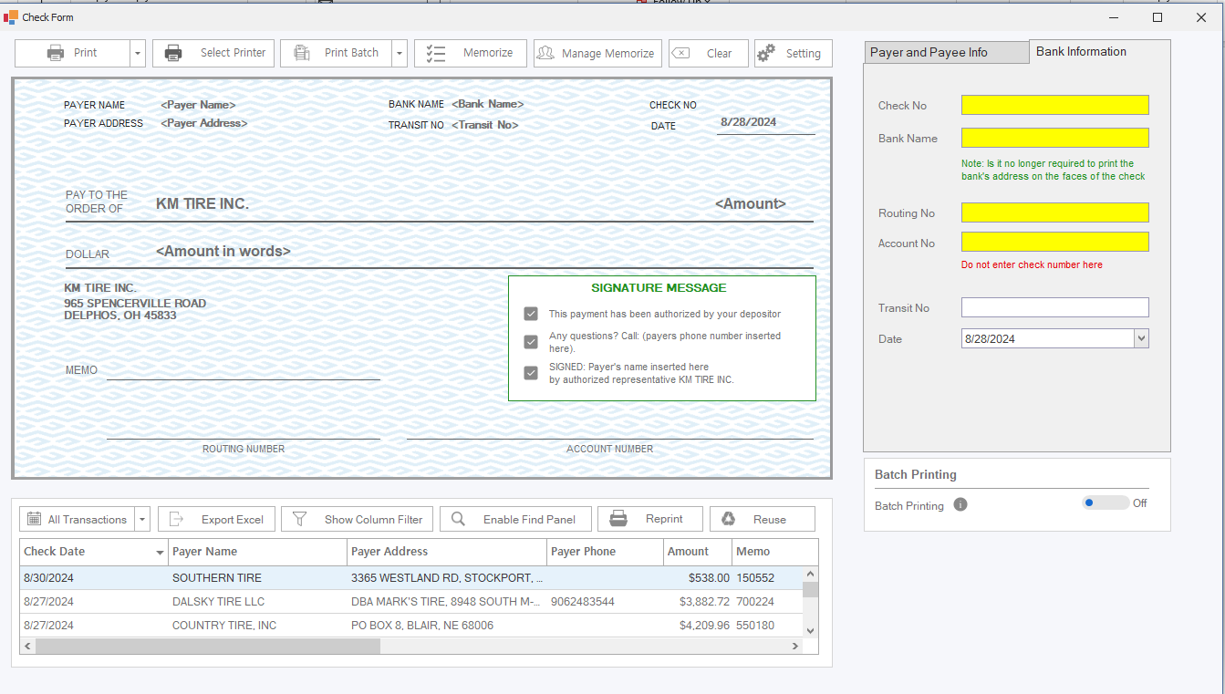
  - All Payee/Customer information entered in Chax is saved unless it is manually deleted after creating the Chax check.
  - Once all information has been verified, click print in the top left corner.
  - Verify the following in the fields below
    - Payor Name
    - Amount
    - Memo
    - Check #
    - Bank Name
    - Routing & Account numbers
      - Add initials to support for issuing check when verifying payor name, bank name, routing & account number
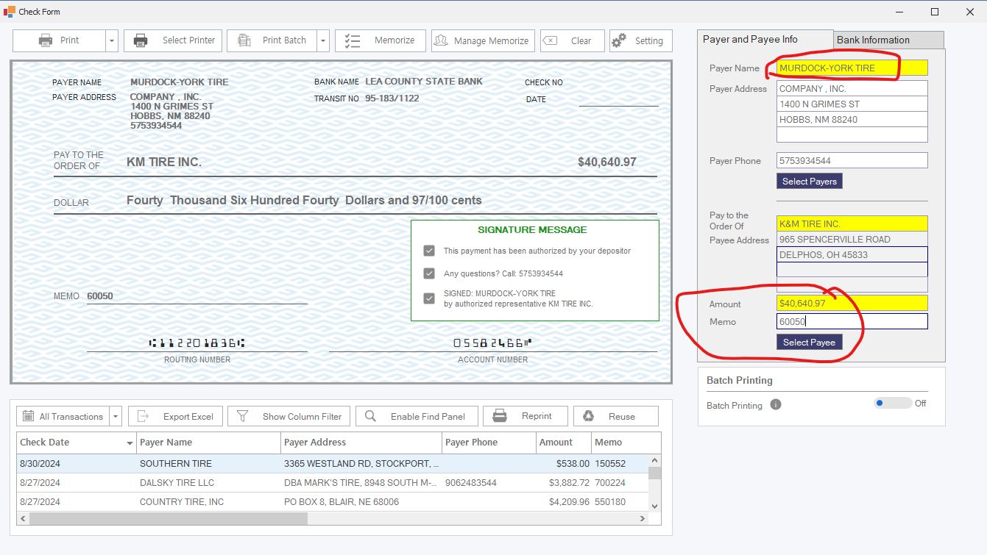
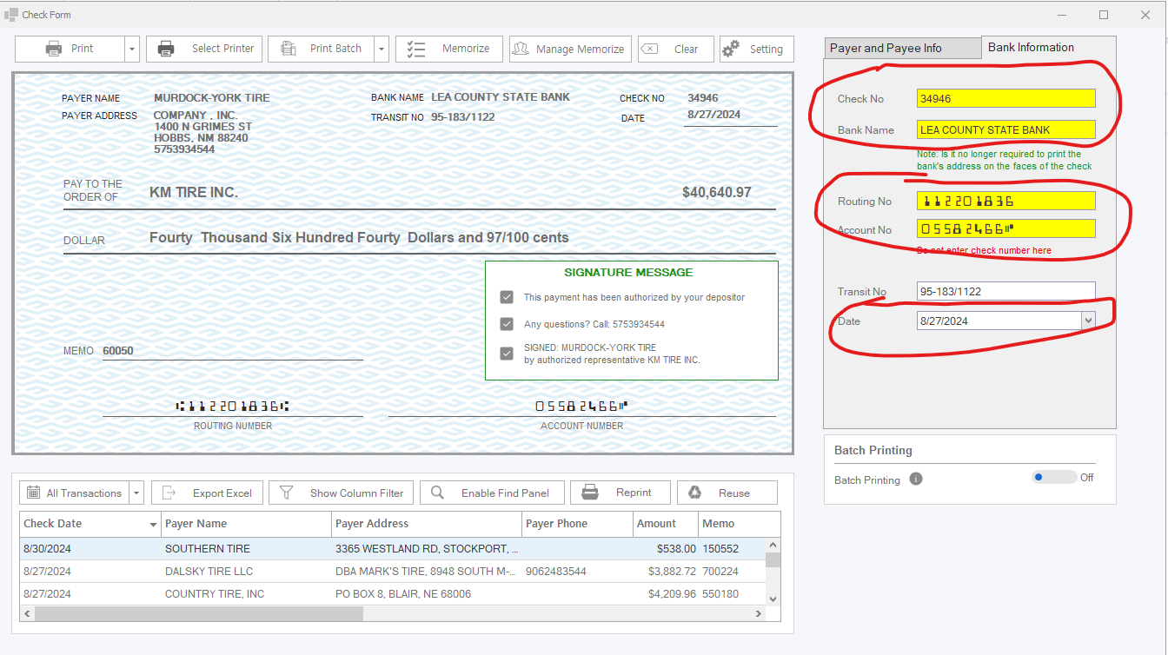
  - Click "YES" and "OK" after thoroughly proofreading.
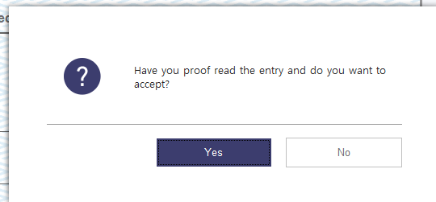
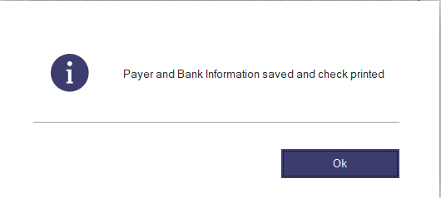
  - Printed check and support for payment should be given to a 2nd team member.
    - The 2nd team member should verify Payee name, address, customer number, and the last four of account number and should initial and date the bottom portion of the check with will get attached with payment support .
  - Once signed off, check can be placed with Mail Checks in AR for processing.
  - Email confirmation of payment to the customer, if requested.
  - Check support & bottom portion of check will be filed with Chax Payments.
  - The customer's checking information is confidential and must be handled with extreme care. Accuracy is essential when processing these payments to ensure errors are completely avoided.

Merchant Partners Payment Processing
If a customer would like to pay via credit/debit card or bank to bank (check by phone), we are able to accommodate them by using the Merchant Partners website. This procedure provides directions on how to process payments, as well as specifications on fees.
Credit Card Fees are not charged on the following:

- Debit Card Transactions
- COD transactions in the States of Texas, Colorado, Kansas, and Oklahoma.
- ALL transactions in the States of Maine, New York, California, Connecticut, Florida, and Massachusetts.
- A 2% CC Fee must be processed on all other Credit Card Transactions.

Credit Card Payment Processing (First Time!)
- To charge an invoice on a credit card of a customer with purchase history.
- Log in @ www.onlinemerchantcEnter.com.
- Username and Password are with permission only.
- Select Process Online Charge
- Enter the Amount to be charged. (Don’t forget the fee!)
- Type in the Cardholders Name. (Must be in either the Owners OR the Business Name)
- Enter Card #.
- Check the Bypass CVV2 Verification.
- Enter the Expiration Date.
- Under Invoice Number, Enter the Invoice(s) to be paid. If it’s a balance, please Enter something such as Oldest Balance and/or 4/10 Due.
- Enter the Customer Number.
- Under the Purchase Order Number, Enter the invoice # and/or customer # again and click the Tax-Exempt Box.
- Enter the Billing Zip Code.
- Hit process credit card.

Credit Card Payment Processing (Card on File)

- Click on Transaction Search.
- Enter the Customer Number and hit Search.
- Verify the last 4 digits of the Card that is to be processed.
- Click on the most recent transaction (Check the dates) where the last 4 numbers match up.
- Check the Issue New Sale Box.
- Click Submit.
- Click Continue to Issue New Sale.
- Enter the amount. (Don’t forget the fee!)
- Enter any info invoice Number and Customer Number.
- Check the Sales Tax-Exempt Box.
- Click Process Credit Card.
Check Payment Processing (First Time!)
- Select Process Online Check.
- Enter the Amount. (No Fee for Checks)
- Under the Description, list the Check # and any remittance information provided by the customer.
- Enter the Exact Name on Checking Account.
- Enter the Account Number.
- Enter the Routing Number.
- Enter the Invoice # if necessary and/or detail the same information as listed under the Description again.
- Enter the Customer Number.
- Check the Save As Stored Profile Box.
- Click Process.
Check Payment Processing (On File)
- Click on Transaction Search.
- Enter the Customer Number and hit Search.
- Verify the last 4 digits of the Checking Account that is to be processed.
- Click on the most recent transaction (Check the dates) where the last 4 numbers match up.
- Check the Issue New Sale Box.
- Click Submit.
- Click Continue to Issue New Sale.
- Enter the amount.
- Enter any invoice Number and Customer Number.
- Click Process.

Processing the CC Fee
As addressed in the previous section, credit card fees must be charged in accordance with state laws. If a credit card fee needs to be manually added to an order, an invoice will have to be processed onto the customer’s MaddenCo account as well. This script explains how to process that fee.

Go to MaddenCo and the following:
1 – Tire Dealer System
8 – Point of Sale Menu
4 – Counter Billing
Enter the location # of the account – Hit Enter
Hit F6 to create a new invoice.
Enter the customer number.
Hit F6 to create a new invoice.
Hit Enter
Enter you salesman # - Field Exit – Hit Enter
Enter Product ‘CCFee’ – Hit Enter
Enter Quantity ‘1’
Enter your price.
Hit Enter.
Hit F3
Hit F3
Is Invoice to be closed Y/N – Defaults to Y (which you want)
Tab down to “Print on Printer” and type P273ZHOLD (this will prevent the invoice from physically printing P273ZHOLD
Hit Enter.
Hit Enter.
Your invoice has closed.

Credit Card Fees are NOT charged on the following:
- Debit Card Transactions
- COD transactions in the States of Texas, Colorado, Kansas, and Oklahoma.
- ALL transactions in the States of Maine, New York, California, Connecticut, Florida, and Massachusetts.
- A 2% CC Fee must be processed on all other Credit Card Transactions.

Increased Level Duties

"Do By" Tasks and Expectations of Completion
Everything in this section is done at specified times throughout the month, quarter, or year.

Maintenance Log
The IT Manager sends a report of all Customer Maintenance Changes Quarterly to once every other month. This report is sent to both the Logistics Supervisor and the Credit Manager.

This Log needs to be reviewed for any inaccurate changes in Madden Co. It can be filtered down by name and/or by change.

Any errors found should either be forwarded to that Department Manager or Supervisor to discuss with the employee or sent directly to the employee themselves if the one reviewing it is the Manager of stated department.

Collection Agency Audit
Quarterly we should perform an Audit on the Performance of our Collections Agencies. The months of October, January, April, and July.

To do this, you must Save the Monthly Status Report provided to K&M by the Agency. (This report is usually given to the Credit Manager and/or the Credit Analyst).

All closed files must be reviewed to ensure that we have them closed.

All Active Files must be reviewed to ensure that we have the same balance listed and that we aren’t missing any payments.

All balances are in the Actual File Folder for the Customer at Collections.

They are listed in Alphabetical Order by Agency, in the Credit Departments Filing Cabinets.

Any/All Discrepancies must be notated in a Spreadsheet and reported to the Agency, Credit Manager, Office Manager and VP of Finance.

Annual Report on Customer over $100K
Annually a Query needs to be ran to determine what customers have a credit line of over $100K. This Report needs to be sent to the VP of Operations? for Review.

To pull the report in Madden (Follow the Query Procedure)

Query Name is KB.100Plus.

Hit a 9 to Run this Query and then follow the steps to pull the Query from ISeries and into an Excel Format for Review.

75% Of Line KPI Tracking
As part of the Credit Department’s KPI tracking, we monitor and track accounts that are utilizing 75% or more of their current credit line. This report is used by Credit to evaluate accounts utilizing 75% or more of their current line, so we can proactively evaluate them for an increase.
- Steps to Pull and Complete the Report:
  - Refer to SOP 4.2.4 – 75% of Credit Line Procedure to generate the necessary report.
  - Save or open the Excel version of the report.
  - Navigate to the F:\ Drive > Credit KPI’s folder, and open the document titled ‘Charts 75p Line’.
- Entering Data into the ‘Charts 75p Line’ Document:
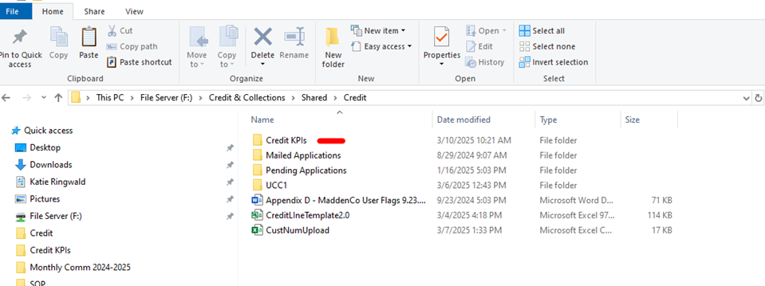
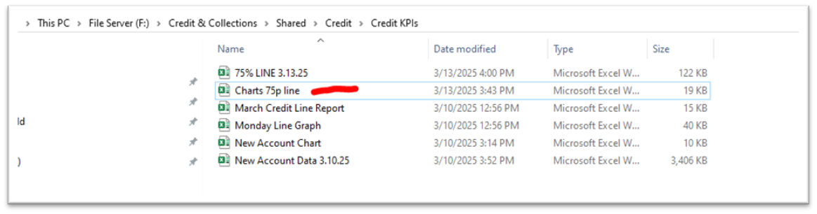

  - Once the file is open, begin entering the following data from your spreadsheet:
    - # of Accounts
    - Total number of accounts listed in the report.
    - At Collections
Number of accounts currently with a status of “At Collections.”

    - On COD / No Sales

Number of accounts that are on COD or marked as No Sales.

    - Other Past Due

Number of accounts with a past due balance that are not categorized as "At Collections" or "COD/No Sales."

    - Total Past Due

This value is calculated automatically along with the accounts to be reviewed for a potential credit limit increase.
2. ⚠️ Note: Not all accounts in the report will qualify for an increase.
    - # of Accounts Reviewed

Enter the number of accounts that you have reviewed.
2. Reviewing means you assessed the account and determined whether a credit limit increase is appropriate or necessary.

    - Percentages

All percentages are calculated automatically within the spreadsheet.

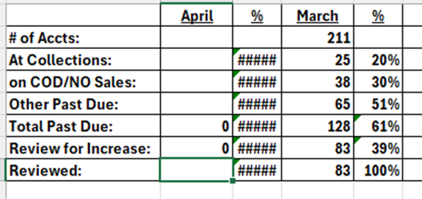

    - Final Steps

The Credit Manager will review the report and include the data in the Monthly Communication submitted to the President and Executive Vice President.
2. The Credit Manager will include any observations made and steps we’re taking based on this data.

Bad Debt and Collections Agency

Bad Debt Tracking
When an account is sent to collections as determined by the Credit Manger, the following procedures are performed:

- Add a “#” to the beginning of the customer’s name in customer maintenance. If the customer already has a $ (for CASH/COD), leave the $ first and add the # second.
- Also, add BD X/XX (date) behind the customer’s name to indicate the date the customer’s account went to collections.
- Change the statement from being printed to being e-mailed to the Credit Department.
- Set the account up as s/c exempt until the Collections balance is paid in full.
- On the F2 Screen, under Statement, add an ‘E’ for emailed.
- Add a user flag field of “C” to indicate the account is at collections.
- Update the sort name in MaddenCo to include “ZZZ” in the beginning of the name. This will force those accounts to the bottom of the ageing reports and other reports used by Credit.
- Send Inside Sales Manager an email to add ‘No Sales’ to the TOAST screen.
Payments received from the agency or the customer once they are at collections need to be reported to the Credit Manager or Credit Analyst prior to being applied to the account. Once those are received, the payment will be applied to the appropriate invoices. If the payment made includes agency fees, therefore not paying the entire invoice, adjust the agency fee to the GL, 5370 - Loc (Legal & Professional Fees). Also, if the fee is not paid in full, the balance will stay on the customer’s account until it’s paid or 90 days. After 90 days of non-collectability, it should be written off to 5370-Loc.
Below are a couple scenarios/examples:
- Customer A owes $10,000 and was sent to collections. The agency fee is 15% to assist us in collecting from our customer. The agency will attempt to collect the amount of our invoices and the agency fee from the customer. Therefore, the total attempt to collect is $11,500. The agency can collect the entire $11,500 from the customer but keeps the $1,500 for their fee. Apply the payment to the customer account.
- Customer B owes $10,000 and was sent to collections. The agency fee is 15% to assist us in collecting from our customer. The agency will attempt to collect the amount of our invoices and also the agency fee from the customer. Therefore, the total attempting to collect is $11,500. The agency is only able to collect $10,000 from the customer but keeps the $1,500 for their fee. Apply the payment of $8,500 to the customer account and adjust/write off the remaining balance to 5730-Loc.
- Customer C owes $10,000 and was sent to collections; however, is still buying from K&M on COD. The agency fee is 15% to assist us in collecting from our customer. The agency will attempt to collect the amount of our invoices and the agency fee from the customer. Therefore, the total attempting to collect is $11,500. The agency is only able to collect $10,000 from the customer but keeps the $1,500 for their fee. Apply the payment $8,500 to the customer account and leave the remaining balance. Add a memo to the invoice indicating the customer still owes for agency fees not collected.
At some point, an account may be deemed uncollectible (info provided by the collections agency). At that time, we’ll write off the customer’s account. The write off will include a Debit to 1290 (Bad debt Accrual) and the Credit will be to 1200 (AR). This removes the balance from AR. This process should only be done by the AR supervisor once the correct paperwork is completed by the Credit Manager.
In the event that we collect on an account that has been previously written off, the Credit Manager should be notified first, then AR Supervisor should apply the payment through AR adjustments and post it to 1290 (Bad debt Accrual). This will offset the original write off and correct the 1290 GL account.
At year end, the doubtful account will be reconciled to determine if our monthly estimates are accurate or need adjusted.

Query Procedure
A query is a detailed report that is pulled from MaddenCo based on different MaddenCo fields. There are existing saved queries, but you can also create your own. This procedure gives examples of topics to enter for a query.
- From anywhere in MaddenCo, hit the ESC button. Put a 1 on the Query line and Enter.
- Make sure the library says “USRQRY”.
- Then opt- 2
- Query- F4
- KBCODCHECK- 2 & Enter
- Select & Sequence Fields- 1 & Enter
- Seq should be in 10’s for fields CUNUMBER, CUNAME, CUTERMS & CUUSFLAG10 (see below)
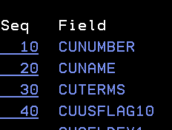

- Enter
- Select records- 1 & Enter
- Field should be CUDELETECD
- Test should be EQ
- Value “A”
- And CUTERMS, EQ & “007” (If pulling COD query)
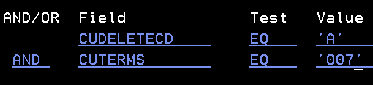

- ENTER
- F3
- SAVE DEFIINITION- Y
- RUN OPTION- 1
- ENTER
- F3.
- OPEN SYSTEM I NAVIGATOR
  - Open folders: my connections, basic operations, printer output.
  - Find today’s dated report & drag to desktop.

Bad Debt Write-Offs
Purpose: The purpose of this SOP is to establish guidelines for managing past-due customer accounts uncollectible and must be written off as Bad Debt Expense. Regular and timely reviews of Accounts Receivable (AR) balances ensure accuracy while allowing the Credit & Collections Team to follow consistent collection procedures and determine when accounts should be written off.
Scope: This SOP ensures that all uncollectible amounts are promptly adjusted from K&M books as Bad Debt expense in a timely manner and posted to the correct account within our general ledger.
- Bad Debt Guidelines
  - 90-Day Past Due Balances
    - Customer accounts that reach 90 days past due are:
      - Contacted a final time by Account Specialist to pursue payment, and either:
        - Placed on an in-house payment plan with a written promissory note; or
        - Sent to an Outside Collection Agency by the 5th business day of the month.
See section 5.1.9 Sending an Account to Outside Collections

    - Our first preference when feasible is to place accounts on an in-house payment plan.

See section 5.1.8 Repayment Plans
Note: an in-house payment plan has a 5-day window of payment agreement. If the account starts an in-house repayment plan but fails to follow through, it will still be turned over to collections.
  - NSF/Returned Payments
    - NSF (Non-Sufficient Funds) checks are billed back to customers and are due within 10 days.
    - Account Specialist contacts customers to notify them of NSF and request payment. If unpaid:
      - Accounts are placed on CASH-only status.
      - Texas accounts are placed on CASH-only immediately upon receiving an NSF notification.
    - If the NSF balance remains unpaid after 14 days, a Final Demand Notification is sent via Certified Mail.
    - If the balance remains unpaid after 3 weeks, the account is sent to an Outside Collection Agency.
  - Accounts Placed with a Collection Agency
    - Once an account is placed with an Outside Collection Agency, the K&M Team will no longer contact the customer for payment. The Collection Agency provides monthly updates on all accounts.
  - Writing off Uncollectible Accounts
    - An account is deemed uncollectible and written off K&M Tire’s accounts receivable under the following conditions:
      - The debtor files for bankruptcy.
      - The agency determines the account uncollectible and closes it.
      - NSF-related items unpaid 90 days after placement.
        - The collection of these items is still pursued by the agency. We will write off after 90 days because any likelihood of recovery is de minimis.
The following accounts are reviewed by the Credit Manager and submitted to the EVP on an individual basis for determination of accounting status and the next steps.
A judgment is filed, and funds are pending from a property sale.
  - Audit Process
    - Quarterly, the Credit Manager will review accounts 90+ days past due or in collections.
    - Any 90-day past-due accounts not placed with an agency will be reviewed for an in-house payment plan or agency placement by the 5th of the month.
    - Accounts meeting Bad Debt Expense criteria will be compiled and submitted to the Executive Vice President for write-off approval.
- Write-Off to General Ledger (GL) Accounts
The following accounts are used when recording bad debts.
  - 1403-1-1 Credit Risk Pass-Thru
    - All bad debts that qualify for Credit Risk Reimbursement should be posted to 1403-1-1. Accounts qualify for Credit Risk Reimbursement if:
      - The loss is incurred as a direct result of the customer’s failure to pay for goods or services purchased from K&M Tire. Loss must be caused by financial insolvency of the customer.
      - The loss is reported to 5-Star insurance within 100 days after K&M deems the Note:
Disputed amounts should not be turned in for reimbursement unless determined to be the valid and legally enforceable obligations of the customer. See 5-Star credit risk policy when in question. Balance uncollectible.
    - The annual combined reimbursable loss is limited to no more than $500,000 in aggregate for any fiscal year ending September 30th.
    - The annual combined reimbursable loss is limited to no more than $500,000 in aggregate for any fiscal year ending September 30th.

  - 1290-1-1 Allowance for Bad Debts
    - All other bad debts should be posted to 1290-1-1 Allowance for Bad Debts.
      - The controller makes a monthly Journal Entry to Credit 1290-1-1 bad debt reserve for an estimated accrual and debits each location’s bad debt expense 5980-Loc with an expense allocation based on sales.
      - The credit manager writes off individual accounts that don’t qualify for credit risk reimbursement to 1290-1-1.
      - At year-end The Controller reconciles the 1290 -1-1 account and adjusts the accrual as required by Generally Accepted Accounting Procedures.

Note: Both the insurance premium for Credit Risk Insurance and the monthly and year-end entries for bad debt expense are allocated to locations by sales volume. We are no longer writing off bad debts directly to individual locations.

Customer Number Change
Purpose:
This process ensures that updated customer numbers align with routing changes and are implemented without disruption to service.

Customer Number Change Process
- Coordination and Scheduling
  - Once a date is set, with alignment from Logistics, Credit & Collections, and IT, the Logistics Team will provide the Credit Manager with a list of proposed customer number changes.

- Timing of Changes
  - Changes typically occur on a weekend (Saturday) to accommodate IT system updates.
  - Preparations begin on Friday afternoon, a day prior to the scheduled change.
    - This allows time to address issues, make adjustments, and set up new customer accounts during regular hours.
- Important Note: **Account Setup Restriction**
  - Do not use Account Flow to set up new accounts during this process.
    - Account Flow auto-generates the next available customer number, which will disrupt the planned customer number changes.
2. Customer Number Assignment
  - Prepare for New Customer Numbers
  - Open the spreadsheet provided by Logistics and sort it by the new assigned location.
  - Use Customer Number Generator
  - Access the ‘Customer Number Generator’ portal.
  - Select the location and specify the quantity of new numbers needed based on the Logistics list.
    - Generate numbers for each location individually.
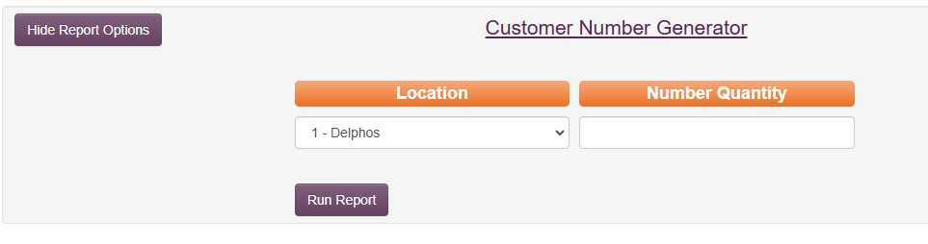
- Access CSV File Location
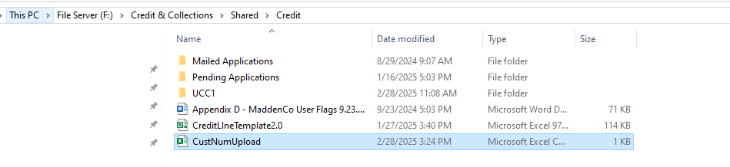
  - Navigate to:
F:\Credit & Collections\Shared\Credit\CustNumUpload

- CSV File Requirements
- File must be saved as a .csv format.
- Column headers must remain intact.
- Column 1 = Old Customer Number
Column 2 = New Customer Number
- Save the file to:
F:\Credit & Collections\Shared\Credit\CustNumUpload.csv
- After entering the data, save the file to your personal desktop as a .csv file only (Do NOT use ‘Save As’ to change the file type).
3. Uploading the File and Final Steps
- Upload the File
  - Go to the ‘Customer Number Change’ section on the Intranet.
  - Click ‘Choose File’, select your saved Customer Number CSV file, and upload it.
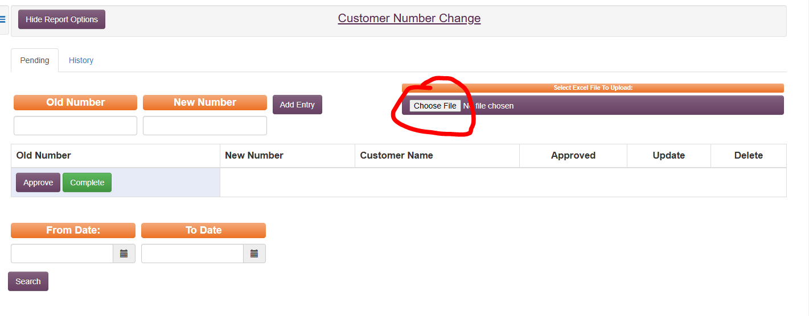
- Handling Errors
  - If an error occurs, a message will appear.
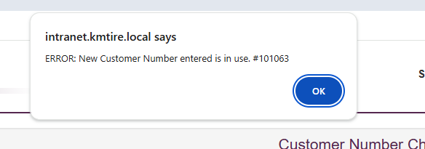
  - Open the CSV file, correct the customer number(s) as indicated, and re-upload.
- Final Confirmation with IT
  - Email IT to confirm everything is locked down and ready on their end.
  - IT will process the customer number change on Saturday and send a confirmation list of all completed changes.

Signature Capture Report

Purpose: This report is run daily and shared with Credit & Collections Manager. We use it to identify any unsigned but delivered orders, Cash & COD transactions where tires were delivered but a payment note was not recorded, and other potential errors in a timely manner.
- Process Overview
Frequency: Daily
Report Source:
    - An Excel report is emailed each morning by IT to:
financial.analyst@kmtire.com
    - This report includes all customer orders delivered 4 days prior.
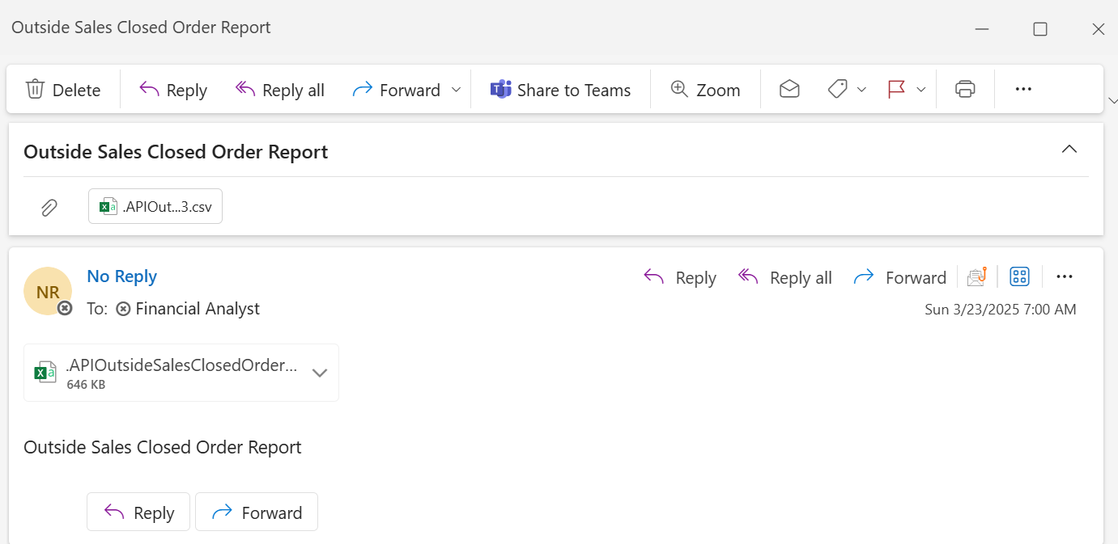

- Steps to Review and Save the Report
  - Open the Excel attachment from the email.
    - Click “Open” when prompted.
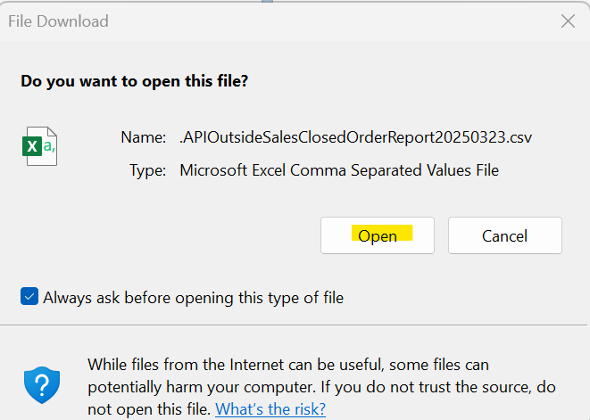

  - Enable filtering to sort data:
    - Highlight Row 1.
    - Click on the “Data” tab.
    - Select “Filter”.
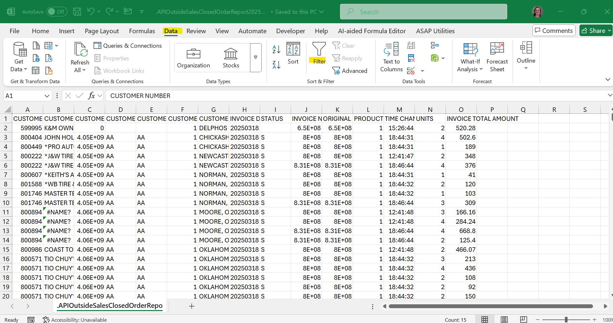
  - Filter out signed deliveries:
    - Click on the dropdown in Column I (Status).
    - Uncheck "S" to exclude signed deliveries.
    - This will show only those not signed.
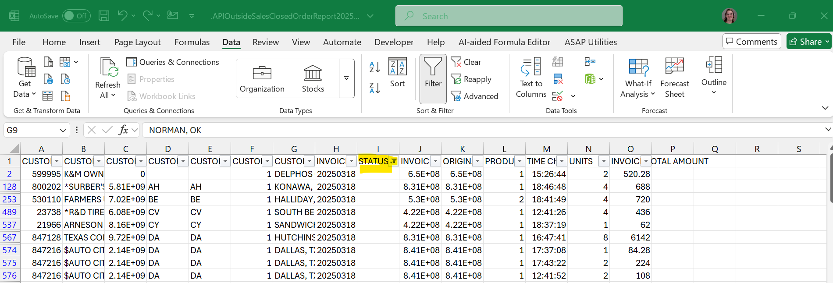
  - Remove "Own Use" customer names:
    - Click the filter icon in Column B.
    - Type “Own” in the search box.
    - Uncheck any customer with “Own Use” in their name.
    - Ensure the “Add current selection to filter” box is checked.
    - Click “OK”.
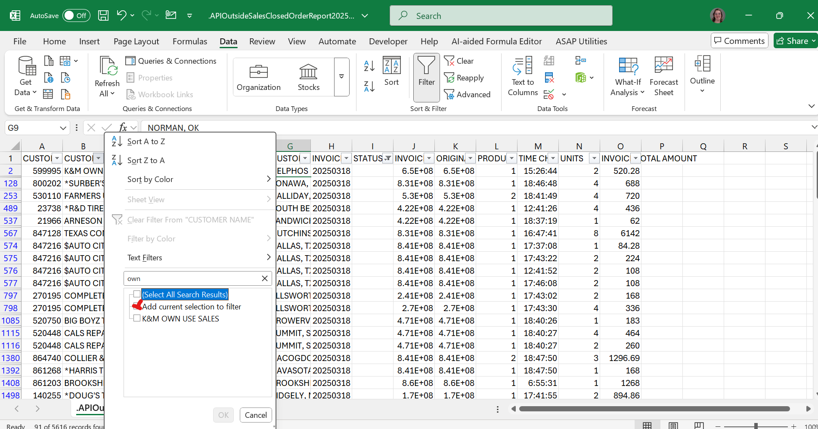
  - Save the filtered file:
    - Click “File” > “Save As”.
    - No need to change the filename.
    - Change “Save as type” to "Excel Workbook".
    - Click “Save”.

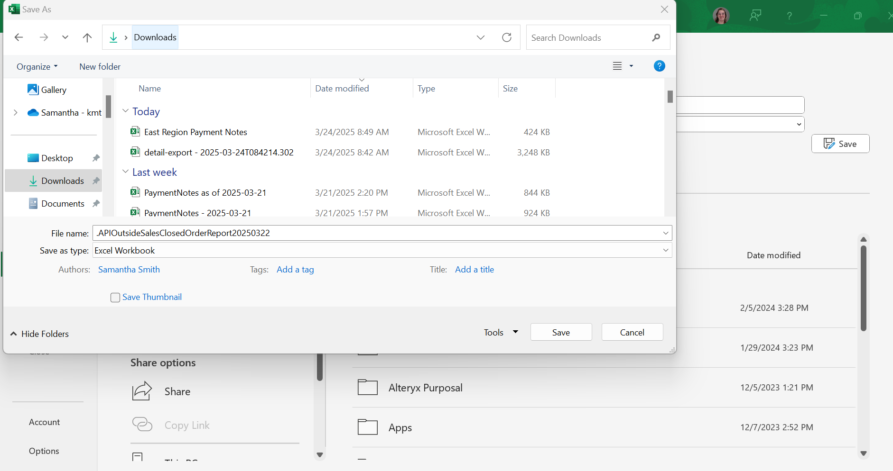

- File Distribution
  - Upload the file to Teams:
    - Navigate to:
Finance Goals & KPIs > Financial Analytics > AR > Signature Capture Report > 20XX
    - Drag and drop the saved Excel file into this folder.
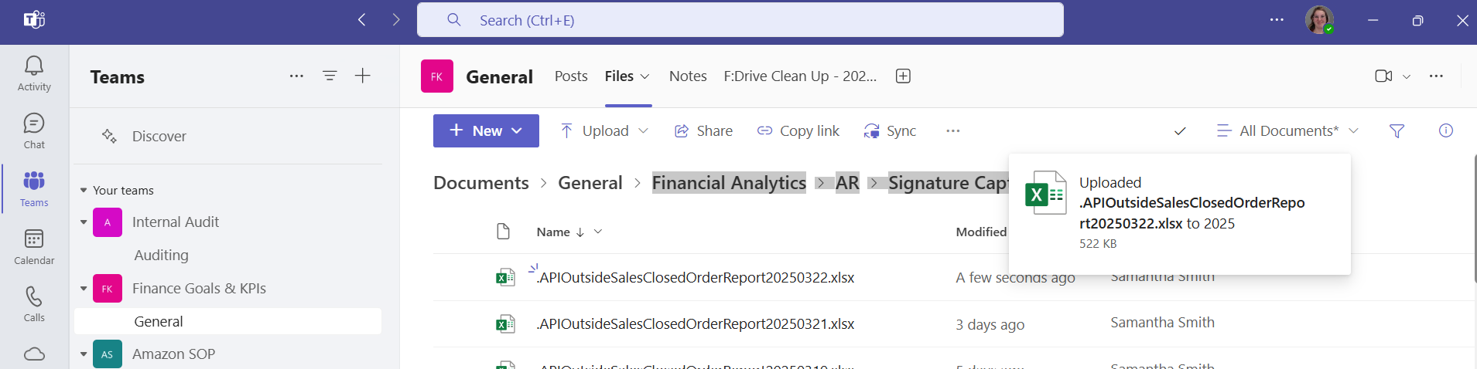

  - Notify the Credit & Collections Manager:
    - Email the saved file for additional research and follow-up, as needed.
  - Manager Use:
    - Accounting Dept Managers use this report for transaction monitoring and research, such as viewing transactions where tires were invoiced but no signature was obtained.

    - Managers will also un-filter this report to research Cash & COD transactions where tires were delivered to COD customer and signatured was obtained, but payment is still missing and there is no corresponding payment note.
    - To focus on fixing the root cause of issues identified by Signature Capture Report, Credit & Collections Manager will identify pain points and communicate to VP of Operations during our reoccurring monthly meeting between Accounting & Ops.
    - This report is an additional internal auditing resources to match tires delivered with payments received.

MaddenCo Procedure in case of Dashboard or Internet Outage
This Addendum should only be used when the Dashboard or internet is down.

Setting Up COD Accounts In Madden Co
This procedure outlines the setup of Collect on Delivery (COD) accounts. A COD account requires the customer to pay for the tires at the time of delivery. Note that COD accounts should not be confused with CASH ONLY accounts.
COD accounts must be set up in MaddenCo with Management approval. The Account Flow ensures that all necessary steps are completed.
- Confirm Account: Check the Intranet to ensure the account is new before proceeding, as outlined earlier in the procedure.
- MaddenCo Setup:
  - Log into the MaddenCo Tire Dealer System:
  - Navigate through: Accounts Receivable > Customer Maintenance Menu > Customer Maintenance.
  - To create a new account, press F6.
  - Back Tab: Use Shift + Tab to navigate back and enter the new account number.
b. Enter Customer Information:
  - Enter the Sort Name (business name).
  - Ensure the Sort Name and Customer Name match, following the same naming conventions as outlined earlier.
c. Enter Account Details:
  - Class Code: 2(except for specific states: OH, NY, PEN, ME, KS, and IL
where Class Code 3 may apply).
  - Home Store: 000
  - Price Code: 2
  - Salesman: 10
  - Terms Code: 007
  - Credit Limit: $10,000
  - Retread: n
  - Federal Tax ID: Must be provided (9-digit number or SSN).
  - State Code: Use F4 to select from the list.
  - Tax Authorization: Use F4 to select.
  - Tax Exempt: wh (indicated on application with tax-exempt number).
  - Walk-in Customer: n
  - Tender Type: COD
  - Past Due: n
  - Balance Forward: n
  - Service Charge Exempt: n
  - Statement Hold: n
  - Disc Structure: leave blank
  - Route Code: Provided by Logistics
  - Delivery Sequence: leave blank
  - Allow Back Orders: y
  - Can’t Buy File: n
  - Officer Name: leave blank
  - Move Account Selling: n
  - Service Charge Write-Off: 999
  - Allow Hot Sheet: y
  - P.O. #: n
  - Vehicle Required: n
  - Brand #: n
  - County: Provided on the application or look up by zip code.
- Sales Tax Form:
  - If sales tax information is provided, enter the ending year number (e.g., 2016 = 6).
- Finalizing Setup:
  - Statement: c
  - Check Enterprise: N
  - Commissions: Z (unless specified on the application).
  - First Order: N (indicating the customer hasn't placed their first order yet).
  - Complete any remaining fields and press Enter to finalize the account setup.
- Miscellaneous Notes:
- Ohio Customers: Class code 3 unless they are a registered tire dealer (as per the Ohio state website).
- New York and Maine Accounts: Set up with Class code 3.
- Kansas and Illinois Accounts: Class code 2 by default but can be set to 3 if requested and approved.
- Class Code 3: Applies state tire fees to the customer.
- Municipalities: Class code 4. Tax exempt is 04. (If 04 code is not available, contact K&M’s IT Department) Service charge exempt

Setting Up Charge Accounts in Madden Co
This section explains how to set up a customer's charge account. A charge account allows customers to receive products throughout the month and pay later. The standard setup includes 30-day Net 10th terms, with options for 60- and 90-day terms (subject to additional approval).
Important: Accounts should only be set up with Management approval, as Account Flow ensures all points of contact are properly established.

Steps for Setting Up Charge Accounts:
- Confirm Account: Ensure it is a new account by checking the intranet (refer to earlier procedures).
- Run DNBi Report: Use DNBi to assess whether the account can be set up on charge. (See Credit Line Template and Decision Tree for guidance).
- Set Up in MaddenCo:
  - Navigate to MaddenCo tire dealer system.
  - Go to Accounts Receivable → Customer Maintenance.
  - Enter store number 001.
  - To create a new account, press F6.
  - Use Shift + Tab to back-tab through fields.
  - Enter the new account number (provided from the new account spreadsheet).
  - Enter Sort Name: Use DBA if applicable and ensure it matches the customer’s name.
  - Follow the sorting rules for names (e.g., no spaces or special characters, numbers spelled out, drop "the" at the start).
Special Exceptions for Sort Names (for customers with 10 or more stores):
- Belle tire- belle followed by store number
- Discount tire- disc followed by store number
- Firestone-fire followed by city name
- Just tires- just followed by city name
- Levin tire- levin followed by city name
- Midas- midas followed by city name
- Meineke- mein followed by city name
- Monro mufflers- monro followed by city name
- Northwest tire- northwest followed by store number
- Tireman- tireman followed by city name
- Tires plus- tiresplus followed by city name
- Tuffy- tuffy followed by city name
- Bob sumerel- bobsum followed by city name
- Goodyear- good followed by city name
- TGK Auto – TGKAuto followed by store number
- Sun Auto – SunAuto followed by the store number
- Enter Account Information:
  - Sort Name (as explained above).
  - Customer Name and Contact Information.
  - Class Code:
    - Default is 2 (unless Ohio, New York, Pennsylvania, or Maine, where it's 3).
  - Home Store: 000 (unless it's location 84).
  - Price Code: 2
  - Salesman: 10
  - Terms Code: 001
  - Credit Limit: $5000
  - Federal Tax ID: Must be provided.
  - State Code and Tax Authority: Use F4 to select.
  - Tax Exempt: Select wh if indicated on the application.
  - Walk-in Customer: n
  - Tender Type: 1 (COD).
  - Past Due: n
  - Balance Forward: n
  - Service Charge Exempt: n
  - Statement hold: n
  - Disc structure: leave blank
  - Rt code: provided by logistics
  - Delivery sequence: leave blank
  - Allow Back Orders: y
  - Can/can’t buy file: n
  - Officer Name: Leave blank.
  - Move acct selling: n
  - Service charge write off: 999
  - Allow hot sheet: y
  - P.O. #: n
  - Vehicle required: n
  - Brand #: n
- Proceed to F2 Screen:
  - For Sales Tax Form: Enter the year (e.g., 2016 = 6).
  - First Order: Select N (if the customer hasn't placed their first order yet).
  - County: Enter based on the application or zip code lookup.
  - Date Received Charge Application: Enter in the bottom section.
  - Leave all other fields blank and press Enter to complete.

Special Class Codes and Exemptions:
- Class Code 3: Used for Ohio, New York, Maine, Kansas, Illinois (if requested).
- Class Code 4: For municipalities, with Tax Exempt Code 04.

Setting Up PR/SSP Miscellaneous Accounts in Madden Co
PR (Program) and SSP (Secondary Supply Point) accounts are special types of accounts requiring management approval. These accounts should only be set up in Madden Co with Management approval.
***These accounts must be approved by the Director of Marketing or the Marketing Coordinator prior to set up! ***
- Enter Account Details:

  - Add SSP or PR after the name.
  - Add the dealer number or non-sig number.
  - Class Code: 6
  - Price Code: 7
  - Salesman: 10
  - Credit Limit: $5000
  - Retread: n
  - Tax Exempt Code: 06
  - Federal tax id#: Enter off of application
  - State code: hit f4 and a list will be provided. (Should match the location)
  - Tax auth: hit f4 and list will be provided
  - Tax exempt: 06
  - Walk in cust: n
  - Tender type: gy
  - Past due: n
  - Balance frwd: n
  - Srv charge exempt: y
  - Statement hold: n
  - Disc structure: 6
  - Rt code: provided by logistics
  - Delivery seq: leave blank
  - Allow back orders: y
  - Can/can’t buy file: y
  - Officer name: leave blank
  - Move acct selling: n
  - Srv charge write off: 999
  - Allow hot sheet: n
  - P.O. #: y
  - Vehicle required: n
  - Brand #: n
- Additional Information:
  - Large Chain: Mark y if applicable (e.g., Goodyear, Firestone, Discount Tire, gcr, tires plus, just tires, Monro,).
  - Commissions: z
  - County: Enter based on zip code.
  - Check Enterprise: n
  - Car Dealer:
      - a avis
      - s firestone and affiliates
      - c Chrysler
      - f Ford
      - g gm
      - m midas
      - v volvo
      - y goodyear
      - z mazda
      - l alamo
      - R monro / mr. tire / tire barn / car x
      - Others (Honda, Nissan, Etc.)

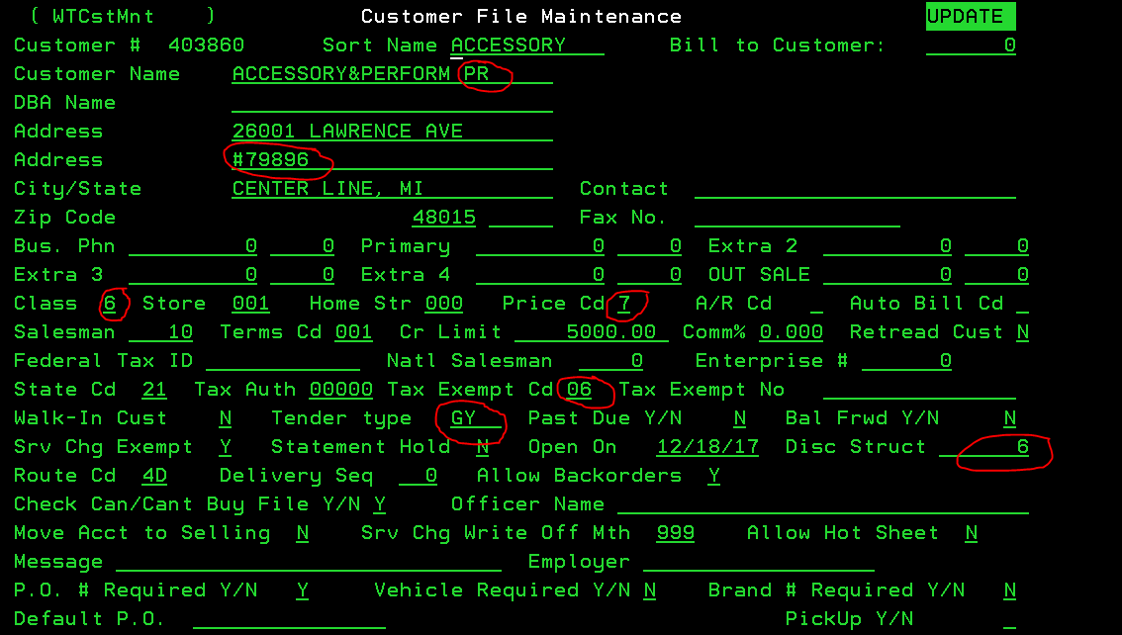

Updating a Due Date in MaddenCo
Use this method in MaddenCo only when necessary or when instructed by a Team Lead or Manager. This SOP corresponds with SOP 6.3 Updating Due Date (using Dashboard.)
Steps to Update Due Date in MaddenCo
- Navigate through the following menu path:
  - 1 – Tire Dealer System
  - 1 – Accounts Receivable Menu
  - 12 – Credit Management Menu
  - 5 – Customer Balance Inquiry
  - Enter:
  - Store Number = 000
  - Customer Name or Account Number
  - On the customer listing screen:
  - Enter a “6” on the line next to the customer’s name
  - Press Enter
  - At the A/R Open Inquiry screen:
  - Press Shift + F4
  - On the invoice line that needs updating:
  - Type “D” to change the due date
  - Press Enter
  - On the next screen:
  - Update the due date
  - Press Enter again to save

Status Changes in MaddenCo.
To Place an Account on COD:
- Open MaddenCo
- Go To:
  - 1 – Accounts Receivable Menu
  - 12 – Credit Management Menu
  - 5 – Customer Balance Inquiry
- Enter for all stores
- Press F9 and enter the customer number.
- Press 2 to edit the account.
- Add an (*) to the front of the customer name.
- Do not change route code or sequence number alignment.
- Change:
  - Terms Code to 007
  - Tender Type to cod
- Press F2
- Under “User Flag Statement,” add the letter ‘c’
- Press Enter twice to save.

To Place an Account on CASH ONLY:
- Open MaddenCo –Tire Dealer System.
- Go to:
  - 1 – Accounts Receivable Menu
  - 12 – Credit Management Menu
  - 5 – Customer Balance Inquiry
- Enter for all stores
- Press F9 and enter the customer number.
- Press 2 to edit the account.
- Add a dollar sign ($) to the beginning of the customer’s name.
- Change:
  - Terms Code to 008
  - Tender Type to CASH
- Press F2
- Under “User Flag Statement,” add the letter ‘c’.
- Press Enter twice to save.

To Place an Account on NO SALES:
- Follow steps for CASH ONLY if the customer is not already on it.
- You must have Credit Manager approval, unless:
  - The account is out of business with a balance due, in which case set to No Sales until paid in full.
- Where it says Past Due Y/N, enter an ‘X’.
- Press Enter

Conclusion

The purpose of this Standard Operations Procedure binder is two-fold. To provide new hire’s with a map to success in their new position here at K&M Tire Inc. By referencing to your Accounting SOP Manual you are already using K&M Tire’s Value #4 “Commit to the pursuit of perfection.” Perfection is our goal as we work to exceed expectations in all of our buisiness and in relationships with customers, suppliers and employees. While perfection is unattainable, we strive for continous improvement in all we do, getting better every day.
The second purpose is to have a reference tool for all employees, whether newly hired or seasonal, to consistently and correctly perform these tasks.

Appendix B: Supportive Department Summaries
How we can help at the field level?

Instructions: Provide a list of acronyms and associated literal translations used within the document. List the acronyms in alphabetical order using a tabular format as depicted below.

Table 1 - Acronyms
Acronym | Literal Translation
COD | Collect on Delivery
RPR | Repayment Plan
Rec’d | Received
Gov’t | Government
NSF | Non-Sufficient Funds
Appendix D: Referenced Documents
Table 2 - Referenced Documents
Document Name | Document Location and/or URL | Audit Schedule | Last Reviewed
All state tax exempt forms | F:\Credit & Collections\Public\Tax Forms | Government Provided | n/a
Blank W-9 | F:\Credit & Collections\Public\Tax Forms | Government Provided | n/a
Account Application – K&M Tire | F:\Credit & Collections\Public\Credit | Annually | 10/31/2018
Common Ownership Form | F:\Credit & Collections\Public\Credit | Annually | 10/31/2018
Dealer Request Fillable | F:\Credit & Collections\Public\Credit | Annually | 9/21/2018
Release of Liability | F:\Credit & Collections\Public\Credit | Annually | 12/5/2017
Spanish Ap | F:\Credit & Collections\Public\Credit | Annually | 4/23/2013
Credit App Worksheet | F:\Credit & Collections\Public | Daily | Updated Daily
Altus (COFACE) **Outside Collections Agency | F:\Credit & Collections\Shared\BadDebt\Collection Accts | Quarterly | ?
ESP **Outside Collections Agency | F:\Credit & Collections\Shared\BadDebt\Collection Accts | Quarterly | ?
BDebt19-20 | F:\Credit & Collections\Shared\BadDebt\BDEBT | Monthly | ?
Repayment List | F:\Credit & Collections\Shared\Collections\PYMNT AGREEMENTS | Monthly | ?
Credit Reject | F:\Credit & Collections\Shared\Collections\Letters | Quarterly | ?
Ex Employee | F:\Credit & Collections\Shared\Collections\Letters | Quarterly | ?
FD – Letter | F:\Credit & Collections\Shared\Collections\Letters | Quarterly | ?
NSF-1 | F:\Credit & Collections\Shared\Collections\Letters | Daily | Updated Daily/Weekly
Reminder | F:\Credit & Collections\Shared\Collections\Letters | Monthly | ?
SC Letter | F:\Credit & Collections\Shared\Collections\Letters | Monthly | ?
Thank You But (TYB) | F:\Credit & Collections\Shared\Collections\Letters | Quarterly | ?
Credit Line Template (Updated) | F:\Credit & Collections\Shared\Credit | Annually | Nov. 2019
Decision Tree | F:\Credit & Collections\Shared\Credit | Annually | Nov. 2019
Check Request | F:\Credit & Collections\Shared\Credit\FORMS | Annually | ?
Collection Form | F:\Credit & Collections\Shared\Credit\FORMS | Quarterly | ?
UCC-1List | F:\Credit & Collections\Shared\Credit\UCC1 | Monthly | ?
UCC Words | F:\Credit & Collections\Shared\Credit\UCC1 | Annually | ?
Blank RPR | F:\Credit & Collections\Shared\Collections\PYMNT AGREEMENTS | Quarterly | ?
Appendix H: Revision History Tracking
The following table records information regarding changes made to the SOP Binder.
Table 3 - Revision History Tracking
Version Number | Date | Author/Owner | Description of Change
4.14 | 1/7/2019 | Joni Zerkel | Updates on How to handle driver calls
 | 1/3/23 | Shaina Johnson | Establishing and Increasing Credit Lines 4.1.4
 | 5/9/2023 | Angie Prichard | Updated 6.2 – Refunds/Check Requests page 79
 | 10/15/2024 | Shaina & Barb | Added 4.9.2 – Credit Auth w/o Dashboard Intranet
 | 3/13/25 | Kayla | Updated 6.5.4/ Added 4.11
 | 3/31/25 | Barb Suever | Added 5.3 Pulling Employee Statements
 | 3-31-25 | Barb Suever | Added 7.3 Customer Number Change
 | 4-28-25 | Barb Suever | Updated 5.1.3 Large Chain Aging/E-Commerce
 | 5/6/2025 | Angie Prichard | Updated: 5.6 Credit Card Declined & 7.2.3 Bad Debt Write-Offs
 | 6/12/2025 | Angie Prichard | Updated 5.1.8 Repayment Plans
 | 6/12/2025 | Angie Prichard | Replaced 6.2.3 Manager Approval – Check Requests
 | 7/30/2025 | Shaina Johnson | Added section 7.4 Signature Capture Report
 | 7/30/2025 | Angie Prichard | Updated 5.1.6 Status Changes & Added 8.4 Status Changes in MaddenCo
 | 7/31/2025 | Shaina Johnson | Replace 5.1.5 with Guideline/Collections Policy
 | 8/4/2025/ | Shaina Johnson | Replace section 5.5 Payment Discrepancy Follow Up with New/ Updated 5.5 Payment Discrepancy Follow
 | 8/11/2025 | Shaina Johnson | Replace section 6.3 & 8.4 Updating a Due Date
 | 9/9/2025 | Shaina Johnson | Add section 5.1.6 California collections Guidelines
 | 11/12/2025 | Angie Prichard | Removed 4.3.9 Scanning customer Files and 5.1.2 Payment Discrepancies
 | 11/12/2025 | Angie Prichard | Added 5.2.1 Daily Tasks – account Specialist and Updated 5.2.2 Final Demand Notices

